Professional Responsibility in Immigration Litigation

1

(b) (6)

Papu Sandhu, OIL

INTRODUCTION

Role of Professional Responsibility Officer (PRO).

- Two set of rules: (1) professional responsibility rules and (2) DOJ ethics rules.

2

  - http://www.justice.gov/jmd/ ethics/
    - David Cohen
    - Natalie Waites
    - Holly Snow

3

Question
- The Virginia Bar Association would like you to teach a session in one of its training programs and has offered modest compensation as well as travel

expenses. You would like to know if you can accept these benefits.

4

Which Set of Rules Does This Fact Pattern Implicate?

(b) (5)

5

Who is the Client?
  - The client for a DOJ lawyer is the United States, acting through the AG and his or her designees. See PRAO memo, July 2011.

6

Core Duties to Client

  - Duties of competence, diligence and loyalty

Duty of communication

  - Duty of confidentiality

7

HYPO – Question 1
  - You have a 9th Cir 238(b) case where the FARO is based on P’s COV conviction. After the FARO is issued, but before the reasonable fear proceeding ends, the court decides Dimaya, under which P is no longer removable (P is still removable on non-criminal charge). P files a PFR pro se. In his opening brief, P challenges only the RF finding and not COV charge.

8

(b) (5)
Do you have a duty to bring
Dimaya to the Court’s attention?

Duty of Candor - Rule 3.3(a)(2)

- Requires disclosure of “legal authority in the controlling jurisdiction known to the lawyer to be directly adverse to the position of the client and not disclosed by opposing counsel”

10

Questions to Consider
  - Is the decision one the court should “clearly consider” in deciding the case?

  - Might the judge consider himself or herself misled by an implied representation that the lawyer knew of no adverse authority?”
  - ABA Formal Op. 280 (1949).

11

Role of Government Attorney
  - A government attorney must be “ever cognizant that ‘he is the representative of a government dedicated to fairness and equal justice to all and, in this respect, owes a heavy obligation to [his adversary].’”

7th Circuit

“The ostrich-like tactic of pretending that potentially dispositive authority against a litigant’s contention does not exist is as unprofessional as it is pointless.”

- Hill v. Norfolk &W. Ry. Co., 814 F.2d 1192, 1198 (7th Cir. 1987)

13

“The ostrich is a noble animal, but not a proper model for an appellate advocate.”
- Gonzalez-Servin v. Ford Motor Co., 662 F.3d 931, 934 (7th Cir. 2011)

14

15

HYPO – Question 2

P retains counsel. It turns out that opposing counsel is a former OIL attorney whom you did not get along with because he is a total jerk. You relish the opportunity to defeat him in this litigation.

16

Can You Continue to Handle the Case?

(b) (5)

Personal Conflict of Interest

18

Rule 1.7(a)(2) Personal Interest Conflict
- Conflict of interest if:

Significant risk;
  - that client representation;

will be materially limited
  - by a personal interest

19

(
b) (5)
Rule 1.7(a)(2)
Personal Interest Conflict

20

- But . . .
- even if conflict, could you still handle the case?

21

Rule 1.7(a)(2) Personal Conflict Permissible If:

1. Competent/diligent representation
- 2. Not prohibited by law

3. Not representing one client against other
- 4. Client consent confirmed in writing

22

HYPO – Question 3

The case is transferred to district court after P claims he’s a citizen. In discovery, you subpoena the detention facility’s phone records of P’s calls because you believe P’s citizenship claim is fraudulent. As you review the transcript of P’s phone calls you realize, to your complete surprise, that it includes
23 calls to P’s counsel.

What Should You Do?

(b) (5)

Rule 4.4(a) – Respect for Rights of Third Parties
- (a) In representing a client, a lawyer shall not use means that have no substantial purpose other than to embarrass, delay, or burden a third person, or use methods of obtaining evidence that violate the legal rights of such a person.

25

Rule 4.4(a) – Respect for Rights of Third Parties
- Comment [1] – The rule precludes, among other things, “unwarranted intrusions into privileged relationships, such as the client-lawyer relationship”

26

Rule 4.4(a) – Respect for Rights of Third Parties

(b) (5)

27

HYPO – Question 4

You arrange to have a DHS fraud agent interview P’s mother re: P’s nationality claim. P’s mother is in prison in Ohio serving a prison sentence for material support of the Taliban, and is currently represented by criminal counsel regarding a collateral challenge to her conviction.
28

(b) (5)
May You Direct the Agent to Interview P’s Mother in the Absence of Her Counsel?

First Question
(b) (5)

30

Responsibilities Regarding Non-Lawyer Assistants– Rule 5.3
- A lawyer may be held responsible where:
- (1) lawyer orders or ratifies conduct;
- (2) lawyer has direct supervisory authority over person, and knows of the conduct at a time when its consequences can be avoided or mitigated but fails to take action.

(b) (5)

Second Question

32

Rule 4.2 – Communication with Represented Party

In representing a client, a lawyer shall not communicate about the subject of the representation with a person the lawyer knows to be represented by another lawyer in the matter, unless the lawyer has the consent of the other lawyer or is authorized to do so by law or a court order.

Rule 4.2 – Communication With Represented Party
- Comment [4] – “This Rule does not prohibit communication with a represented person, or an employee or agent of such a person, concerning matters outside the representation.”

34

Rule 4.2 – Communication with Represented Party

(b) (5)

- But, but, but, remember
Rule 4.4

36

Rule 4.4(a) – Respect for Rights of Third Parties

- Lawyer may not use “methods of obtaining evidence that violate the legal rights of such a person” such as attorney/client privilege.

What does this mean practically?

37

Rule 4.4(a) – Respect for Rights of Third Parties

(b) (5)

38

Responsibilities Regarding Non-Lawyer Assistants– Rule 5.3
- “[A] lawyer having direct supervisory authority over the nonlawyer shall make reasonable efforts to ensure that the person’s conduct is compatible with the professional obligations of the lawyer.”

HYPO – Question 5

In drafting your summary judgment motion, you demolish P’s theory of the case pointing out numerous weaknesses. You also characterize opposing counsel’s work in the case as that of “second-rate lawyer.”

40

(b) (5)
What Professional Responsibility Rules Might be Implicated?

Inappropriate Language
(b) (5)

42

Rule 4.4(a) – Respect for Rights of Third Parties
- (a) In representing a client, a lawyer shall not use means that have no substantial purpose other than to embarrass, delay, or burden a third person, or use methods of obtaining evidence that violate the legal rights of such a person.

43

In re First City Bancorporation of Texas, Inc. (N.D. Tex. 2001)

“Stooges”
- “Various incompetents”

“Falling all over themselves, wasting endless hours.”
- “An underling who graduated from a 29th-tier law school”

44

HYPO – Question 6

You genuinely believe opposing counsel is an incompetent attorney who should not be practicing law. In your reply to P’s summary judgment opposition, you state that opposing counsel fails to meet even minimum levels of competence and diligence.

45

Is Your Statement Appropriate?

(b) (5)

Rule 8.3(a) Reporting Misconduct
- A lawyer who knows another lawyer
- Violated Professional Conduct Rules
- Violation raises substantial question as to honesty, trustworthiness or fitness,
- Shall inform disciplinary authority.

47

(b) (5)
Accusing Counsel of an Ethics Violation

48

Report to OPR
- OPR decides whether to report misconduct and consent to disclosure

- OPR stands in shoes of US with regard to authorizing disclosures to state bar

- Thus, you satisfy any professional responsibilities by reporting to OPR.

49

HYPO – Question 7

A hearing is scheduled in San Fran on your summary judgment motion. You have a good friend who clerks for a judge (not the Judge who will hear your motion), and would like to meet him for coffee after your argument to catch up.

50

(b) (5)
Can You Meet Your Friend?

Ex Parte Communications- Rule 3.5

A lawyer shall not:
- (a) seek to influence a judge, juror, prospective juror or other official by means prohibited by law;

(b) communicate ex parte with such a person during the proceeding unless authorized to do so by law or court order.

Rule 8.4 - Maintaining The Integrity Of The Profession

- It is professional misconduct for a lawyer to:

(f) knowingly assist a judge or judicial officer in conduct that is a violation of applicable rules of judicial conduct or other law

Judicial Code of Conduct

- Canon 2 of the Code of Conduct for Judicial Employees prohibits “activities that would put into question the propriety of the judicial employee’s conduct in carrying out the duties of the office.”

Judicial Code of Conduct
(b) (5)

Thank You For Your Attention!

56

2019 WL 4266121
Only the Westlaw citation is currently available. United States Court of Appeals, Fifth Circuit.

Maria Suyapa GONZALES-VELIZ, Petitioner, v.
William P. BARR, U.S. Attorney General, Respondent.
No. 18-60174
|
FILED September 10, 2019

Synopsis
Background: Native and citizen of Honduras filed petitions for review of Board of Immigration Appeals (BIA) orders dismissing her appeal of immigration judge's (IJ) denial of her application for asylum, withholding of removal, and protection under Convention Against Torture (CAT), and denying her motion for reconsideration.

Holdings: The Court of Appeals, Elrod, Circuit Judge, held that:

substantial evidence supported BIA's finding that alien failed to show that she was harmed on account of her membership in particular social group of Honduran women unable to leave relationship;

substantial evidence supported IJ's finding that Honduran police did not and would not acquiesce to alien's alleged torture by her ex-boyfriend;

alien exhausted her administrative remedies before seeking judicial review of BIA's denial of her motion for reconsideration;

injunction issued in another case did not preclude Court of Appeals from reviewing decision in order to rule on alien's petition;

Honduran women unable to leave their relationships did not constitute particular social group;

Attorney General did not act arbitrarily or capriciously in issuing decision and guidance memorandum that addressed whether asylum applications based on domestic or gang
violence could establish membership in particular social group; and

BIA did not abuse its discretion in failing to reconsider its denial of alien's application for CAT relief.

Petitions denied.

Procedural Posture(s): Review of Administrative Decision.

Petitions for Review of Orders of the Board of Immigration Appeals
Attorneys and Law Firms

Ryan Jeffrey Watson, Jones Day, Washington, DC, Christina Therese Mastrucci, Jones Day, Miami, FL, for Petitioner.

Aric Allan Anderson, Trial Attorney, U.S. Department of Justice, Office of Immigration Litigation, Washington, DC, for Respondents.

Before ELROD and WILLETT, Circuit Judges. *
Opinion

JENNIFER WALKER ELROD, Circuit Judge:

*1 Maria Suyapa Gonzales-Veliz, a Honduran citizen, petitions for review of the denial of asylum, withholding of removal, and protection under the Convention Against Torture (CAT). While her initial petition for review was pending before us, Gonzales-Veliz also filed a motion for reconsideration with the Board of Immigration Appeals (BIA), which subsequently denied reconsideration by invoking an intervening decision in Matter of A-B-, 27 I. & N. Dec. 316 (A.G. 2018). Gonzales-Veliz also petitions for review of the denial of reconsideration. We deny both petitions for review.

I.

Gonzales-Veliz is a native and citizen of Honduras. In August 2014, Gonzales-Veliz entered the United States without inspection, was apprehended at the United States border, and was removed to Honduras under an expedited removal order. In a sworn statement, Gonzales-Veliz stated that she entered the United States “to look for employment” and that she had no fear of harm or returning to Honduras. Later in April

2015, Gonzales-Veliz once again entered the United States illegally and was apprehended. The Department of Homeland Security reinstated the 2014 removal order and sought to remove her, but this time, Gonzales-Veliz claimed that she feared returning to Honduras due to widespread gang violence there. An asylum officer referred the matter to an immigration judge (IJ).

After hearing testimony, the IJ denied Gonzales-Veliz's application for asylum, withholding of removal, and CAT protection. Citing controlling Fifth Circuit cases, the IJ held that Gonzales-Veliz was ineligible to apply for asylum because she unlawfully reentered the United States and had her previous removal order reinstated. See Ramirez-Mejia v. Lynch, 794 F.3d 485, 491 (5th Cir. 2015) (“[A]liens whose removal orders are reinstated may not apply for asylum.”). The IJ further concluded that Gonzales-Veliz failed to demonstrate that she was harmed on account of a membership in a particular social group—Honduran women unable to leave their relationship. The IJ also determined that Gonzales- Veliz failed to demonstrate that the Honduran government was unable or unwilling to protect her because her testimony showed that the police took actions to protect her. Moreover, the IJ found her not credible. As to her application for CAT protection, the IJ found that the Honduran government would not acquiesce in torture that she was allegedly expecting at the hands of another individual with whom she had previously been in a relationship. Alternatively, the IJ denied Gonzales- Veliz CAT relief because she lacked credibility.

Gonzales-Veliz appealed to the BIA, which dismissed the appeal. The BIA found that, even if Gonzales-Veliz was credible, she did not belong to her proffered particular social group because her own testimony showed that she was able to leave her relationship. The BIA further found that Gonzales- Veliz was not harmed on account of belonging to that group. The BIA denied Gonzales-Veliz's asylum and withholding of removal claims based on these grounds, and it did not rely on other grounds offered by the IJ in denying relief, such as the reentry bar for asylum and Gonzales-Veliz's lack of credibility. As to the IJ's denial of CAT relief, the BIA found insufficient evidence to disturb the IJ's finding that the Honduran government would not acquiesce in torture. Gonzales-Veliz petitioned for review of the BIA's denial of asylum, withholding of removal, and CAT protection.

*2 After filing her initial petition for review, Gonzales- Veliz also filed a motion for reconsideration before the BIA. See Espinal v. Holder, 636 F.3d 703, 705 (5th Cir. 2011)
(“In addition to filing a petition for review in this court, an alien may simultaneously seek reconsideration by the BIA.”). While Gonzales-Veliz's motion for reconsideration was still pending, then-Attorney General Sessions issued his decision in Matter of A-B-, 27 I. & N. Dec. 316 (A.G. 2018), holding that “married women in Guatemala who are unable to leave their relationship” did not constitute a particular social group and clarifying other points of law pertaining to asylum and withholding of removal claims. The BIA denied Gonzales-Veliz's motion for reconsideration by invoking the Attorney General's A-B- decision. Gonzales- Veliz filed a second petition for review, challenging the denial of reconsideration.

II.

We first turn to Gonzales-Veliz's initial petition for review concerning the denial of asylum, withholding of removal, and CAT relief. We review factual findings for substantial evidence and “may not reverse the BIA's factual findings unless the evidence compels it.” Wang v. Holder, 569 F.3d 531, 536–37 (5th Cir. 2009); 8 U.S.C. § 1252(b)(4)(B) (“[T]he
administrative findings of fact are conclusive unless any reasonable adjudicator would be compelled to conclude to the contrary.”). We hold that substantial evidence supports the BIA's denial of asylum, withholding of removal, and CAT relief.

A.

To qualify for asylum, an alien must show “that he is ‘unable or unwilling to return to ... [and] avail himself ... of the protection of [his home] country because of persecution or a well-founded fear of persecution on account of race, religion, nationality, membership in a particular social group, or political opinion.' ” Ghotra v. Whitaker, 912 F.3d 284, 288 (5th Cir. 2019) (alterations in original) (quoting 8 U.S.C.
§ 1101(a)(42)(A)). To qualify for withholding of removal, the alien must make the same showing but must establish that persecution is “more likely than not,” which is “a higher bar than the ‘well-founded fear' standard for asylum.” Id. (quoting Efe v. Ashcroft, 293 F.3d 899, 906 (5th Cir. 2002)). “If an applicant does not carry his burden for asylum, he will not qualify for withholding of removal.” Id.

For both asylum and withholding-of-removal claims, the alleged persecutor's motive—whether the persecutor acted

against the alien on account of her membership in a particular social group—is crucial. Thus, an alien must show that a protected ground (e.g., membership in a particular social group) was “at least one central reason for persecuting the applicant.” 8 U.S.C. § 1158(b)(1)(B)(i). “[A]lthough a statutorily protected ground need not be the only reason for harm, it cannot be ‘incidental, tangential, superficial, or subordinate to another reason for harm.' ” Shaikh v. Holder, 588 F.3d 861, 864 (5th Cir. 2009) (quoting Matter of J-B-N &
S-M-, 24 I. & N. Dec. 208, 214 (BIA 2007)).

Here, the BIA found that Gonzales-Veliz failed to show that she was harmed on account of her membership in a particular social group—i.e., that her ex-boyfriend harmed her for being a Honduran woman unable to leave her relationship. Substantial evidence supports this finding. Gonzales-Veliz's own testimony belies her claim. Gonzales-Veliz testified before the IJ that she and her ex-boyfriend had no problem after she left him and that “problems began” only after she sued her ex-boyfriend for child support. Gonzales-Veliz argues that the machismo culture and her ex-boyfriend's desire to sexually dominate her were additional reasons that
her ex-boyfriend harmed her. ¹ However, the BIA found that her ex-boyfriend was “motivated only by retribution after she sued him,” and the record does not compel a contrary conclusion. See Wang, 569 F.3d at 536–37.

B.

*3 “To obtain protection under the CAT, an alien must demonstrate that, if removed to a country, it is more likely than not [she] would be tortured by, or with the acquiescence of, government officials acting under the color of law.” Hakim
v. Holder, 628 F.3d 151, 155 (5th Cir. 2010). Acquiescence by the government includes “willful blindness of torturous activity.” Id.

Gonzales-Veliz argues that the BIA failed to provide a reasoned explanation in denying her CAT relief. Because the Chenery doctrine restricts a reviewing court to evaluate the propriety of an agency's decision on the grounds invoked by the agency, “that basis must be set forth with such clarity as to be understandable.” SEC v. Chenery Corp., 332 U.S. 194, 196, 67 S.Ct. 1760, 91 L.Ed. 1995 (1947). “It will
not do for a court to be compelled to guess at the theory underlying the agency's action.” Id. at 196–97, 67 S.Ct. 1760. The central question under Chenery is whether the BIA's decision “deprive[s] [us] of a reasoned basis for review.”
Soadjede v. Ashcroft, 324 F.3d 830, 832 (5th Cir. 2003). The BIA does not implicate Chenery if it adopts the IJ's opinion such that “the [IJ's] opinion provides the basis for review.” Id. Here, the BIA observed that “there [was] insufficient reason to disturb the denial of the applicant's request for protection under the [CAT], on the basis of the [IJ's] conclusion that she did not meet her burden ” The BIA's statement can
fairly be read as incorporating the IJ's opinion. The IJ denied CAT relief because Gonzales-Veliz failed to show that the Honduran government would consent to or acquiesce in her torture and because she lacked credibility.

Substantial evidence supports the IJ's finding that the Honduran police did not and would not acquiesce to Gonzales-Veliz's alleged torture by her ex-boyfriend. Gonzales-Veliz testified that when her ex-boyfriend came to her house to threaten her, the police came and stopped the harassment. Against this record evidence, Gonzales- Veliz simply speculates that her ex-boyfriend called someone higher-up in the police ranks who ordered the police officer to return the gun to her ex-boyfriend and let him go and that her ex-boyfriend later murdered that police officer. However, speculation alone is insufficient to compel a conclusion that is contrary to the IJ's finding. See Milat v. Holder, 755 F.3d 354, 363–64 (5th Cir. 2014) (rejecting an alien's speculation as the basis for reversing a BIA's finding under the substantial evidence standard). Furthermore, although Gonzales-Veliz testified that the police also told her that they could not help her as they lacked the personnel, to the extent that this statement is to be believed, it points to a lack of resources and funding, not consent or acquiescence, on the part of the police force. Tamara-Gomez v. Gonzales, 447 F.3d 343, 351 (5th Cir. 2006) (holding that “the [alien's home government's] lack of financial resources to eradicate the threat or risk of torture” is insufficient to warrant CAT relief).

* * *

Because substantial evidence supports the denial of asylum, withholding of removal, and CAT relief, we deny Gonzales- Veliz's first petition for review.

III.

We now turn to Gonzales-Veliz's second petition for review concerning the BIA's denial of her motion for reconsideration. As discussed above, Gonzales-Veliz filed her motion for reconsideration with the BIA while her first petition for

review was pending before us. On June 11, 2018, while Gonzales-Veliz's motion for reconsideration was still pending before the BIA, Attorney General Sessions issued Matter of A-B-, overruling the BIA's precedential decision in Matter of A-R-C-G-, which Gonzales-Veliz cited in crafting her asylum and withholding of removal claims. Matter of A-B-, 27 I. & N. Dec. 316 (A.G. 2018), vacated in part, Grace v. Whitaker, 344 F. Supp. 3d 96 (D.D.C. 2018), appeal filed sub nom. Grace v. Barr, No. 19-5013 (D.C. Cir. filed Jan. 30, 2019). On June 29, 2019, the BIA denied reconsideration, holding that Gonzales-Veliz “has not demonstrated that reconsideration is warranted.” In particular, the BIA invoked A-B- in denying reconsideration of its previous denial of
asylum and withholding of removal. ²

*4 We review the BIA's denial of a motion for reconsideration under a highly deferential abuse-of-discretion standard. Lowe v. Sessions, 872 F.3d 713, 715 (5th Cir. 2017). To succeed on a motion for reconsideration, the petitioner must “identify a change in the law, a misapplication of the law, or an aspect of the case that the BIA overlooked.” Zhao v. Gonzales, 404 F.3d 295, 301 (5th Cir. 2005). Gonzales-Veliz puts forth a comprehensive challenge against the BIA's decision not to reconsider its denial of asylum and withholding of removal. First, she argues that the BIA misinterpreted A-B-. Second, assuming arguendo that the BIA correctly interpreted A-B-, she contends that the A-B- decision was arbitrary and capricious. Third and alternatively, she asks us to remand her matter to the immigration judge so that she can have a fresh start under the A-B- standard. The government responds that we lack jurisdiction to entertain Gonzales-Veliz's arguments relating to A-B- because Gonzales-Veliz failed to exhaust all available administrative remedies.

Adding to the complexity of the A-B- issue, while Gonzales- Veliz's second petition for review was pending before us, the District Court for the District of Columbia enjoined and vacated in part the A-B- decision. Grace, 344 F. Supp. 3d at 146. The government in that case appealed the decision, and the appeal is currently pending before the D.C. Circuit. However, because the district court denied the stay of the injunction, the injunction still stands. Grace v. Whitaker, No. 18-1853, 2019 WL 329572 (D.D.C. Jan. 25, 2019).

We hold that: (1) we have jurisdiction to entertain Gonzales- Veliz's arguments concerning A-B-; (2) the Grace injunction does not affect our ability to review A-B-, nor could it, as it does not bind courts in this circuit; (3) the BIA correctly
interpreted A-B-; (4) A-B- was not arbitrary and capricious; and (5) remand to the immigration judge is not warranted. We address each issue in turn.

A.

We first turn to the government's argument that we lack jurisdiction to entertain Gonzales-Veliz's arguments concerning A-B-. “[F]ailure to exhaust an issue deprives this court of jurisdiction over that issue.” Omari v. Holder, 562 F.3d 314, 319 (5th Cir. 2009). “Petitioners fail to exhaust their administrative remedies as to an issue if they do not first raise the issue before the BIA ....” Id. at 318. “This exhaustion requirement applies to all issues for which an administrative remedy is available to a petitioner ‘as of right.' ” Id. A remedy is available as of right if: (1) the petitioner could have raised the issue before the BIA; and (2) the BIA has adequate mechanisms to address and remedy such a claim. Id. at 318–19.

The government argues that Gonzales-Veliz failed to exhaust all available administrative remedies. Because the Attorney General issued the A-B- decision after Gonzales-Veliz filed her motion for reconsideration, Gonzales-Veliz could not present her arguments concerning A-B- to the BIA in her motion. However, the government asserts that Gonzales-Veliz could have presented her arguments by requesting the BIA to sua sponte reconsider its denial of reconsideration.

We reject the government's argument. As Gonzales-Veliz points out, the regulations state that “[a] party may file only one motion to reconsider any given decision and may not seek reconsideration of a decision denying a previous motion to reconsider.” 8 C.F.R. § 1003.2(b)(2). The regulatory text does not carry an exception for situations when the BIA's denial of a motion for reconsideration creates a new issue. Therefore, Gonzales-Veliz was barred from requesting the BIA to reconsider its denial of reconsideration. Furthermore, although the regulations allow the BIA to reconsider any matter “on its own motion,” this sua sponte mechanism is available to the BIA, not to aliens as of right. 8
C.F.R. § 1003.2(a). ³ Because Gonzales-Veliz exhausted all administrative remedies that were available to her, we have jurisdiction to consider her A-B- arguments. See Omari, 562 F.3d at 318.

B.

*5 We hold that the Grace injunction does not affect our ability to review or rely on A-B- in deciding this case. Under 8 U.S.C. § 1103(a)(1), the “determination and ruling by the Attorney General with respect to all questions of law” controls how the Department of Homeland Security carries out its duties. After the Attorney General issued his A-B- decision, the United States Citizenship and Immigration Service (USCIS) issued a memorandum providing USCIS officers guidance on processing credible-fear claims in accordance with A-B-. Grace, 344 F. Supp. 3d at 109. The Grace plaintiffs, who were given a negative credible-fear determination under A-B- and facing removal, sought an injunction against the government from enforcing A-B- and the guidance memorandum. Id. at 112. The Grace court agreed with the plaintiffs that both A-B- and the guidance memorandum were arbitrary and capricious; enjoined the government from applying the new credible-fear policies against the plaintiffs; and vacated A-B- and the guidance memorandum in part. Id. at 141, 146. By its own terms, the Grace injunction expressly limited its applicability to the plaintiffs in that case. See Grace Injunction Order at 3, Grace v. Whitaker, 344 F.Supp.3d 96 (D.D.C. 2018), ECF No. 105 (enjoining the government “from removing any plaintiffs without providing each of them a new credible fear process”). However, the Grace court later denied the government's motion for a stay pending appeal “to enable the [challenged] policies to continue to apply in all expedited removal cases, except the plaintiffs.” Grace, 2019 WL 329572, at *1.

The Grace court's order does not prevent us from reviewing A-B- in order to rule on Gonzales-Veliz's petition for review. As discussed, the Grace injunction is limited to the plaintiffs in that case and does not extend to Gonzales-Veliz. See Trump v. Hawaii, ––– U.S. ––––, 138 S. Ct. 2392, 2427–28, 201
L.Ed.2d 775 (2018) (Thomas, J., concurring) (observing that the traditional function of equitable relief is to vindicate the rights of the parties in the suit); cf. Texas v. United States, 809 F.3d 134, 187–88 (5th Cir. 2015) (crafting the injunctive relief to fully vindicate the rights of the plaintiff-states in the case); see also Fed. R. Civ. P. 65(d)(2) (listing those who can be bound by an injunction). But even if it were not, the vacatur from the Grace decision is limited: the court vacated A-B- and the guidance memorandum as they pertain to credible- fear claims in expedited removal proceedings only. Grace Injunction Order at 3. Here, A-B- governs Gonzales-Veliz's asylum and withholding of removal claims.
Most importantly, we have an independent duty “to say what the law is” in this case. Marbury v. Madison, 5 U.S. 137, 1 Cranch 137, 177, 2 L.Ed. 60 (1803). “Those who apply the rule to particular cases[ ] must of necessity expound and interpret that rule.” Id. We have an independent duty to decide whether the Attorney General's A-B- decision accords with existing immigration law and properly governs Gonzales- Veliz's petition for review. See id. (“If two laws conflict with each other, the courts must decide on the operation of each.”). We cannot be hindered from performing our duty by an injunction in another jurisdiction that is currently being appealed and is predicated on a view of immigration law with which we disagree, as we explain below.

C.

We now turn to Gonzales-Veliz's argument that the BIA misinterpreted A-B-. More specifically, according to Gonzales-Veliz, the BIA misinterpreted A-B- as (1) creating a categorical ban against recognizing groups based on domestic violence as a particular social group; (2) altering the standard for showing the government's inability or unwillingness to control a private actor inflicting harm; and (3) changing the standard for demonstrating the nexus between persecution and membership in a particular social group.

1.

We begin by examining the relevant immigration law. Asylum and withholding of removal claims, in part, turn on: (1) whether a group constitutes a cognizable particular social group; (2) whether there is a nexus between the harm and membership in the particular social group; and (3) whether the government is unable or unwilling to protect the alien. Ghotra, 912 F.3d at 288; Efe, 293 F.3d at 906.

Through its precedential decisions, the BIA clarified the requirements for a “particular social group.” Matter of M- E-V-G-, 26 I. & N. Dec. 227, 234–49 (BIA 2014); Matter
of W-G-R-, 26 I. & N. Dec. 208, 224 (BIA 2014); see
also Hernandez-De La Cruz v. Lynch, 819 F.3d 784, 787
n.1 (5th Cir. 2016) (noting that the BIA “adher[ed] to its prior interpretations” in clarifying the requirements for a “particular social group”). Under M-E-V-G-, a particular social group must: (1) consist of persons who share a common immutable characteristic; (2) be defined with particularity;

and (3) be socially visible or distinct within the society in question. M-E-V-G-, 26 I. & N. Dec. at 237. The BIA also emphasized another principle “well established in [its] prior precedents and ... already a part of the social group analysis”: “[T]he social group must exist independently of the fact of persecution.” Id. at 236 n.11.

*6 In clarifying the nexus requirement, the BIA explained that “[t]he [alien] bears the burden of showing that his membership in a particular social group was or will be a central reason for his persecution.” W-G-R-, 26 I. & N. Dec. at 224. Moreover, the BIA emphasized again that the alien must establish that his harm was inflicted by the government or private actors that the government was unable or unwilling to control. Id. at 224 n.8 (citing Matter of Acosta, 19 I. & N. Dec. 211, 222 (BIA 1985)).

Shortly after deciding M-E-V-G- and W-G-R-, the BIA issued another precedential decision in Matter of A-R-C-G-, 26 I. &
N. Dec. 388 (BIA 2014), overruled by A-B-, 27 I. & N. Dec. at 346. Purporting to apply the M-E-V-G- requirements, the BIA held that A-R-C-G-'s proposed group—married women in Guatemala who are unable to leave their relationship—was a cognizable particular social group. 26 I. & N. Dec. at 391– 94.

However, that decision was based on the government's concession that A-R-C-G- “suffered past harm rising to the level of persecution and that the persecution was on account of a particular social group comprised of ‘married women in Guatemala who are unable to leave their relationship' ”—thereby short-circuiting the analysis on the particular social group, nexus, and level of persecution. Id. at 390. The only issues that the government contested in that case were whether the Guatemalan government was unwilling or unable to control A-R-C-G-'s husband and whether relocation was reasonable, which the BIA remanded to the immigration judge to resolve. Id. at 395.

2.

Against this backdrop, the Attorney General issued A-B-. See 8 C.F.R. § 1003.1(h)(1)(i) (“The [BIA] shall refer to the Attorney General for review of its decision all cases that ... [t]he Attorney General directs the [BIA] to refer to him.”); id. § 1003.1(g) (“[D]ecisions of the [BIA], and decisions of the Attorney General, shall be binding on all officers[,] employees ... or immigration judges ....”). A-B-
applied for asylum and withholding of removal, claiming that “El Salvadoran women who are unable to leave their domestic relationships where they have children in common [with their partners]” constituted a particular social group. A-B-, 27 I. &
N. Dec. at 321. The immigration judge initially denied these claims, holding that (1) A-B- was not credible; (2) A-B-'s group did not constitute a particular social group; (3) even if it did, A-B- failed to show that her membership in the group was a central reason for the persecution; and (4) A-B- failed to show that the El Salvadoran government was unable or unwilling to protect her. Id.

The BIA reversed the immigration judge on all four grounds and remanded. Id. Specifically, the BIA held that the immigration judge erred because A-B-'s group was substantially similar to “married women in Guatemala who are unable to leave their relationship,” which the BIA had accepted in A-R-C-G-. Id. On remand, however, the immigration judge, “certif[ied] and administratively return[ed] the matter to the [BIA] in light of intervening developments in the law,” implying that the BIA's analysis rested on weak legal support. Id. at 321–22. The immigration judge cited cases from the First, Fourth, Sixth, and Eight Circuits that rejected asylum claims involving similar groups
based on domestic violence. ⁴ Id. at 322. Subsequently, the Attorney General directed the BIA to refer the matter to him for his review. Id. at 323.

*7 In A-B-, the Attorney General held that “A-R-C-G- was wrongly decided and should not have been issued as a precedential decision.” Id. at 333. The Attorney General evaluated A-R-C-G-'s analysis on particular social group, government's inability to protect, and nexus between harm and membership in a particular social group under established BIA precedents. Turning first to the particular social group issue, the Attorney General determined that “[h]ad the [BIA] properly analyzed the [particular social group] issues, then it would have been clear that [A-R-C-G-'s group] was not cognizable.” Id. at 334. The Attorney General observed that the BIA's analysis of particular social group in A-R-C-G- was largely based on the government's concessions, “lacked rigor[,] and broke with the [BIA's] own precedents.” Id. at 333.

Reaffirming M-E-V-G-'s requirement that “a particular social group must ‘exist independently' of the harm asserted,” the Attorney General explained that defining a group by its members' persecution would “moot[ ] the need to establish actual persecution.” Id. at 334–35 (quoting M-E-V-G-, 26 I. &

N. Dec. at 236 n.11). The Attorney General held that A-R-C- G- failed to see that “ ‘married women in Guatemala who are unable to leave their relationship' was effectively defined to consist of women in Guatemala who are victims of domestic abuse because the inability ‘to leave' was created by harm or threatened harm.” Id. at 335.

The Attorney General further explained that, under M- E-V-G-, to be “particular,” a social group must not be “amorphous, overbroad, diffuse, or subjective,” and that “[s]ocial groups defined by their vulnerability to private criminal activity likely lack the particularity required under M-E-V-G-, given that broad swaths of society may be susceptible to victimization.” Id. (quoting M-E-V-G-, 26 I. & N. Dec. at 239). A-R-C-G-, however, did not provide how “married women in Guatemala who are unable to leave their relationship” provided the “clear benchmark” for determining who would belong to the group. Id. The Attorney General also explained that, to be socially distinct, a group must be “recognizable by society at large.” Id. at 336 (citing W-G- R-, 26 I. & N. Dec. at 217). However, A-R-C-G- failed to explain how the reports of Guatemala's machismo culture “established that Guatemalan society perceives, considers, or recognizes ‘married women in Guatemala who are unable to leave their relationship' to be a distinct social group.” Id.

Turning next to the issue of whether the Guatemalan government “was unable or unwilling to control” A-R-C- G-'s ex-husband, the Attorney General noted that the BIA in A-R-C-G- declined to resolve the issue and remanded to the immigration judge. Id. at 337. Nevertheless, the Attorney General explained that “[a]n applicant seeking to establish persecution based on violent conduct of a private actor ‘must show more than difficulty ... controlling' private behavior.” Id. (quoting Menjivar v. Gonzales, 416 F.3d 918, 921 (8th Cir. 2005)). “The applicant must show that the government condoned the private actions ‘or at least demonstrated a complete helplessness to protect the victims.' ” Id. (quoting Galina v. INS, 213 F.3d 955, 958 (7th Cir. 2000)).

Finally, turning to the nexus issue, the Attorney General reaffirmed that “[e]stablishing the required nexus between past persecution and membership in a particular social group is a critical step for victims of private crime who seek asylum.” Id. at 338 (citing In re R-A-, 22 I. & N. Dec. 906, 920–23 (BIA 2001)). The focus of the nexus analysis “is on ‘the persecutors' motives'—why the persecutors sought to inflict harm.” Id. (quoting INS v. Elias-Zacarias, 502 U.S. 478, 483, 112 S.Ct. 812, 117 L.Ed.2d 38 (1992)). A
victim's membership in a particular social group must be a central reason for the harm; however, “[r]easons incidental, tangential, or subordinate to the persecutor's motivation will not suffice.” Id. (citing J-B-N- & S-M-, 24 I. & N. Dec. at 214). The Attorney General further reasoned that “[w]hen private actors inflict violence based on a personal relationship with a victim, then the victim's membership in a larger group may well not be ‘one central reason' for the abuse.” Id. at 338–39. The Attorney General then held that A-R-C-G- was erroneous because it “cited no evidence that [A-R-C-G-'s] ex- husband attacked her because he was aware of, and hostile to, ‘married women in Guatemala who are unable to leave their relationship.' Rather, he attacked her because of his preexisting personal relationship with [her].” Id. at 339.

*8 Having overruled A-R-C-G-, the Attorney General also vacated the BIA's decision in A-B- and remanded for further proceedings. Id. at 340. Citing M-E-V-G- and W-G-R-, the Attorney General reiterated that “[n]either immigration judges nor the [BIA] may avoid the rigorous analysis required in determining asylum claims, especially where victims of private violence claim persecution based on membership in a particular social group.” Id.

3.

We now address Gonzales-Veliz's argument that the BIA misinterpreted the Attorney General's A-B- decision as:
- creating a categorical ban against recognizing groups based on domestic violence as particular social groups; (2) altering the standard for showing the government's inability or unwillingness to protect the victim; and (3) changing the standard for showing the nexus between persecution and membership in a particular social group. We hold that the BIA correctly interpreted A-B- in denying her motion for reconsideration.

a.

As to the particular social group issue, the BIA stated that “[t]he Attorney General held that [the groups], like the one articulated by [Gonzales-Veliz], lack the requisite particularity and social distinction and thus are not cognizable.” Gonzales-Veliz argues that this statement shows the BIA's misunderstanding of A-B- as creating a categorical ban on groups based on domestic violence. She points us to the Attorney General's statement that “groups defined

by their vulnerability to private criminal activity likely lack the particularity.” A-B-, 27 I. & N. Dec. at 335 (emphasis added). Because the Attorney General said that “there may be exceptional circumstances when victims of private criminal activity could meet these requirements,” Gonzales-Veliz argues that A-B- cannot be read as creating a categorical ban on groups based on criminal activity. Id. at 317.

Although we agree with Gonzales-Veliz that the Attorney General did not create a categorical ban against groups based on domestic violence, she still cannot prevail. Contrary to her characterizations, the BIA did not construe A-B- as creating a categorical ban on groups based on domestic violence: the BIA never even stated that groups based on domestic violence are categorically banned. Instead, the BIA reasonably relied on the Attorney General's reasoning regarding the groups in A-R-C-G- and A-B- because Gonzales-Veliz's group— Honduran women unable to leave their relationship—is substantially similar to those groups. See A-B-, 27 I. & N. Dec. at 321 (El Savadoran women who are unable to leave their domestic relationships where they have children in common with their partners); A-R-C-G-, 26 I. &. N. Dec. at 389 (married women in Guatemala who are unable to leave their relationship). As an adjudicatory body, the BIA necessarily relies on established precedents to decide matters pending before it and to avoid re-inventing the wheel every time. See 8 C.F.R. § 1003.1(g) (BIA's decisions “may be designated to serve as precedents in all proceedings involving the same issue or issues.”). Here, A-B-'s substantive reasoning happened to squarely foreclose Gonzales-Veliz's group, and the BIA did not blindly apply A-B- as a categorical ban against groups based on domestic violence.

Indeed, as the BIA observed, under A-B-'s analysis, Gonzales- Veliz's group cannot constitute a particular social group. As in A-R-C-G- and A-B-, “Honduran women unable to leave their relationship” is impermissibly defined in a circular manner. The group is defined by, and does not exist independently of, the harm—i.e., the inability to leave. A-B-, 27 I. & N. Dec. at 334–35; M-E-V-G-, 26 I. & N. Dec. at 236 n.11. Gonzales- Veliz's group also lacks particularity because “broad swaths of society may be susceptible to victimization.” A-B-, 27 I. &.
N. Dec. at 335; cf. Orellana-Monson v. Holder, 685 F.3d 511, 521 (5th Cir. 2012) (rejecting “men who ... refused to join [a gang]” because that group was “exceedingly broad” and “encompass[ed] a diverse cross section of society”); Santos Mejia v. Sessions, 717 F. App'x 257, 261 (4th Cir. 2018) (“[A] group consisting of ‘Honduran women evading rape and extortion' would surely include every woman in Honduras.”).

*9 Gonzales-Veliz has similarly failed to explain how Honduran society views women unable to leave their relationship as a socially distinct group. Gonzales-Veliz cites to several reports of a widespread machismo culture. However, those reports provide no guidance or aid in discerning whether or how Honduran culture “perceives, considers, or recognizes” women who are unable to leave their relationship “to be a distinct social group.” A-B-, 27 I. &
N. Dec. at 336. For these reasons, we agree with the BIA that Gonzales-Veliz's group is not a particular social group under A-B-.

b.

Gonzales-Veliz also argues that the BIA misinterpreted A-B- as heightening the standards for showing the government's inability and unwillingness to control a private actor and for demonstrating a nexus between persecution and membership in a particular social group.

We disagree. There is no indication that the BIA misinterpreted A-B- because it almost verbatim restated the standards that A-B- articulated. First, the BIA stated that “an applicant whose asylum claim is based on private actors must show that the government either condoned the private actions ‘or at least demonstrated a complete helplessness to protect the victims.' ” Second, the BIA stated that “to establish a nexus to a protected ground, an applicant must show that the persecutor was motivated by membership in the proposed [particular social group] and not by a pre-existing personal relationship.” Thus we reject Gonzales-Veliz's argument that
the BIA misinterpreted A-B-. ⁵

D.

Gonzales-Veliz alternatively argues that, if the BIA correctly interpreted A-B-, then A-B- constituted an arbitrary and capricious change in policy. Gonzales-Veliz argues that A-B- was arbitrary and capricious because the Attorney General failed to acknowledge or explain (1) a blanket preclusion of social groups involving women seeking to escape abusive domestic relationships; (2) raising the standard for the “unable or unwilling” standard to the “complete helplessness” standard; and (3) the statement that a private actor's violence based on a personal relationship with the victim may not suffice as a nexus between persecution and protected grounds.

We reject this argument for two reasons. First, A-B- did not constitute a change in policy. Second, assuming arguendo that A-B- can be read to constitute a change in policy, the Attorney General adequately acknowledged and explained the reasons for the change.

1.

A-B- did not constitute a change in policy. As we already discussed, the Attorney General's A-B- decision did not create a blanket preclusion for groups based on domestic violence. The Attorney General expressly stated that “there may be exceptional circumstances when victims of private criminal activity could meet these requirements.” A-B-, 27 I. & N. Dec. at 317. “[The applicants] must satisfy established standards when seeking asylum.” Id. The Attorney General relied on the standards firmly established in BIA precedents to hold that A- R-C-G-'s and A-B-'s groups were not cognizable.

The Attorney General also did not raise the standard for the government's unwillingness or inability to protect to the “complete helplessness” standard. As Gonzales- Veliz acknowledges, in this circuit as well as others, the “inability or unwillingness” standard is interchangeable with the “complete helplessness” standard. See Garcia-Garcia v. Mukasey, 294 F. App'x 827, 829 (5th Cir. 2008); Shehu
v. Gonzales, 443 F.3d 435, 437 (5th Cir. 2006); see also Menjivar, 416 F.3d at 921; Galina, 213 F.3d at 958. These two formulations accomplish the same purpose: to show that an alien's home government has “more than difficulty ... controlling private behavior.” A-B-, 27 I. & N. Dec. at 337 (quoting Menjivar, 416 F.3d at 921); accord Matter of McMullen, 17 I. & N. Dec. 542, 546 (BIA 1980).

*10 Similarly, A-B- did not alter an applicant's burden to show the nexus between persecution and membership in a particular social group. The Attorney General restated the existing requirement that “[w]hen private actors inflict violence based on a personal relationship with a victim, then the victim's membership in a larger group may well not be ‘one central reason' for the abuse.” A-B-, 27 I. & N. Dec. at 338. This restatement is consistent with established BIA precedents as well as existing asylum law. See R-A-, 22 I. & N. Dec. at 920–23; J-B-N- & S-M-, 24 I. & N.
Dec. at 214; see also 8 U.S.C. § 1158(b)(1)(B)(i) (requiring membership in a particular social group to be a central reason for persecution); Thuri v. Ashcroft, 380 F.3d 788, 792 (5th
Cir. 2004) (upholding the denial of asylum when the applicant only demonstrated “purely personal” motives). We therefore reject Gonzales-Veliz's argument.

In sum, because A-B- did not change any policy relating to asylum and withholding of removal claims, we reject Gonzales-Veliz argument that A-B- constituted an arbitrary and capricious change in policy.

2.

Even assuming arguendo that A-B- can be read to constitute a change in policy, the Attorney General sufficiently explained the reasons for the change. An agency is not permanently bound to the first reasoned decision that it makes. “Agencies are free to change their existing policies as long as they provide a reasoned explanation for the change.” Encino Motorcars, LLC v. Navarro, ––– U.S. ––––, 136 S. Ct. 2117, 2125, 195 L.Ed.2d 382 (2016). When the agency changes its position, it “need not always provide a more detailed justification than what would suffice for a new policy created on a blank slate.” Id. at 2125 (quoting FCC v. Fox Television Stations, Inc., 556 U.S. 502, 515, 129 S.Ct. 1800, 173
L.Ed.2d 738 (2009)). However, “the agency must at least ‘display awareness that it is changing position' and ‘show that there are good reasons for the new policy.' ” Id. at 2126 (citation omitted). The agency “must also be cognizant that longstanding policies may have ‘engendered serious reliance interests that must be taken into account.' ” Id. (citation omitted). “ ‘[U]nexplained inconsistency' in agency policy is a ‘reason for holding an interpretation to be an arbitrary and capricious change from agency practice.' ” Id. (alteration in original) (quoting Nat'l Cable Telecomms. Ass'n v. Brand X Internet Servs., 545 U.S. 967, 981, 125 S.Ct. 2688, 162
L.Ed.2d 820 (2005)).

In the A-B- decision, the Attorney General sufficiently explained his reasons for overruling A-R-C-G-. The Supreme Court has held that “an agency may justify its policy choice by explaining why that policy ‘is more consistent with statutory language' than alternative policies[.]” Id. at 2127 (quoting Long Island Care at Home, Ltd. v. Coke, 551 U.S. 158, 175, 127 S.Ct. 2339, 168 L.Ed.2d 54 (2007)). Echoing Judge
Wilkinson's cogent concurring opinion in Velasquez, the Attorney General stated his concerns that “the [BIA]'s recent treatment of the term ‘particular social group' is ‘at risk of lacking rigor.' ” A-B-, 27 I. & N. Dec. at 346 (quoting Velasquez, 866 F.3d at 198 (Wilkinson, J., concurring)).

Judge Wilkinson wrote that the phrase “particular social group” “must be understood in the context of the other statutory grounds for asylum protection.” Velasquez, 866 F.3d at 198 (Wilkinson, J., concurring). Indeed, the Attorney General mirrored this observation: “[n]othing in the text of the [Immigration and Nationality Act (INA) ] supports the suggestion that Congress intended ‘membership in a particular social group' to be ‘some omnibus catch-all' ” for solving every ‘heart-rending situation.' ” A-B-, 27 I. & N. Dec. at 346 (quoting Velasquez, 866 F.3d at 198 (Wilkinson, J., concurring)).

To the extent that the Attorney General overruled an erroneous BIA decision to be more faithful to the statutory text, there is no error. See Encino Motorcars, 136 S. Ct. at 2127. The Attorney General's interpretation of the INA in A-B- is not only “permissible under the statute,” but is a much more faithful interpretation of the INA. Fox Television, 556 U.S.at 515, 129 S.Ct. 1800. We agree that interpreting the phrase “particular social group” to include “[v]ictims of general extortion and domestic violence ... that affects all segments of the population” would render the asylum statute unrecognizable. Velasquez, 866 F.3d at 199 (Wilkinson, J., concurring) (internal quotation marks and citation omitted). “Consistent with the interpretive canon ‘ejusdem generis,' the proper interpretation of the phrase can be only achieved when it is compared with the other enumerated grounds of persecution,” such as race, religion, nationality, and political opinion. M-E-V-G-, 26 I. & N. Dec. at 234. The Attorney General's interpretation was, if anything, a return to the statutory text as Congress created it and as it had existed before the BIA's A-R-C-G- decision.

*11 The Attorney General further found problematic the fact that A-R-C-G-, which was decided based on the government's concession on many important issues, conflicted with other established BIA precedents and created confusion for asylum applicants, asylum officers, immigration judges, and the BIA. A-B-, 27 I. & N. Dec. at 319; see also id. at 334 (“By accepting [the government's] concessions as conclusive, the [BIA] in A-R-C-G- created a misleading impression concerning the cognizability of similar social groups ....”). Removing the source of confusion for those who rely on BIA precedents is a “good reason[ ] for the new policy.” Fox Television, 556
U.S. at 515, 129 S.Ct. 1800. Thus, assuming arguendo that the A-B- decision constituted a change in policy, the Attorney General adequately justified that change.

* * *

For these reasons, we reject Gonzales-Veliz's contention that
A-B- was arbitrary and capricious.

E.

We now turn to Gonzales-Veliz's request that we should remand her matter back to the immigration judge so that she may restart her application process under the A-B- standard. We deny this request. The premise of Gonzales-Veliz's argument is that A-B- changed her burden for the asylum and withholding of removal claims. This is not true. As we discussed above, A-B- did not alter the legal requirements; it simply restated established principles and overruled A-R- C-G- because A-R-C-G- deviated from those principles. In sum, there was no change in law or policy that would entitle Gonzales-Veliz to a remand.

However, even assuming arguendo that A-B- altered the standards, Gonzales-Veliz is still not entitled to a remand. Even if there were a change in legal standard, A-R-C-G- constituted the easier burden for Gonzales-Veliz, which she failed to satisfy. If she cannot prevail under A-R-C-G-, she also cannot prevail under A-B-. Thus, remand would be futile in her case. Cf. Cantarero-Lagos v. Barr, 924 F.3d 145, 153 (5th Cir. 2019) (holding that “[e]ven if [the BIA] announced a new legal rule, which [was] dubious [in that case],” petitioners failed to show justifiable reliance interest to avoid retroactive application).

* * *

For these reasons, we hold that the BIA did not abuse its discretion in denying reconsideration as to the asylum and withholding of removal claims.

IV.

Finally, we address Gonzales-Veliz's argument that the BIA should have reconsidered its denial of CAT relief. Gonzales- Veliz first argues that the BIA abused its discretion in failing to reconsider the denial of CAT relief because the BIA provided no analysis. However, as we held in Part II.B, substantial evidence supports the denial of CAT relief. Gonzales-Veliz has not identified a change in law, a misapplication of the law, or an aspect of the case that the BIA overlooked in its CAT denial. See Zhao, 404 F.3d at 301.

Therefore, the BIA did not abuse its discretion in concluding that Gonzales-Veliz failed to show that reconsideration was warranted on the CAT issue.

V.

We DENY Gonzales-Veliz's initial petition for review as the BIA's denial of asylum, withholding of removal, and
CAT relief is supported by substantial evidence. Because we hold that the BIA correctly interpreted A-B- and that A-B- is not arbitrary and capricious, we DENY Gonzales-Veliz's petition for review concerning the denial of her motion for reconsideration.

All Citations

--- F.3d , 2019 WL 4266121

Footnotes
* This matter is being decided by a quorum. 28 U.S.C. § 46(d).
- See Sealed Petitioner v. Sealed Respondent, 829 F.3d 379, 383 (5th Cir. 2016) (“[A]n additional central reason for [the persecutor’s] actions is persecution on account of a protected category.”).
- The BIA alternatively denied reconsideration of the asylum claim because Gonzales-Veliz unlawfully reentered the United States and had her previous removal order reinstated and was thus ineligible to apply for asylum. See Ramirez-Mejia, 794 F.3d at 491 (“[A]liens whose removal orders are reinstated may not apply for asylum.”). We alternatively affirm the denial of reconsideration as to the asylum claim on this ground. See Pierre-Paul v. Barr, 930 F.3d 684, 689 (5th Cir. 2019) (“In this circuit, alternative holdings are binding and not obiter dictum.”).
- Indeed, the government’s argument contradicts itself. If the BIA does something because an alien requests it to do it, then the BIA’s action cannot be characterized as sua sponte. See Sua sponte, Black’s Law Dictionary (11th ed. 2019)
(“Without prompting or suggestion; on its own motion.”).
- Velasquez v. Sessions, 866 F.3d 188, 197 (4th Cir. 2017); Fuentes-Erazo v. Sessions, 848 F.3d 847, 853 (8th Cir. 2017);
Cardona v. Sessions, 848 F.3d 519, 523 (1st Cir. 2017); Marikasi v. Lynch, 840 F.3d 281, 291 (6th Cir. 2016).
- Recognizing that the BIA largely restated A-B-, Gonzales-Veliz further contends that the BIA failed to provide a reasoned analysis in applying A-B- to her case as to the government’s inability and nexus elements. Even if we agree, she cannot prevail. Given that Gonzales-Veliz’s group does not constitute a particular social group under A-B-, she would not be entitled to asylum and withholding of removal even if she prevails on other grounds.

End of Document © 2019 Thomson Reuters. No claim to original U.S. Government Works.

Realistic Probability & Facial Overbreadth

PRESENTED BY:
IMI ZAIDI, MELISSA LOTT, AND WALTER BOCCHINI

Recap: Categorical Approach

Comparing:
statute of conviction generic crime

Generic burglary is the “unlawful or unprivileged entry into, or remaining in, a building or structure, with intent to commit a crime.”

Al is convicted of burglary in Oregon. The term “building” in Oregon includes “any booth, vehicle, boat, or aircraft.”
  - Has Al been convicted of a “burglary” aggravated felony ?

- Of course; the Oregon statute substantially corresponds to generic burglary.
- Certainly not; the Oregon statute is clearly overbroad.
- No, if Al shows that Oregon actually prosecutes burglary of booths, vehicles, boats, or aircrafts.
- Yes, if the Oregon statute is divisible and Al was convicted of burglary of a home.

  - 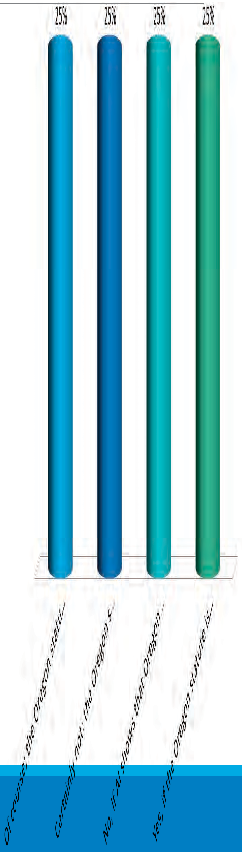Has Al been convicted of a “burglary” aggravated felony?
- Of course; the Oregon statute substantially corresponds to generic burglary
- Certainly not; the Oregon statute is clearly overbroad.
- No, if Al shows that Oregon actually prosecutes burglary of booths, vehicles, boats, or aircrafts.
- Yes, if the Oregon statute is divisible and Al was convicted of burglary of a home.

Realistic Probability Test
To show that a crime falls outside of the generic definition, there must be a realistic probability, not a theoretical possibility, that the statute criminalizes non-removable conduct. Gonzales v.
Duenas-Alvarez, 549 U.S. 183 (2007).

Realistic Probability Test
  - Concerned with how statute is actually applied as opposed to how it could be applied
  - not an invitation for “legal imagination”

Realistic Probability Test
“To show [a] realistic probability, an offender, of course, may show that the statute was so applied in his own case. But he must at least point to his own case or other cases in which the state courts in fact did apply the statute in the special (nongeneric) manner for which he argues.” Gonzales v. Duenas-Alvarez, 549 U.S. 183 (2007).

Generic burglary is the “unlawful or unprivileged entry into, or remaining in, a building or structure, with intent to commit a crime.”

Al is convicted of burglary under a Michigan statute not requiring the “intent to commit a crime” to exist at time of the entry.
  - Has Al been convicted of a “burglary” aggravated felony ?

- Yes; because it does not matter for generic burglary when the intent to commit a crime is formed.
- Certainly not; the Michigan statute is overbroad as to the timing of the intent.
- No, if Al can show that Michigan actually prosecutes burglary when intent to commit a crime forms after time of entry.

2. Has Al been convicted of a “burglary”
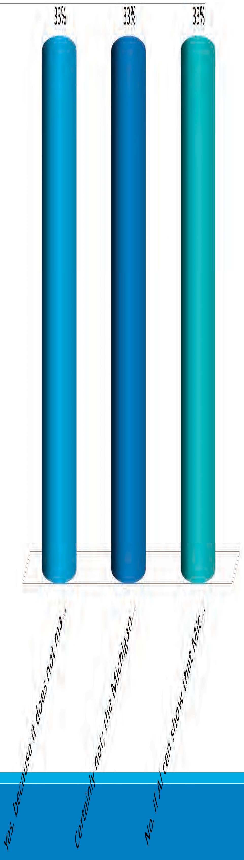 aggravated felony?
    - Yes, because it does not matter for generic burglary when the intent to commit a crime is formed
    - Certainly not; the Michigan statute is overbroad as to the timing of the intent.
    - No, if Al can show that Michigan actually prosecutes burglary when intent to commit a crime forms after time of entry

Generic burglary is the “unlawful or unprivileged entry into, or remaining in, a building or structure, with intent to commit a crime.”

Al was convicted of burglary in Maryland, which criminalizes the “burglary of a dwelling.” There is no statutory definition of “dwelling.”
  - Al been convicted of a “burglary” aggravated felony?

- Of course; the statutes substantially correspond.
- Yes, if Maryland caselaw limits “dwelling” to locations where people live.
- No, if Al can show that Maryland prosecutes burglary of non- buildings/structures, such as cars or boats.

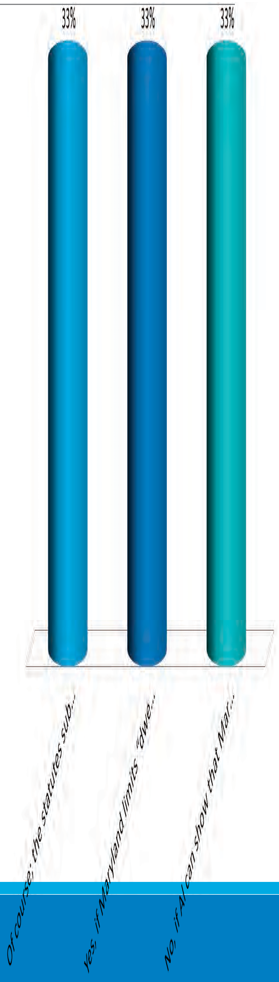Has Al been convicted of a “burglary” aggravated felony?
  - Of course; the statutes substantially correspond.
  - Yes, if Maryland limits “dwelling” to locations where people live.
  - No, if Al can show that Maryland prosecutes burglary of non buildings/structures, such as cars or boats.

Elements of generic stalking are (1) conduct engaged on multiple occasions (2) directed at a specific individual (3) with intent to place the individual in fear of bodily injury or death.

Elements of state stalking are (1) conduct engaged on multiple occasions (2) directed at a specific individual (3) with intent to place the individual in fear of his or her safety or cause emotional distress.
- there a categorical match between generic stalking and the state stalking statute?

- Absolutely, there is no real distinction between the two terms.
- No, intent to cause “emotional distress” is clearly broader than intent to place individual in fear of “bodily injury or death.”

4. Is there a categorical match between generic stalking and the state stalking statute?
  - Absolutely; there is no real distinction between the two terms
  - No, intent to cause “emotional distress” is clearly broader than intent to place an individual in fear of “bodily injury or death”

If overbreadth is clear?
If a statute expressly includes a factor outside of the generic definition, do you need to show a realistic probability?

Facial Overbreadth
Most courts say no > if a criminal statute is overbroad on its face, there is NO need to show a realistic probability that the state will apply its statute to conduct that falls outside the generic definition.

Circuit Adopting some form of Facial Overbreath

ADOPTS some form of Facial Overbreadth

- Swaby v. Yates, 847 F.3d 62 (1st Cir. 2017)
- Hylton v. Sessions, 897 F.3d 57 (2d Cir. 2018)
- Singh v. U.S. Att’y Gen., 839 F.3d 273 (3d Cir. 2016)
- U.S. v. Aparicio–Soria, 740 F.3d 152 (4th Cir. 2014) (en banc)
- Mendieta–Robles v. Gonzales, 226 F. App’x 564 (6th Cir. 2007) (unpublished)
- Chavez-Solis v. Lynch, 803 F.3d 1004 (9th Cir. 2015)
- U.S. v. Titties, 852 F.3d 1257 (10th Cir. 2017)
- Vassell v. U.S. Att’y Gen., 839 F.3d 1352 (11th Cir. 2016)

An offender is guilty under the federal statute for possession of child pornography if he or she “possesses” child pornography.
In contrast, the state possession statute requires one to “possess or control”
- Is there a categorical match on the possession element?

- No way; control is facially overbroad as to possession.
- No, if caselaw shows “possess or control” to be broader than merely “possess.”
- Yes, if there is no legal difference between “possess or control” and “possess.”

- 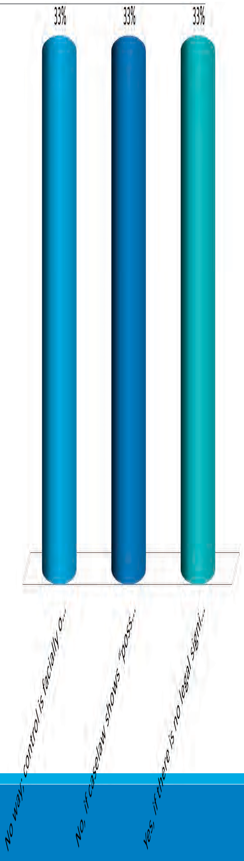Is there a categorical match on the possession element?
  - No way; control is facially overbroad as to possession
  - No, if caselaw shows “possess or control” to be broader than merely “possess”
  - Yes, if there is no legal difference between “possess or control” and “possess”

Facial Overbreadth

(b) (5)

Aggravated felony “theft” is (1) taking or exercise of control over property (2)
without consent (3)
with intent to deprive.
Robbery in Oregon requires threat or use of physical force. But, Oregon robbery also incorporates a statutory definition of theft that includes theft by deception, which the BIA deems consensual.

- Al is arguing that Oregon robbery is facially overbroad as to aggravated felony theft. Is Al correct?

- Yes, the statute is facially overbroad because the theft component of robbery can be satisfied by deception.
- No, because it is a legal impossibility to commit robbery by deception given that the statute also requires force.

6. Al is arguing that Oregon robbery is facially overbroad as to aggravated felony theft. Is Al correct?
  - Yes, the statute is facially overbroad because the theft component of robbery can be satisfied by deception.
  - No, because it is a legal impossibility to commit robbery by deception given that the statute also requires force.

Lopez-Aguilar
  - Majority: Categorical match because no realistic probability that Oregon applies robbery statute (ie, requiring force) to cases involving theft by deception

  - Dissent (J. Berzon): no need to show realistic probability because statute, on its face, could be applied to theft by deception because force could be used against someone other than property owner

State drug schedule includes 2 drugs that are not listed in the federal drug schedules
- Is the state drug schedule overbroad?

- Yes, it is facially overbroad

- Must have an actual case where someone was convicted based on the substance that falls outside of the federal drug schedule

- Depends on the circuit

- 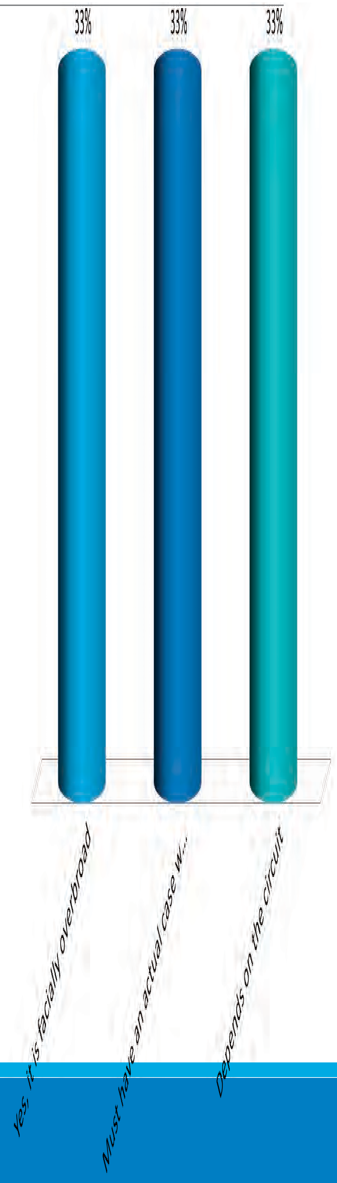Is the state drug schedule overbroad?
  - Yes, it is facially overbroad
  - Must have an actual case where someone was convicted based on the substance that falls outside of the federal drug schedule
  - Depends on the circuit

Fifth Circuit & BIA on Facial Overbreadth

REJECTS Facial Overbreadth
    - Vazquez v. Sessions, 885 F.3d 862 (5th Cir. 2018)
(b) (5)

BIA Rejects Facial Overbreadth
BIA says statutory language is not determinative
> alien must identify a case where the state court applies the statute of conviction in a manner that is outside the generic decision of the crime. Matter of Navarro Guadarrama/Ferreira / Sanchez-Lopez / Chairez.

(b) (5)

Drug Schedules

Federal definition of “firearm”: contains exception for “antique firearms”

Narnia definition of “firearm”: silent on antique firearms
- Is the Narnia firearm statute facially overbroad?

- Yes, because the federal definition has an exception for antique firearms and Narnia does not
- No, because face of statute still does not make clear that Narnia prosecutes antique firearms

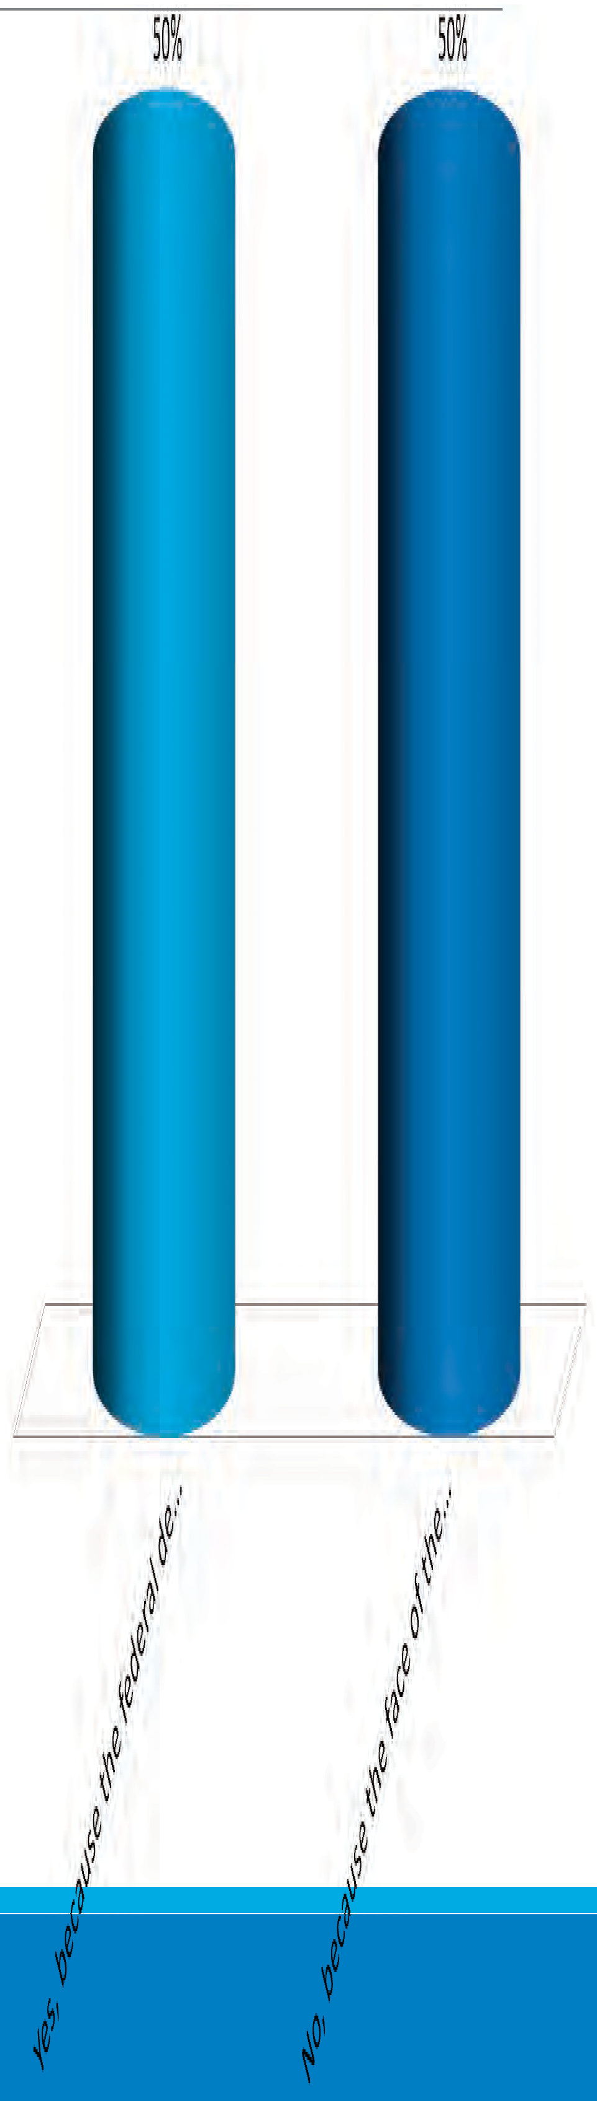8. Is the Narnia firearm statute facially overbroad?
  - Yes, because the federal definition has an exception for antique firearms and Narnia does not
  - No, because the face of the statute still does not make clear that Narnia prosecutes antique firearms.

Firearm Statutes & Moncrieffe Dicta
Moncrieffe: “The Government fears that a conviction under any state firearms law that lacks such an exception will be deemed to fail the categorical inquiry. But Duenas–Alvarez requires that there be “a realistic probability, not a theoretical possibility, that the State would apply its statute to conduct that falls outside the generic definition of a crime.” To defeat the categorical comparison in this manner, a noncitizen would have to demonstrate that the State actually prosecutes the relevant offense in cases involving antique firearms.”

Federal definition of “firearm”: contains exception for “antique firearms”

NY definition of “firearm”: contains exception for “unloaded antique firearms”
- Is the NY firearm statute facially overbroad?

- Yes, because NY statute appears to cover loaded antique firearms while federal statute excludes all antique firearms
- No, face of statute still does not make clear that NY covers loaded antique firearms

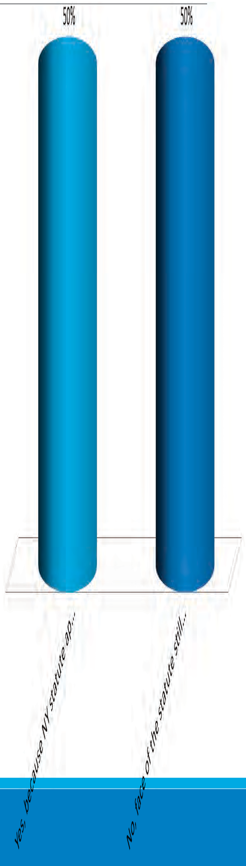Is the NY firearm statute facially overbroad?
  - Yes, because NY statute appears to cover loaded antique firearms while federal statute excludes all antique firearms
  - No, face of the statute still does not make clear that NY covers loaded antique firearms

Firearm Statutes
Federal “firearm” definition: contains exception for “antique firearms”

FL “firearm”: contains exception for ”antique firearms” UNLESS they are “used in commission of a crime”
    - FL appears to prosecute offenses where an antique firearm is used in commission of crime, unlike federal definition

Federal statute defines marijuana as “all parts of marijuana except for mature stalks”

State statute defines marijuana as “all parts of marijuana”
- Is the state statute facially overbroad?

- Yes, because “all parts” would include mature stalks.
- No, because it is not clear that state’s definition of “all parts” would include mature stalks.

10. Is the state statute facially
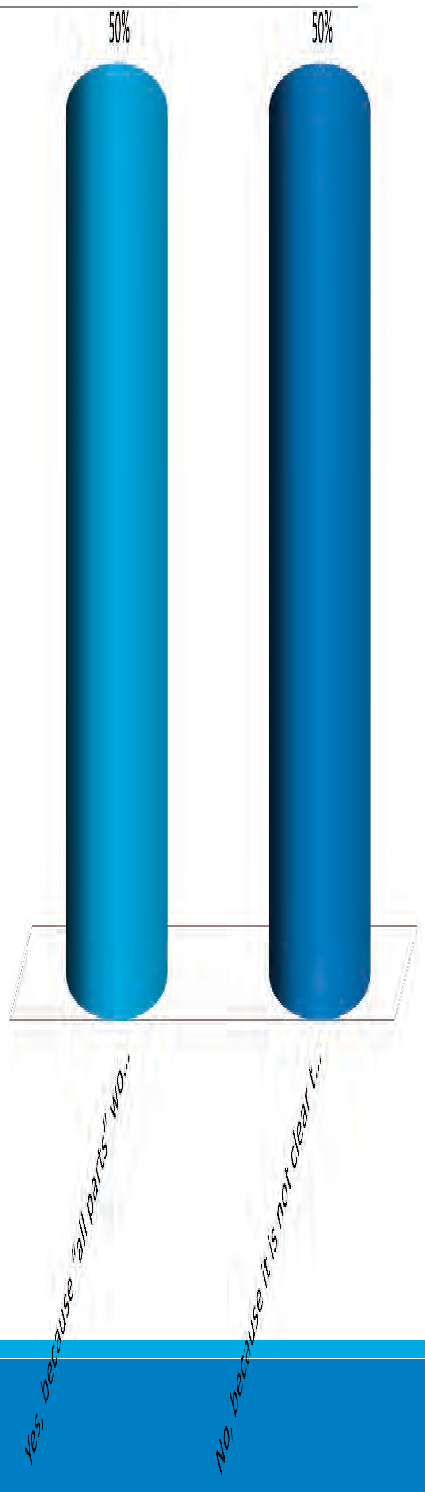overbroad?
  - Yes, because “all parts” would include mature stalks.
  - No, because it is not clear that state’s definition of “all parts” would include mature stalks.

BRIEFING TIPS
(b) (5)

BRIEFING TIPS
(b) (5)

Use of a charging document that narrows the charge to the generic offense

Lassend v. United States, 898 F.3d 115 (1st Cir. 2018) (affirming that “[b]oth the indictment and plea-colloquy transcript are Shepard-approved documents” and rejecting claim that the indictment must cite the exact subsection, rather than track the language of the subsection).

Kuhali v. Reno, 266 F.3d 93, 106-07 (2d Cir. 2001) (rejecting petitioner’s claim that the government “should have been required to submit a transcript of the plea colloquy” and finding that the indictment and judgment were sufficient to establish what petitioner pleaded guilty to under the modified categorical approach).

Evanson v. Attorney General of U.S., 550 F.3d 284, 292-93 (3d Cir. 2008) (“a court applying the modified categorical approach may only consider the charging document to the extent the petitioner was actually convicted of the charges”).

U.S. v. Gomez-Alvarez, 781 F.3d 787, 794-96 (5th Cir. 2015) (court may “rely on charging document ‘unambiguously identifying the one particular subdivision charged . .
. absent anything in the record affirmatively casting doubt on, or creating an ambiguity respecting, that conclusion”) (citation omitted).

Davis v. United States, 900 F.3d 733, 737 (6th Cir. 2018) (relying on charging documents as Shepard documents).

U.S. v. Vinton, 631 F.3d 476, 485-86 (8th Cir. 2011) (considering the information, which tracked the language of one subpart of a divisible statute, under the modified categorical approach even though defendant entered an Alford plea, because a generically limited charging document indicates the basis for a conviction whether or not it was accompanied by an admission of guilt).

United States v. Torre-Jimenez, 771 F.3d 1163, 1169 (9th Cir. 2014) (“as charged in” language required only when the documents “raise[] doubt about the crime”).

United States v. Leal, 680 F.3d 1160, 1168-69 (9th Cir. 2012) (“as charged in” language not required because there was no evidence suggesting that “any modifications were made to the felony complaint” and there was no “paltry record” as in Vidal).

Cabantac v. Holder, 736 F.3d 787, 794 (9th Cir. 2012) (the amended abstract indicated that the petitioner pleaded guilty to “count 1” of the complaint, which specified methamphetamine, such that the amended abstract and complaint “together establish that Cabantac pleaded guilty to possession of methamphetamine.”)

U.S. v. Ridens, 792 F.3d 1270, 1273 (10th Cir. 2015) (Because Ridens pleaded guilty to a charging document that “narrowed the charges to the generic limit . . . his conviction was a generic burglary conviction”).

Use of plea colloquy

U.S. v. Moreno, 821 F.3d 223, 229 (2d Cir. 2016) (absent an adoption by the defendant (or his counsel) of the prosecutor’s account of the factual basis of the plea, the prosecutor’s account may not be used to narrow the offense to a generic crime under the modified categorical approach).

Singh v. Attorney General, 839 F.3d 273, 285-86 (3d Cir. 2016) (relying on plea colloquy to identify drug type under modified categorical approach).

United States v. Taylor, 659 F.3d 339, 348 (4th Cir. 2011) (defense counsel can assent to factual basis of plea in plea colloquy).

U.S. v. Alston, 611 F.3d 219, 227 (4th Cir. 2010) (the proffer of the factual basis of an Alford plea alone cannot be used to narrow an offense under the modified categorical approach, unless the defendant admits to the factual basis).

U.S. v. Flores-Vasquez, 641 F.3d 667, 671-72 (5th Cir. 2011) (can consider the defendant’s admission of the facts in the plea colloquy even if the defendant enters an Alford plea).

United States v. McMurray, 653 F.3d 367, 378-81 (6th Cir. 2011) (cannot rely on plea colloquy where the defendant did not admit the state’s proffered factual basis of an Alford plea), abrogated on other grounds, 136 S. Ct. 2272 (2016).

U.S. v. Amerson, 599 F.3d 854, 855 (8th Cir. 2010) (defendant’s counsel stated “no objection” after the judge recited the facts, and the court found that he “assented to factual findings” that satisfy the generic offense).

Sahagun-Gallegos, 782 F.3d 1094 (9th Cir. 2015) (defendant, not his counsel, must assent to the factual basis of the plea).

Martinez-Lopez, 864 F.3d 1034, 1043 (9th Cir. 2017) (relying on the plea colloquy to narrow drug offense to generic crime where Martinez-Lopez was asked, “[O]n or about December 31st, 1997, [did] you . . . sell cocaine base—.42 grams of cocaine base?” and he responded, “Yes.”)

Use of criminal records that are incorporated into the guilty plea

United States v. Simms, 441 F.3d 313, 317-18 (4th Cir. 2006) (relying on application facts under the modified categorical approach because although it is not a Shepard document, it was explicitly incorporated into the charging document), abrogated on other grounds as recognized in United States v. Lopez-Collazo, 824 F.3d 453 (4th Cir. 2016).

United States v. Castillo-Morales, 507 F.3d 873, 876 (5th Cir. 2007) (“We hold that when a defendant stipulates that ‘a factual basis’ for his plea is present in ‘court

documents,’ courts may use any uncontradicted facts in those documents to establish an element of a prior conviction”).

U.S. v. Almazan-Becerra, 537 F.3d 1094, 1098 (9th Cir. 2008) (considering police report because defense counsel stipulated that the police report contained a factual basis for the guilty plea).

Parrilla v. Gonzales, 414 F.3d 1038, 1044 (9th Cir. 2005) (“Although police reports and complaint applications, standing alone, may not be used to enhance a sentence following a criminal conviction . . . the contents of these documents may be considered if specifically incorporated into the guilty plea or admitted by the defendant.”).

United States v. Gandy, 917 F.3d 1333, 1339 (11th Cir. 2019) (“arrest report that is incorporated by reference in a plea agreement qualifies as a ‘record of comparable findings of fact adopted by the defendant upon entering the plea’ that we may consider) (citing Shepard v. U.S., 544 U.S. 13 (2005)).

Working backwards

Kaufmann v. Holder, 759 F.3d 6, 8-9 (1st Cir. 2014) (finding that petitioner’s admission during the plea colloquy that the images portrayed child “having sex” was sufficient to narrow the offense to generic child pornography, which required “sexual intercourse”).

Akinsade v. Holder, 678 F.3d 138, 145-46 (2d Cir. 2012) (not relying on admission in plea colloquy—“‘he process[ed] fraudulent checks . . . and that he ‘knowingly embezzle[d] money from the bank’”—to infer that he had the intent to defraud, a necessary element to constitute an aggravated felony).

United States v. McCants, 920 F.3d 169, 180 (3d Cir. 2019) (“We agree with the Government that McCants's admissions that he threatened or attempted to threaten another with force is evidence of guilt under subsection (a)(2), which requires that a defendant “’[t]hreaten[ ] another with or purposely put[ ] him in fear of immediate bodily injury.’”)

U.S. v. Marrero, 743 F.3d 389, 397 (3d Cir. 2014) (plea colloquy established that petitioner was convicted of intentional assault because he “admitted to placing his hands around his wife’s neck and attempting to pull her up a flight of stairs”), abrograted on other grounds as recognizing by United States v. Calabretta, 831 F.3d 128 (3d Cir. 2016).

United States v. Reyes-Contreras, 910 F.3d 169, 175-79 (5th Cir. 2018) (stating that “[n]othing in Shepard or Taylor requires us to ignore the necessary implications from the formal documents in the file of a judgment of conviction” and considering the indictment and judgment to infer that petitioner was convicted of generic offense).

U.S. v. Herrera-Alvarez, 753 F.3d 132, 140 (5th Cir. 2014) (relying on information that alleged that defendant used a knife to “rule out” that he was convicted under the “poison prong” of the battery statute, and to narrow the offense to the generic crime), overruled on other grounds by U.S. v. Reyes-Contreras, 910 F.3d 169 (5th Cir. 2018).

U.S. v. Denson, 728 F.3d 603, 613 (6th Cir. 2013) (relying on plea colloquy in which the defendant agreed that he “knocked somebody out, choked somebody” to narrow conviction to a subsection of felonious assault that met generic definition).

Davis v. United States, 900 F.3d 733, 737-38 (6th Cir. 2018) (finding that the petitioner could “have been convicted only under the (a)(1) variant of the Tennessee aggravated assault statute” based on the facts alleged in the charging document).

United States v. Howard, 742 F.3d 1334, 1347 n.7 (11th Cir. 2014) (stating “[w]e do not understand Descamps to have limited the modified categorical approach so that courts cannot declare a prior conviction to be an ACCA predicate unless the Shepard documents quote the ‘magic words’ from the alternative element of the statute,” and reasoning that a guilty plea to entering a “house” is sufficient to show that the defendant was necessarily conviction of entering a “building,” the generic crime).

What’s happening in nexus?

Susan Green
Sr. Litigation Counsel OIL-Appellate
Oct. 2019

What we’ll cover:
- AG restores L-E-A-’s mixed motive holding

- Circuit split on whether to follow L-E-A- or go with the Fourth Circuit’s but-for cause reasoning

- SG’s cert. opposition dealing with whether “one central reason” applies in withholding

L-E-A- is back!
- L-E-A- I held:
  - Mixed-motive analysis requires two tests:
    - But-for cause test
    - More than minor, incidental, or tangential test
      - And more than minor, incidental includes an inquiry into what persecutor was trying to accomplish: “Fact that a persecutor targets a family member simply as a means to an end is not, by itself, sufficient to establish a claim.” 27 I&N Dec. at 45.

Q: How is L-E-A- faring in the circuits?
A: Mixed results.

Courts that have followed L-E-A-’s nexus reasoning

(b) (5)

(b) (5)

A little closer:

But it hesitates a bit:
(b) (5)

Barajas-Romero and the nexus standard in withholding

9th Circuit’s Barajas-Romero: “a reason” test for withholding, not “one central reason”
- In REAL ID Act, Congress put “one central reason” in asylum statute, but failed to put it in withholding.
- Board said silence was “not conclusive” and “one central reason” should be read into withholding, either at Chevron I or II.
  - Matter of C-T-L- , 25 I&N Dec 341 (2010).
- 9th Circuit said the REAL ID Act chose a different standard for withholding, “a reason,” and it is “less demanding” than “one central reason.”
  - Barajas-Romero, 846 F.3d at 361.
- “A reason” seems to be the same “in part” standard that Congress tried to overrule in the REAL ID Act.

Barajas spreading to other circuits?

(b) (5)

Fawzer cert. op. , 2019 WL 2006240 (5/6/19)

C-T-L- focused on the REAL ID Act—it was meant to correct the Ninth Circuit’s “any part” test in withholding as well as asylum, even though the language didn’t wind up in the withholding statute
25 I&N Dec at 346 (“Congress intended to apply the ‘one central reason’ standard uniformly to both asylum and withholding claims”)
(b) (5)

Ramifications of switching from “one central reason” as operative language to “because of”?

(b) (5)

Questions?
(I certainly have some!)

HYPO #1

Applicant’s father owned a store on a busy street that military vehicles often used, and the gang had previously attempted to extort, threaten, and recruit the father as a lookout. The father fled to the United States and Applicant was then in charge of the store. The gang then began to extort, threaten, and attempt to recruit Applicant. The IJ, issuing her decision before the A.G.’s issuance of Matter of L-E-A- II, declined to address whether the proposed PSG of “immediate family members of Applicant’s father” was a cognizable PSG. The IJ denied his claim, however, on nexus grounds, finding that the applicant failed to establish that his family membership was more than minor or incidental to the harm he experienced, citing Matter of L-E-A- I. She further noted that the gang’s “main motivation” was to further its criminal ends.

While the applicant’s appeal the Board was pending, the A.G. decided Matter of L-E-A- II.
(b) (5)

(b) (5)

HYPO #2

Facts:

- Applicants are a Grandmother and Grandson (Mother moved to the U.S. long ago, and Grandson has lived with Grandmother in El Salvador for the majority of his childhood). Grandmother and Grandson filed separate asylum applications, but their hearing was consolidated because they were based on the same events.
- When Grandson turned 13, gang members started coming to his house, asking him to join. Initially, Grandson agreed, for fear that the gang would harm him if he refused, but then stopped going to gang meetings. The gang continued to visit Grandson and asked him to do gang tasks for them, and they also threatened to hurt him and his Grandmother if he refused. A gang member saw Grandmother at the market on one occasion, and told her that she would be harmed if Grandson did not come back to the gang.
- Grandson proposed two particular social groups: (1) former gang members, and
- young men in El Salvador that gangs wish to recruit. Grandmother also proposed two social groups: (1) immediate family members of Grandson, and (2) family members of young men in El Salvador who gangs try to recruit.
(b) (5)
(b) (5)

  - Ordinarily, the power of the political branches
(President and Congress) to make determinations regarding admission and removal
  - Presumes limited role for the Article III branch (Courts)
  - Also limited role for states
    - But why is immigration a “federal” concern?

  - The power to make citizens
    - Article I, section 8
    - 14th Amendment; Wong Kim Ark (1903)

  - The power to exclude
    - Chinese exclusion case (1889)
    - Ekiu principal (1892)

  - The power to deport
    - Fong Yue Ting (1893)

  - The meaning of “plenary power”

  - The concept of “due process”
    - “Substantive” (Fong Yue Ting vs. Wong Wing)
    - Procedural (Knauff and Yamataya)

  - The concept of “equal protection”
    - “Facially legitimate and bona fide”

  - How has concept evolved?
  - Where were we 25 years ago?
  - Where are we now?
  - Does the concept of “plenary power” exist in 2019?
  - What happened to the idea of a “limited” role for the courts?
  - Making sense of the last 25 years!

  - Immigration law involves the “ultimate
political question – i.e., who is to be a member of our club”
  - The role of separation of powers and “the strange doctrine of consular non- reviewability”
  - Extraordinary deference owed to the Attorney General, etc. (and “no duty to articulate”)

  - Fiallo v. Bell (1977)

  - Harisiades v. Shaughnessy (1952)

  - INS v. Abudu (1988)

  - INS v. Elias-Zacarias (1992)

  - INS v. Pangilinan (1988)

  - Kleindienst v. Mandel (1972)

  - Landon v. Plasencia (1982)

  - Shaughnessy v. Mezei (1953)

  - Immigration and Nationality Act of 1952, as amended in 1961, 1980, 1986, 1988, 1990, and 1994

  - Anti-Terrorism and Effective Death Penalty
Act of 1996

  - Illegal Immigration Reform and Immigrant Responsibility Act of 1996

  - Zadvydas v. Davis (2001)
  - INS v. St. Cyr (2001)
  - INS v. Ventura (2002)
  - Homeland Security Act of 2002
  - REAL ID Act of 2005
  - Nken v. Holder (2009)
  - Padilla v. Kentucky (2010)

  - The docket explosion of 2001-2006
  - The “categorical approach“
(b) (5)

  - Many more cases now

  - Immigration is “mainstream”

  - Criminal law and immigration law concepts are merging

  - Basic or seemingly settled concepts are questioned routinely

  - Next 25 years will be even more eventful and

(b) (5)
momentous than the past 25

  - Probably not, so let’s do the immigration
quotes instead of speculating

Hot Topics in Criminal Immigration Litigation
- Sufficiency of Shepard Documents
- Inchoate Crimes—CIMT Focus
- Obstruction of Justice Crimes

Presented by: Rebekah Nahas, Craig Newell, and Rebecca Hoffberg Phillips
Moderated by: Erica Miles

Sufficiency of
Shepard Documents
REBEKAH NAHAS, TRIAL ATTORNE Y, CRIMINAL IMMIGRATION TEAM, OIL-APPELLATE

Roadmap
- Basic principles of the modified categorical approach.
- Categories of Shepard
documents and issue spotting.

Modified Categorical Approach
(b) (5)

Modified Categorical Approach
(b) (5)

Shepard
  - Terms of the charging document;
  - Terms of plea agreement;
  - Transcript of colloquy where factual basis of plea confirmed by the defendant; or
  - Some comparable judicial record of this information.

Where to start?

(b) (5)

Hypothetical
Petitioner is charged with removability for a drug trafficking crime aggravated felony based on his conviction for possession for sale of a controlled substance in violation of Cal. Health & Safety Code 11378 (Count 2). California drug schedules are overbroad because California prohibits more drugs than the federal Controlled Substance Act. Section 11378 is divisible by drug type, so we can use the modified categorical approach.

Beyond the Judgment
  - Charging Document Plus Judgment
  - Plea Colloquy
  - Police reports or other

Charging Document Plus

(b) (5)

Charging Document Plus
(b) (5)

(b) (5)

Charging Document Plus

Takeaway
(b) (5)

Takeaway

(b) (5)

Takeaway

(b) (5)

(b) (5)

Takeaway

Plea Colloquy
  - At plea hearing, judge will ask for factual basis of plea.
  - Plea colloquy may narrow an overbroad and divisible statute to a generic offense.

Hypothetical
P convicted of Arizona aggravated assault under ARS 13- 1203(A)(1) and 13-1204. Arizona assault under 13- 1203(A)(1) has three mens reas (intentional, knowing or reckless), with reckless falling outside of the generic definition of crime of violence. Assume the statute is divisible by mens rea, and that we can proceed to the modified categorical approach to determine whether the defendant pleaded guilty to intentional or knowing, rather than reckless.

Takeaway

(b) (5)

Takeaway

(b) (5)

Hypothetical
Look at Packet D. Assume the generic CIMT definition is “sexual contact committed by force.” Michigan fourth degree sexual contact is overbroad as compared to this generic definition because it encompasses sexual contact through force or coercion which can include implied force. Assume the Michigan statute is divisible by force and coercion. The plea colloquy indicates that the police report was incorporated as the factual basis of the plea. The police report indicates that the defendant “grabbed hard on the breast” of the victim.

Takeaway
(b) (5)

Takeaway

(b) (5)

INCHOATE CRIMES
Specific Focus on Crimes Involving Moral Turpitude

CRAIG NEWELL
TRIAL ATTORNEY, CRIMINAL IMMIGRATION TEAM OIL – APPELLATE SECTION

What are Inchoate Crimes?
- Also known as “preparatory crimes”

- Involve taking a step toward the commission of another crime

- Perpetrator intends the other crime to be completed, but in reality it was not.

Types of Inchoate Crimes

- Attempt
- Conspiracy
- Solicitation
- Others: Facilitation, Accessory Before the Fact

Attempt

- Intent to commit a crime
- Overt act constituting a substantial step toward the commission of the crime.

Conspiracy

- Agreement to commit an unlawful act
- Board does not require an overt act
- Circuit split as to overt-act requirement
- 9th Circuit vs. 4th, 5th, 10th Circuits

Solicitation
- An attempt to conspire
- Occurs when one person encourages or requests another person to commit a crime
- No meeting of the minds required

Crimes Involving Moral Turpitude

The “look through” approach

Matter of Vo

25 I. & N. Dec. 426 (BIA 2011)

- Pivotal attempt-as-a-CIMT case
- Applies to inchoate offenses more broadly
- Board looks only at the substantive offense

The Board’s Reasoning
- No distinction between the commission of the crime and the attempt to commit it
- Attempt is a specific intent crime
- Moral turpitude inheres in the intent
- Applies to all inchoate offenses

The Ninth Circuit

Agrees or Disagrees?

Agrees!

  - Rohit v. Holder, 607 F.3d 1085 (9th Cir. 2012)
  - Barragan v. Mukasey, 508 F.3d 899 (9th Cir. 2007)

Matter of Gonzalez Romo

26 I. & N. Dec. 743 (BIA 2016)

  - 8 U.S.C. § 1182(a)(2)(A)(i)(I) encompasses solicitation even though that section expressly refers to only attempt and conspiracy
  - Again relies on the “look through” approach

The Ninth Circuit

Agrees or Disagrees?

Gonzalez Romo v. Barr (9th Cir.)

    - The Ninth Circuit deferred to the Board’s interpretation in Matter of Gonzalez Romo
    - Citation: --- F.3d ---, No. 16-71559, 2019 WL 3808515 (9th Cir. Aug. 14, 2019)

Ninth Circuit’s Reasoning
- CIMT is a “separate concept with a long history”
- Unsure why Congress included attempt and conspiracy but not solicitation
- Tolerate redundancy to avoid dubious result

Problems?

(b) (5)

What if the underlying substantive

offense is not a CIMT?

  - Does the “look through” analysis work in reverse?
  - What is the methodology?

CIMT or Not?
- Substantive offense requires only general intent
- Substantive offense covers arguably reprehensible conduct
- Inchoate offense requires specific intent
- Combine elements to make a CIMT?

Matter of Jimenez-Cedillo

27 I. & N. Dec. 1 (BIA 2017)
  - Maryland offense for sexual solicitation of a minor is a categorical CIMT
  - Substantive offense did not require culpable mental state with respect to victim’s age
  - Relied on specific intent mens rea from solicitation

Other Consequences of Inchoate Crimes
- Aggravated Felonies
8 U.S.C. § 1101(a)(43)(U) – Attempt or Conspiracy 8 U.S.C. § 1101(a)(43)(B) – Drug Trafficking
8 U.S.C. § 1101(a)(43)(F) – Crime of Violence
- Controlled Substance Violations

Rebecca Hoffberg Phillips
Trial Attorney, OIL-Appellate

OBSTRUCTION OF JUSTICE CRIMES

Overview

- What is obstruction of justice?
- When is obstruction of justice an agfel?
- When is it a CIMT?
- Identifying circuit splits & remands
- Hypotheticals

Obstruction of Justice Defined Generally

- Knowingly or willfully interfere w/ pursuit of justice
- Directed at prosecutors, investigators, gov officials
- Interference could be in the form of
🞑threat to witnesses, jurors, or other legal officials
🞑physical harm, hindering apprehension of a suspect
🞑destroying evidence, w/holding info or giving false testimony during an investigation or legal process

Immigration Consequences for an Obstruction of Justice type of offense?
  - Two main/common possibilities:

🞑 (1) An “offense relating to obstruction of justice” for which the term of imprisonment is at least one year is an aggravated felony

🞑 (2) A “crime involving moral turpitude”

Obstruction of Justice As An Agfel

- “An offense relating to obstruction of justice, perjury or subornation of perjury, or bribery of a witness, for which the term of imprisonment is at least one year.” (emphasis added)

- 8 U.S.C. § 1101(a)(43)(S)

Accessory After The Fact -18 U.S.C. § 3

  - Mens Rea = knowledge/specific intent
“Whoever, knowing that an offense against the United States has been committed, receives, relieves, comforts or assists the offender in order to hinder or prevent his apprehension, trial or punishment, is an accessory after the fact.”
18 U.S.C.
§ 3.

  - Actus Reus = LOTS of things!

  - Matter of Batista-Hernandez, 21 I. & N. Dec. 955 (BIA 1997): AATF is an agfel

Misprision of a Felony under 18 U.S.C. § 4

  - Two basic elements:
Whoever, having knowledge of the actual commission of a felony cognizable by a court of the United States, conceals and does not as soon as possible make known the same to some judge or other person in civil or military authority under the United States, shall be fined under this title or imprisoned not more than three years, or both. 18
U.S.C. § 4.
🞑 Knowledge of a crime (felony)
🞑 Affirmative act of concealment or participation
  - Branzburg v. Hayes, 408 U.S. 665, 696 n.36 (1972)
  - Matter of Espinoza-Gonzalez, 22 I. & N. Dec. 889 (BIA 1999): Misprision is NOT an agfel

🞑Matter of Baptista: little analysis

🞑Matter of Espinoza: analysis geared toward explaining why misprision is not an agfel

- Matter of Valenzuela Gallardo, 25 I. & N. Dec. 838 (BIA 2012) (“Valenzuela Gallardo I”)
🞑 “process of justice” not require ongoing investigation or proceeding;

🞑 Critical element: “an affirmative and intentional attempt, motivated by a specific intent, to interfere with the process of justice.”

🞑 BUT what is the “process of justice”? where does it begin & end?

Ninth Circuit Rejects BIA’s Construction

  - Valenzuela Gallardo v. Lynch, 818 F.3d 808 (9th Cir. 2016)
🞑 Serious concerns BIA’s construction unconstitutionally vague

🞑 invoked constitutional avoidance principles

🞑 Remanded for further consideration instead of Chevron

  - Matter of Valenzuela Gallardo, 27 I. & N. Dec. 449 (BIA 2018) (“Matter of Valenzuela Gallardo II”)
  - Definition: crimes involving
- An affirmative and intentional attempt
- motivated by a specific intent
- to interfere with “an investigation or proceeding that is ongoing, pending, or reasonably foreseeable by the defendant, or in another’s punishment resulting from a completed proceeding”

  - Difference? Thorough reasoning and modified #3

- Ch 73 still the starting point
- Sup Ct construed broad provisions to apply to “reasonably foreseeable” proceedings or investigations
- Ch 73 not cross-referenced
- AATF has been regarded as a form of obstruction of justice under federal court decisions, MPC, USSG

Definitely IN
Definitely OUT

- Any offense listed under chapter 73 of the federal criminal code (18 U.S.C. §§ 1501-1521)
- State counterparts to chapter 73
- Accessory after the fact type of offenses
- Any other offense carrying specific intent to interfere with a “reasonably foreseeable” investigation, arrest, trial, or punishment
- Misprision of a felony

- Valenzuela Gallardo v. Barr, 9th Cir. Case No. 18-72593

- Again argued Brand X/Chevron

- TBD

  - 3d Circuit: agfel provision unambiguous, no deference
🞑 Flores v. US Att’y Gen., 856 F.3d 280 (3d Cir. 2017) (requires “a logical or causal connection between an alien’s offense and a relevant Chap 73 offense”); Denis v. US Att’y Gen., 633 F.3d 201 (3d Cir. 2011) (must “relate to” ch 73 offense)

  - 2d & 8th Circuits: ?
🞑 Declined to reach deference in pre-VG decisions; conviction at issue qualified under “narrower” BIA defn and 3d Cir precedent. Higgins v. Holder, 677 F.3d 97 (2d Cir. 2012); Armenta-Lagunas v. Holder, 724 F.3d 1019 (8th Cir. 2013)

  - 7th Cir: no deference to Matter of Valenzuela Gallardo I following 9th Cir review. Victoria-Faustino v. Sessions, 865 F.3d 869 (7th Cir. 2017) (applying Espinoza defn)

  - 5th Cir: ? Cruz v. Sessions, 689 F. App'x 328 (5th Cir. 2017) (remanded after VG I vacated without passing judgment on BIA’s construction or 9th cir decision)

  - Still waiting on 1st, 4th, 6th, 10th, 11th

  - CIMT generic definition, generally
🞑reprehensible conduct & culpable mental state.”
🞑Matter of Silva-Trevino, 26 I. & N. Dec. 826 (BIA 2016)

  - BIA and courts have also created generic definitions for classes of crimes as CIMTs

Murder
CIMTs

Burglary
Sex Offenses

Obstruction of justice
Assault Battery

Reckless Endangerment

Kidnapping
Domestic Violence

Destruction of Property

DUIs
Drug Trafficking

Theft Offenses
Fraud Offenses

Non-Fraudulent CIMTs
Intent to defraud or inherently fraudulent
Intent to harm,
actual harm, or protected class (Not always?)

Fraudulent CIMTs
CIMTs

  - crime involving impairing or obstructing a function of the Gov by deceit, graft, trickery, or dishonest means is CIMT

  - Matter of Pinzon, 26 I. & N. Dec. 189 (BIA 2013); Matter of Jurado-Delgado, 24 I. & N. Dec. 29 (BIA 2006); Matter of Flores, 17 I. & N. Dec. 225 (BIA 1980)

  - “impair or obstruct the government by deceit” standard was espoused in Flores as a proxy for fraud

Concealment Of A Crime (Misprision of a Felony) is a CIMT (because it involves intentional deceit)

    - Affirmative act of concealing a known felony is deceitful & thus a CIMT, regardless of whether underlying felony is a CIMT

    - Matter of Mendez, 27 I. & N. Dec. 219 (BIA 2018) (relying on Villegas-Sarabia v. Duke, 874 F.3d 871 (5th Cir. 2017); Itani v. Ashcroft, 298 F.3d 1213 (11th Cir. 2002))

    - But see Robles-Urrea v. Holder, 678 F.3d 702, 710 (9th Cir. 2012) (misprision not CIMT bc no specific intent to conceal or obstruct justice)

Emerging Issue 1: using a fraud rationale to classify an obstruction offense as a CIMT
  - BIA uses fraud cases to find “obstruction” is a CIMT

  - Obstruction need not occur via fraud, although it can

  - Ramirez v. Sessions, 887 F.3d 693 (4th Cir. 2018); Ildefonso-Candelario v. Att’y Gen. of the U.S., 866 F.3d 102 (3d Cir. 2017)
  - BIA needs generic defn for CIMTs based on obstruction of government functions

Emerging Issue 2: false statements to officials
- When is false statement to the gov a CIMT?
🞑Not enough to just provide false info
🞑Not enough to intentionally make an official’s task more difficult
🞑Must reach certain level of depravity
  - Specific intent element, such that stmt given for particular purpose?
  - Did stmt result in an actual benefit to the person who made it or impair important gov function?

False Statements under 18 U.S.C. § 1001(a)(2)

    - Statute at issue in Matter of Pinzon
Whoever “in any matter within the jurisdiction of the executive, legislative, or judicial branch of the Government of the United States, knowingly and willfully -- . . . (2) makes any materially false, fictitious, or fraudulent statement or representation . . .
. . . shall be fined under this title or imprisoned not more than 5 years, or both.” 18 U.S.C.
§ 1001(a)(2)).
    - In finding CIMT, BIA relied on federal interpretation of the statute as
🞑 (1) requiring “proof of a specific intent to deceive” and
🞑 (2) for a false statement to be “material” under that provision it must “have the capacity to impair or pervert the functioning of a government agency.”
    - Distinguishable from other false statement statutes

Hypotheticals

- Pet in Philly imm ct convicted 18 Pa.C.S. § 5105(a)(2) & (5)
- Under 5105(a), A person commits an offense if, with intent to hinder the apprehension, prosecution, conviction or punishment of another . . ., he [or she]:
🞑 (1) harbors or conceals the other; (2) provides . . . a means of avoiding apprehension or effecting escape;
  - conceals or destroys [or tampers with] evidence [], . . .;
  - warns the other of impending discovery or apprehension . . . ; or (5) volunteers false info to a law enforcement officer.

Which of the following statements are true?

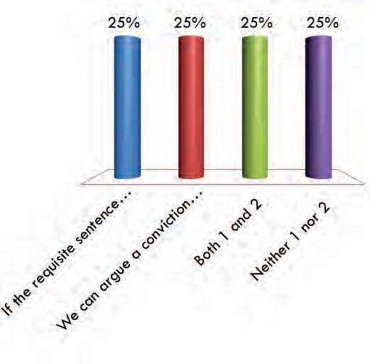
- If the requisite sentence was imposed, we can argue a conviction under 5101(a)(2) is an agfel because it is an accessory after the fact type of offense.
- We can argue a conviction under 5101(a)(5) is a CIMT because the state court has held paragraph
  - is “intended to reach those who take the initiative in throwing the police off track.”
- Both 1 and 2
- Neither 1 nor 2

  - Petitioner convicted of A.R.S. § 13-2402(A)(1)
  - 13-2402 (“Obstructing governmental operations; classification”)
  - (A) A person commits obstructing governmental operations if, by using or threatening to use violence or physical force, such person knowingly obstructs, impairs or hinders: (1) The performance of a governmental function by a public servant acting under color of his official authority.

In which circuits could we argue Petitioner was convicted of a CIMT?

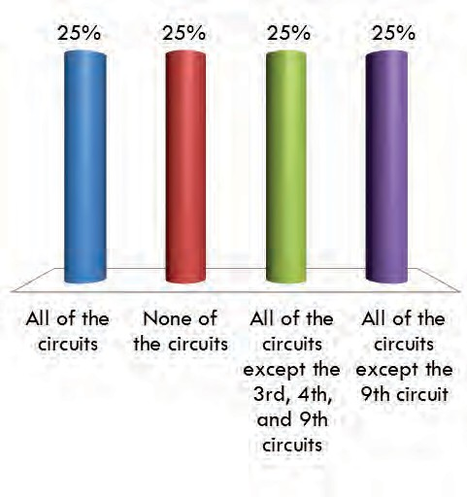
- All of the circuits
- None of the circuits
- All of the circuits except the 3rd, 4th, and 9th circuits
- All of the circuits except the 9th circuit

ENDNOTE 1: Decisions Upholding CIMT determinations based on false statements

- Adame-Hernandez v. Barr, 929 F.3d 1020 (8th Cir. 2019) (Nebraska’s false-reporting statute required the intent to impede an actual criminal investigation. This alleviates any concern that Adame-Hernandez’s conviction could have been for a crime that did not involve moral turpitude)
- Afamasaga v. Sessions, 884 F.3d 1286, 1290 (10th Cir. 2018) (agreeing with BIA and second circuit that fraud is an “essential element[ ]” of § 1542 because “the applicant must knowingly make a false statement with the specific intent that the false statement should be acted upon by the Government” and thereby “induce or secure the issuance of a passport”)
- Castillo–Torres v. Holder, 394 F. App’x 517, 521 (10th Cir. 2010) (unpublished) (giving false name with intent to mislead peace officer lawfully discharging duties);
- Daibo v. Att’y Gen., 265 F. App’x 56, 60-62 (3d Cir. 2008) (unpublished) (knowingly false statements on ATF forms “obstructed an important government function ... [and] constituted a crime of moral turpitude.”);
- Rodriguez v. Gonzales, 451 F.3d 60, 63-64 (2d Cir. 2006) (knowingly false statement on passport is CIMT because it involves “deceit and an intent to impair the efficiency and lawful functioning of the government”);
- Padilla v. Gonzales, 397 F.3d 1016, 1020 (7th Cir. 2005) (knowingly providing false information to police officer to prevent apprehension or obstruct prosecution);
- Omagah v. Ashcroft, 288 F.3d 254, 262 (5th Cir. 2002), and cases cited (“almost all other courts have held that intentionally deceiving the government involves moral turpitude”).

ENDNOTE 2: Instances Where False Statement Not CIMT

- Flores-Molina v. Sessions, 850 F.3d 1150, 1171 (10th Cir. 2017) (Denver Municipal Code conviction for giving false information to a city official during an investigation is not a CIMT because the minimum conduct proscribed by the ordinance does not require that the false information be material, or be given with the intent to mislead, or otherwise cause any harm to obtain a benefit).
- Rivera v. Lynch, 816 F.3d 1064, 1075-76 (9th Cir. 2015) (perjury statute was not a CIMT because “intent to defraud is not required for conviction under [the statute]; it requires only that the false statements have been made ‘deliberately and with knowledge’”);
- Bobadilla v. Holder, 679 F.3d 1052, 1058 (8th Cir. 2012) (crime of misrepresenting identity to police “with intent to obstruct justice” was not a CIMT because it did “not require proof that the ‘intent to obstruct justice’ was successful, or that it misled the police officer even for a moment”);
- Blanco v. Mukasey, 518 F.3d 714, 718-19 (9th Cir. 2008) (crime of falsely representing identity to police “to evade the process of the court, or to evade ... proper identification ... by the [police]” was not a CIMT because it “require[d] only the knowing provision of false information,” rather than explicit or implicit intent to defraud, benefit, or harm);

Table of Contents
Chapter I: Overview of Immigration Law

Section 10 Introduction to Immigration Law Section 11 Immigration Law Sources Section 12 Federal Power Over Immigration

Chapter II: Admission and Removal

Section 20 Immigration Selection System Section 21 Nonimmigrant Visas
Section 22 Visa Waiver Program Section 23 Admission
Section 24 Grounds of Removal Section 25 Grounds of Inadmissibility
Section 26 Issues in Criminal Alien Cases
Section 27 DHS Removal Orders and Reasonable Fear Litigation Section 28 National Security Grounds of Removal

Chapter III: Relief/Protection from Removal

Section 30 Asylum and Withholding of Removal Section 31 The Convention Against Torture Section 32 Adjustment of Status
Section 33 Cancellation of Removal for Certain Lawful Permanent Residents Section 34 Cancellation of Removal for Certain Nonpermanent Residents Section 35 Status of 212(c) Waivers of Inadmissibility
Section 36 Other Waivers of Inadmissibility Section 37 Nationality and Naturalization Section 38 Credibility Determinations Section 39 Corroboration Law and Issues

Chapter IV: Litigation Topics and Ethics

Section 40 Removal Proceedings Under INA § 240, 8 U.S.C. § 1229a
Section 41 Administrative Appeals, Motions to Reopen/Reconsider, Voluntary Departure Section 42 Constitutional Claims and Due Process
Section 43 Ineffective Assistance of Counsel in Immigration Proceedings Section 44 Judicial Review of Removal Orders
Section 45 Writing Rehearing Petitions and Motions to Amend or Reconsider Section 46 EAJA Litigation
Section 47 Litigating Habeas Corpus Cases
Section 48 Professional Responsibility and Ethics in Immigration Litigation Section 49 U Visas and Petitions for Review
Section 50 Res Judicata/Collateral Estoppel/Law of the Case

SECTION 10 INTRODUCTION TO IMMIGRATION LAW
Lance L. Jolley, Trial Attorney

  - OVERVIEW 2
  - SOURCES OF AUTHORITY 2
  - OVERVIEW OF THE FEDERAL AGENCIES 2
  - U.S. IMMIGRATION AND CUSTOMS ENFORCEMENT (ICE) 3
  - U.S. CUSTOMS AND BORDER PROTECTION (CBP) 4
  - U.S. CITIZENSHIP AND IMMIGRATION SERVICES (USCIS) 4
  - EXECUTIVE OFFICE FOR IMMIGRATION REVIEW (EOIR) 4
  - OFFICE OF IMMIGRATION LITIGATION 5
  - DOJ CRIMINAL DIVISION 5
  - RELATED AGENCIES 5
  - OVERVIEW OF THE IMMIGRATION SELECTION SYSTEM 6
  - OVERVIEW OF THE ADMISSION PROCEDURES 8
    - Immigrant Visa Petitions 9
    - Nonimmigrant Visa Petitions 10
  - IMMIGRATION PROCEEDINGS 11
    - Removal Proceedings 11
    - Expedited Removal 11
    - Administrative Removal 12
    - Reinstatement of Removal 12
    - Judicial Removal 13
    - Institutional Hearing Programs 13
  - IMMIGRATION RELIEF 13
    - Waivers of Inadmissibility and Deportability 13
    - Cancellation of removal 13
C.
Voluntary departure 14
Revised July 22, 2019 by Shannon Armstrong, Summer Law Clerk
1

- Asylum, Withholding of Removal, and Protection under the Convention
Against Torture 14
- Adjustment of status 15
- Registry 15
  - GLOSSARY OF TERMS 15
  - LIST OF IMMIGRATION FORMS 20
  - ABBREVIATIONS AND ACRONYMS 21

  - Overview

As the Supreme Court has noted, “[i]mmigration law can be complex.” Padilla v. Kentucky, 559 U.S. 356, 369 (2010). This is particularly true for an individual with little experience in immigration law. This chapter will provide a brief overview of our immigration laws and acquaint you with the agencies that administer and enforce these laws. This chapter also includes a short glossary of frequently used immigration terms, key concepts, and abbreviations, as well as a list of the most familiar immigration forms.

  - Sources of Authority

The primary sources of authority for the United States’ immigration laws are the Immigration and Nationality Act of 1952 (INA), the implementing regulations published by the various agencies charged with the administration of the statute, and the published decisions of the Board of Immigration Appeals (BIA). See Section 11 (Immigration Law Sources). The INA has been amended numerous times since 1952. The most significant legislative changes have been the 1980 Refugee Act, the 1986 Immigration Reform and Control Act (IRCA), the 1990 Immigration Act, the Illegal Immigration Reform and Immigrant Responsibility Act of 1996 (IIRIRA), the Homeland Security Act of 2002 (HSA), and the REAL ID Act of 2005.

  - Overview of the Federal Agencies

The administration and enforcement of our immigration laws resides within various departments throughout the federal government. The INA of 1952 delegated broad authority to the Department of Justice (DOJ) to administer immigration laws. Later, the Homeland Security Act of 2002 shifted the immigration enforcement, service, and benefits functions, which had been delegated to the Immigration and Naturalization Service (INS), to the newly created Department of Homeland Security (DHS). The Department of Justice retained adjudicatory authority over the administration and enforcement of our immigration laws. The Homeland Security Act also transferred control over the issuance and denial of visas to the Department of Homeland Security, although it allowed delegation of authority to the State Department.
Regarding employment visas, the Department of Labor plays in ensuring that foreign workers are not displacing equally qualified U.S. workers.
2

Introduction to Immigration Law

The following considers in greater details the roles and jurisdictions of the various agencies involved in administering and enforcing immigration laws.

  - U.S. Immigration and Customs Enforcement (ICE)

Within the Department of Homeland Security, ICE is the agency that you will most likely be working with as you prosecute immigration violators. ICE, headed by an Assistant Secretary, is responsible for apprehending, detaining, and deporting those aliens or non-U.S. citizens who have managed to enter, or remain in, the country illegally. Toward that end, ICE prosecutes administrative removal cases in the immigration courts as well as employer sanctions and document fraud violations before administrative law judges. Additionally, ICE Special Agents in Charge also work closely with the U.S. Attorneys’ Offices in the investigation and prosecution of immigration-related crimes, such as criminal reentry after deportation and alien smuggling.

Unlike the former INS, ICE’s jurisdiction extends not only over immigration enforcement in the interior of the United States, but over customs laws within the country, the protection of specified federal buildings, and air and marine enforcement. Among the operational divisions involved in immigration enforcement are the following: Homeland Security Investigations (HSI); Enforcement and Removal Operations (ERO); and Office of the Principal Legal Advisor (OPLA).

The ICE Homeland Security Investigations (HSI) is responsible for investigating a wide range of domestic and international activities arising from the illegal movement of people and goods into, within, and out of the United States. HSI investigates immigration crime, human rights violations, human smuggling, smuggling of narcotics, weapons, and other types of contraband, financial crimes, cybercrime, and export enforcement issues. ICE special agents conduct investigations aimed at protecting critical infrastructure industries that are vulnerable to sabotage, attack, or exploitation. In addition to ICE criminal investigations, HSI oversees the agency’s international affairs operations and intelligence functions. HSI consists of more than 8,500 employees, consisting of more than 6,000 special agents, who are assigned to more than 200 cities throughout the U.S. and 51 countries around the world. The field offices are headed by a Special Agent-in-Charge (SAC), who is responsible for the administration and management of all enforcement activities within the geographic boundaries of their offices.

The Office of Enforcement and Removal Operations (ERO) enforces the nation’s immigration laws by identifying and apprehending removable aliens, detaining these individuals when necessary, and removing them from the United States. While this office prioritizes the apprehension, arrest and removal of certain aliens, including convicts and those with outstanding removal orders, it will no longer exempt “classes or categories of removable aliens from potential enforcement.” Memorandum from John Kelly, DHS Secretary, Enforcement of the Immigration Laws to Serve the National Interest (Feb. 20, 2017). In its charge over detained aliens, ERO provides access to legal resources and representatives of advocacy groups.

The Office of the Principal Legal Advisor (OPLA) provides legal advice to ICE on all matters affecting ICE operations, including its exclusive representation of DHS in immigration removal proceedings. The office is headquartered at ICE Headquarters in Washington, D.C., has
3

Revised July 22, 2019

25 Offices of Chief Counsel across the country, and has over 1,100 attorneys. OPLA attorneys assist Department of Justice attorneys in defending immigration actions in federal court.

  - U.S. Customs and Border Protection (CBP)

The CBP, headed by a Commissioner, is the other agency within DHS that exercises immigration enforcement authority. The CBP immigration authority lies principally in enforcing the immigration laws at sea ports and land ports-of-entry. CBP Officers guard our nation’s borders, not only to enforce immigration laws, but also to enforce trade and customs laws as well as drug laws. The U.S. Border Patrol is the mobile, uniformed law enforcement arm of DHS whose primary aim is to detect and prevent the illegal entry of individuals into the United States, particularly those who smuggle people, including terrorists, or smuggle contraband, including weapons of mass destruction, across U.S. borders between official ports-of-entry. The Office of the Chief Counsel within CBP provides legal advice, including advice on immigration matters relating to the enforcement of immigration laws at our borders, and supervises field offices in major cities across the United States.

  - U.S. Citizenship and Immigration Services (USCIS)

The USCIS is the “immigration service” agency within DHS. It is responsible for processing and adjudicating immigrant visa petitions, naturalization petitions, and affirmative asylum and refugee applications. This agency is primarily funded by the fees collected for these applications. Depending on the benefit sought, an application may be adjudicated at an Application Support Center (ASC), a Service Center, or at a local area immigration services field office. The Office of the Chief Counsel within USCIS provides legal advice on all internal adjudication matters, including advice on refugees and asylum law, and communicates with the Office of Immigration Litigation at the Department of Justice regarding areas of special significance to USCIS. Petitioners and applicants may appeal certain negative decisions to the Administrative Appeal Office (AAO) within USCIS. The AAO generally issues non- precedential decisions but may issue a precedential decision after review by the Attorney General.

  - Executive Office for Immigration Review (EOIR)

The Executive Office for Immigration Review (EOIR) is a quasi-judicial agency within the Department of Justice. It was created on January 9, 1983, through an internal DOJ reorganization which brought together the Board of Immigration Appeals (BIA) with the immigration judge (IJ) functions previously performed by the Immigration and Naturalization Service (INS) special inquiry officers. In addition to the BIA and immigration judges, EOIR also includes the Office of the Chief Administrative Hearing Officer (OCAHO), which oversees immigration-related employment and fraud cases before administrative law judges. EOIR is headed by a Director who reports directly to the Deputy Attorney General.

The Board of Immigration Appeals (BIA) is authorized to have 21 members including a Chairman and Vice Chairman. The BIA is an appellate body that does not conduct courtroom proceedings other than a rare oral argument. The BIA has nationwide jurisdiction to hear appeals from certain decisions rendered by immigration judges and the Department of Homeland
4

Introduction to Immigration Law

Security (DHS) in a wide variety of proceedings in which one party is the Government of the United States and the other party is either an alien, a citizen, or a business firm. The BIA’s precedential decisions are binding upon all immigration officers within DHS and all immigration judges within DOJ unless modified or overruled by the Attorney General or a federal court.

The Office of the Chief Immigration Judge (OCIJ) is located at EOIR’s headquarters.
The office provides overall program direction, articulates policies and procedures, and establishes priorities for about 400 immigration judges located in 63 immigration courts throughout the nation. Immigration judges conduct removal proceedings and have the authority to decide various forms of relief. Unless appealed or certified to the BIA, an immigration judge’s decision is administratively final. A list of the immigration courts can be found at: http://www.usdoj.gov/eoir/sibpages/ICadr.htm

  - Office of Immigration Litigation

The Office of Immigration Litigation (OIL) was established in 1983 and is responsible for all civil immigration litigation matters, both affirmative and defensive, in the federal courts. Attorneys at OIL litigate in federal district courts and circuit courts of appeals throughout the United States. In 2008, the Civil Division separately established an OIL District Court Section (OIL-DCS) with its own Director from what is now referred to as the OIL Appellate Section (OIL-Appellate). OIL-DCS litigates and supports the litigation of immigration cases that are initiated in federal district court. OIL-Appellate handles immigration cases that originate in the federal circuit courts of appeals, such as petitions for review of decisions by the Board of Immigration Appeals.

  - DOJ Criminal Division

Within the Criminal Division at the Department of Justice, the Human Rights and Special Prosecution Section (HRSP) handles criminal immigration matters. HRSP was created in March 2010 by combining two Criminal Division units, the Domestic Security Section (DSS) and the Office of Special Investigations (OSI), to enhance federal law enforcement efforts in the areas of human rights, international violent crime, and complex immigration crimes. The Office of Special Investigations (OSI), now merged under HRSP, investigated naturalized U.S. citizens and U.S. residents suspected of participating in crimes of persecution sponsored by Nazi Germany or its allies from 1933-1945, and took legal action to denaturalize and remove (deport) or extradite such persons. The Intelligence Reform and Terrorism Prevention Act of 2004 (IRTPA), Pub. L. No. 108-458, 118 Stat. 3638, granted OSI the additional authority to investigate and take legal action to denaturalize any U.S. citizen who participated abroad in acts of genocide or, acting under color of foreign law, participated in acts of torture or extrajudicial killing.

  - Related Agencies

Within the federal government there are other agencies that share immigration responsibilities with Department of Justice and the Department of Homeland Security (DHS).
5

Revised July 22, 2019

The United States Department of State (DOS) is responsible for the issuance of passports to U.S. citizens and travel documents to authorized aliens. Its overseas consular offices process visa applications by persons seeking to visit, work in, or immigrate to the United States. The State Department also may serve as the investigating law enforcement authority for visa and passport fraud. The Homeland Security Act allocated certain authority to DHS with respect to issuing and denying visas. However, in a Memorandum of Understanding (MOU) signed by the Secretary of State and the Secretary of DHS, DHS re-delegated much of that authority back to the State Department.

The United States Department of Labor (DOL) is generally charged with determining whether American workers are available to perform specific employment and, if not, whether the employment of foreign workers will adversely affect the wages and working conditions of American workers similarly employed. This determination, known as the labor certification process, permits adversely affected petitioning employers to file an administrative appeal to the Board of Alien Labor Certification Appeals (BALCA). Final decisions from the BALCA are subject to judicial review in federal district court under the Administrative Procedure Act (APA).

  - Overview of the Immigration Selection System

The Immigration and Nationality Act (INA) sets up a comprehensive scheme for the admission of aliens or non-citizens into the United States. See 8 U.S.C. § 1101(a)(3) (defining an “alien” to mean any person not a citizen or national of the United States). The INA presumes that all aliens who seek to enter the United States are entering with the intent to remain here permanently, i.e., as immigrants. 8 U.S.C. § 1184(b). Aliens who are not immigrants must prove that they fit within a category of non-immigrants, i.e., those who seek to enter the United States on a temporary basis. See 8 U.S.C. § 1101(a)(15) (listing classes of non-immigrants). Not only must aliens establish their status, but they must also establish that they are not subject to any of the grounds of inadmissibility under 8 U.S.C. § 1182.

Generally, to immigrate to the United States, an applicant must either have a qualifying relative, a job, or luck in the annual visa lottery. Certain relationships and jobs qualify for special treatment. See 8 U.S.C. § 1151. Immigrants to the United States are divided into two categories: those whose ability to obtain permanent residence status is without numerical limitation and those whose ability to obtain permanent residence is subject to an annual limitation.

Aliens who are not subject to any numerical limitations include the immediate relatives of a U.S. citizen, namely the spouse, widow(er), and minor, unmarried children. Additionally, if the U.S. citizen is 21 or older, the citizen’s parents are not subject to any numerical limitation.
Lawful permanent residents (LPRs) who are returning to the United States after a stay of more than one year abroad are also allowed to immigrate without limitation.

Immigrants subject to limitations are restricted to a total annual allocation of 675,000 visas per year. This category is sub-divided into those who seek permanent residence based on
(A) family sponsorship, (B) employment, and (C) a diversity lottery. The INA sets up an elaborate plan for the allocation of family and employment based visas. 8 U.S.C. § 1151(c)-(d).
6

Introduction to Immigration Law

The statute also imposes numerical limitations on the visas allotted to nationals of individual foreign states. 8 U.S.C. § 1152.

Family-based visas (separate from immediate relative visas, which are without numerical limitation) are distributed to four preferred groups (with minimum limits in parentheses). The first preferred group (23,400) includes unmarried sons and daughters (those who are 21 years of age or older) of U.S. citizens and children if any. The second preferred group (114,200) includes the spouses, children, and unmarried sons and daughters of legal permanent residents (LPRs).
The third preferred group (23,400) includes the married sons and daughters of United States citizens and their spouses and children. The final preferred group (65,000) includes the brothers and sisters of U.S. citizens and their spouses and children, which is applicable only to citizens who are at least 21 years of age.

A total minimum of 140,000 immigrant visas are made available annually to employment-based immigrants. This category is divided into five preference groups. The number of visas allocated to each of the preferred groups is shown as a percentage of the yearly limit of the visas allocated to the employment-based category. The first preference (28.6%) is for priority workers, persons of extraordinary ability in the sciences, arts, education, business, or athletics; outstanding professors and researchers; and certain multinational executives and managers. The second preference (28.6%) is for professionals holding advanced degrees and persons of exceptional ability in the sciences, arts, and business. The third preference (28.6%) is for professionals holding baccalaureate degrees, skilled workers with at least two years’ experience, and other workers whose skills are in short supply in the United States. The fourth preference (7.1%) is for special immigrants, certain religious workers, certain international organization employees and their immediate family members, and qualified, recommended current and former U. S. Government employees. The fifth preference (7.1%) is for investors, specifically persons who create employment for at least ten unrelated persons by investing capital in a new commercial enterprise in the United States. The minimum capital required is between $500,000 and $1,000,000, depending on the employment rate in the geographic area.

The INA also allocates a maximum of 55,000 diversity immigrant visas. 8 U.S.C.
§ 1151(e). The persons eligible for these visas are selected at random from countries with low rates of immigration to the United States, hence the common name of “lottery visas.” The Department of State administers this program and announces the registration procedures each year.

In addition to the annual availability of family based, employment based, and diversity visas, each year a certain number of refugees are admitted to the United States under 8 U.S.C.
§ 1157. These refugees may adjust to lawful permanent resident status after one year, provided they maintain their refugee status, have not resettled in any foreign country, and are admissible to the United States. For FY 2019 , up to 30,000 refugees may be admitted under 8 U.S.C. § 1157. Aliens who enter the United States as immigrants, or those who obtain lawful permanent resident status in the United States, are eligible to apply for naturalization when they have met certain eligibility requirements. See 8 U.S.C. § 1422, et seq.
7

Revised July 22, 2019

Unlike the immigrant visas, a person who seeks to enter as a nonimmigrant is coming to the United States for a temporary period of time and for a specific purpose. 8 U.S.C.
§ 1101(a)(15) provides a lengthy list of categories of nonimmigrant visas. The visas are commonly referred to by the letters and numbers of the applicable subsections under this section. The following are examples of some non-immigrant visas:

A Diplomatic Visa B-1 Business Visitor
B-2 Visitor for Pleasure (Tourist) E-1 Treaty Trader
E-2 Treaty Investor F Student
H-1B Temporary Worker J Exchange Visitor
- Fiancé
- Intra-Company Transfer
S-1 Supplier of information in criminal investigation S-2 Supplier of information in espionage case
- Victim of forced labor or serious exploitation
- Victim of domestic violence or other specified crime

In general, a nonimmigrant may apply for an extension of time to stay in the United States, may change his status from one nonimmigrant category to another, and may, in certain limited circumstances, adjust his status to that of a lawful permanent resident.

Generally, aliens who seek to enter the United States must obtain a nonimmigrant visa for temporary stay or an immigrant visa for permanent residence. 8 U.S.C. § 1181(a) (immigrants), 1182(a)(7)B)(i)(II) (nonimmigrants). In one principal exception, visitors from thirty-eight eligible countries can enter the United States under the Visa Waiver Program (VWP). 8 U.S.C.
§ 1187. Under the VWP, a foreign visitor can be admitted to the United States for tourism or business for up to ninety days without a visa.

  - Overview of the Admission Procedures

As noted earlier, most foreigners who want to travel to the United States either as visitors or as intending immigrants must apply for a visa at an American embassy or consulate abroad.
See 8 U.S.C. §§ 1181(a) (immigrants), 1182(a)(7)B)(i)(II) (nonimmigrants). A consular official’s decision is not reviewable so long as the official provides a facially legitimate and bona fide explanation. See Kerry v. Din, 135 S.Ct. 2128 (2015). A visa allows a foreign citizen to travel to a port-of-entry in the United States, such as an international airport, a seaport, or a land border crossing, and apply for admission. Visitors without a visa under the Visa Waiver Program must complete an electronic form prior to travel and sign a waiver of rights. See 8
U.S.C. § 1187; McGuire v. INS, 804 F. Supp. 1229 (N.D. Cal. 1992). Lawful permanent residents returning from a temporary trip abroad are also exempt from the requirement to obtain a visa and may use their alien registration card to re-enter. See 8 U.S.C. § 1151(b), 8 C.F.R.
§ 211.1(a).
8

Introduction to Immigration Law

An alien must apply for admission at a U.S. port-of-entry within the validity period of his or her visa or entry document. A Customs and Border Patrol (CBP) officer will verify the alien is the person issued the visa or entry document and determine whether the alien is admissible to the United States. 8 U.S.C. §§ 1182(b), 1225; 8 C.F.R. § 214.1(a)(3); 22 C.F.R. § 41.112. If the
examining officer determines the alien is not admissible, the alien will be ordered removed without a hearing or, in some cases, the alien will be detained for a removal hearing. 8 U.S.C.
§§ 1225(b), 1229a; 8 C.F.R. Parts 235, 240; see Leal-Rodriguez v. INS, 990 F.2d 939, 946 (7th Cir. 1993) (observing that inspection process is critical to the integrity of the immigration system). An applicant for admission may be paroled into the United States upon a showing of “urgent humanitarian reasons” or a “significant public interest.” See 8 U.S.C. § 1182(d)(5)(A).

A. Immigrant Visa Petitions

To obtain permanent residence in the United States, i.e., a “green card,” an alien must either obtain an immigrant visa at a U.S. consular post abroad or, in certain limited circumstances, the alien may obtain adjustment of status if already residing in the United States. As noted earlier, to obtain an immigrant visa, an alien must have a qualifying relative, an offer of employment, or luck in the diversity visa lottery. Additionally, the alien must not be subject to any grounds of inadmissibility.

To obtain a family-based visa, the qualifying relative who is a U.S. citizen, or a lawful permanent resident (LPR), files a visa petition, Form I-130, with the U.S. Citizenship and Immigration Services (USCIS). The petitioning party is referred to as the “petitioner,” while the alien is referred to as the “beneficiary.” As noted earlier, the allocation of immigrant visas, with the exception immigrant visas for “immediate relatives,” is subject to numerical limitations.
Consequently, an immigrant visa may not always be immediately available. Therefore, even though USCIS may approve the I-130 visa petition, applicants must “wait in line” to actually obtain their visas. The approval of the I-130 also does not guarantee that the immigrant visa will ultimately be issued or that the adjustment of status will be granted. USCIS forwards the approved I-130 to the Department of State’s Visa Processing Center, which will contact the intending immigrant with further information.

The date of the filing of the I-130 with the USCIS is known as the “priority date” for purpose for visa issuance. To determine whether an immigrant visa is immediately available for a family based preference, one must consult the Department of State Visa Bulletin, now published only online at: http://travel.state.gov/content/visas/en/law-and-policy/bulletin.html.
For example, the August 2019 Visa Bulletin indicates that first preference family-based visas (for unmarried sons and daughters of U.S. citizens) are available to applicants who had a priority date earlier than July 1, 2012 , or August 1, 1996 , if the petitioner is from Mexico. Conceivably, an applicant who applied for such visa today would have to wait at least seven years to obtain a visa.

Once a family-based visa becomes immediately available, the beneficiary who is abroad is notified that he must submit additional documents and eventually attend a visa interview. If the
U.S. consular official approves the immigrant visa, the beneficiary is issued a travel document to present himself or herself for inspection and admission at a U.S. port-of-entry. On the other hand, an applicant who is in the United States may, if qualified, apply for adjustment of status
9
Revised July 22, 2019

(Form I-485) under 8 U.S.C. § 1255. Once USCIS grants the adjustment application, the applicant will be issued a “green card” (Form I-551) as evidence of lawful permanent residence.

To obtain an employment-based visa, the process depends on the preference category. In most cases, the petitioning employer must demonstrate to the U.S. Department of Labor that it could not find a qualified U.S. worker for that particular position. The employer does so by filing an Application for Permanent Employment Certification online. If the Department of Labor grants the application, the petitioner must file a Petition for Immigrant Worker (Form I- 140) with USCIS. USCIS permits the concurrent filing of the I-140 and the I-485 application for adjustment when a visa number is immediately available. According to the August 2019 Visa Bulletin, some preference categories for beneficiaries from China, India, and the Philippines, do not have visas immediately available. Following the submission of the I-140, the beneficiary will be interviewed either by a consular official abroad, or by USCIS if the beneficiary is in the United States. If qualified and otherwise eligible, USCIS will grant lawful permanent residence status and eventually issue a green card. If the beneficiary is abroad, he must present himself for inspection and admission at a U.S. port-of-entry.

To obtain a diversity visa, an alien from a country with low rates of immigration to the United States and who meets certain educational or work requirements, first has to register during a month-long period set by the State Department. Upon completion of this registration, the alien is provided a unique confirmation number. At a later time period set by the State Department, starting about six months after the registration period, the alien may check to see whether he was randomly selected from the qualified entries for an interview. If selected, the alien must appear at a scheduled interview. If admissible and otherwise eligible, the visa will be granted but any visa for the alien, the alien’s spouse, or the alien’s children, must be issued by a fixed date, about two years after the start of the registration period. For a small number of aliens who are lawfully in the United States at the time they “win the lottery,” USCIS can process applications to adjust to lawful permanent resident status.

B. Nonimmigrant Visa Petitions

An alien who seeks to enter the United States as a nonimmigrant must obtain a nonimmigrant visa (NIV) abroad by filling out the State Department’s Form DS-160 online. Most nonimmigrants who travel to the United States do so as visitors for pleasure. However, there are broad categories of aliens who must first get approval from U.S. Citizenship and Immigration Services (USCIS) prior to submitting an application for a nonimmigrant visa. For example, an employer who seeks a temporary worker must file with USCIS either a Petition for a Nonimmigrant Worker (I-129) on behalf of the employee beneficiary or a Petition Based on Blanket L Petition (I-129S). USCIS is responsible for determining the conditions of the worker’s entry, including the duration of his status. 8 U.S.C. § 1184. Consultation with the Department of Labor regarding the conditions of employment is required for certain nonimmigrant categories. 8 U.S.C. § 1184(b). Once USCIS approves a nonimmigrant visa petition, the alien may proceed to apply for a visa with the State Department or for a change of nonimmigrant status with USCIS if the alien already is in the United States. 8 U.S.C. § 1258.
The State Department’s Foreign Affairs Manual and USCIS’ website are useful sources of information on visa petitions.
10

Introduction to Immigration Law

  - Immigration Proceedings

Aliens who are inadmissible to the United States or fail to maintain their lawful status after admission are subject to removal. Nonimmigrants and immigrants who land in removal proceedings normally will fit within one of the following classes: (1) inadmissible aliens detained at a port-of-entry or paroled into the United States pending removal proceedings, (2) aliens present in the United States without admission or parole (formerly known as “entry without inspection” or “EWI”), (3) conditional entrants (e.g., refugees) who no longer qualify for admission to the United States, (4) aliens who become removable due to criminal convictions or other violations of law, and (5) non-immigrants who have remained beyond their authorized periods of admission.

Title II of the INA provides the procedure for removal of illegal and criminal aliens. Before April 1, 1997, the manner in which an alien came to the United States determined the type of hearing he received. This legal fiction was known as the “entry” doctrine. See 8 U.S.C.
§ 1101(a)(13); Fleuti v. Rosenberg, 374 U.S. 449 (1963). Deportable aliens were considered to have “entered” the United States, and were entitled to a deportation hearing before their removal. See 8 U.S.C. § 1251(a) (1952) (repealed by IIRIRA § 305(a), 110 Stat. 3009-598); 8 U.S.C. §
1252 (1952) (repealed by IIRIRA § 306, 104 Stat. 3009-3656). Excludable aliens were those seeking admission at a port-of-entry who were denied permission to enter; they were entitled to an exclusion hearing to determine their admissibility. See 8 U.S.C. § 1182(a), 8 U.S.C. § 1226 (repealed by IIRIRA § 303). The separate exclusion and deportation proceedings were eliminated with the enactment of IIRIRA.

    - Removal Proceedings

On or after April 1, 1997, IIRIRA provided for a single proceeding to remove an alien from the United States, called the “removal proceeding.” 8 U.S.C. § 1229a. With certain exceptions noted below, the removal proceeding shall be the sole and exclusive procedure for determining whether an alien is inadmissible or deportable and whether the alien qualifies for any relief. An alien in proceedings on or after April 1, 1997, is considered inadmissible if he has not gained “admission” to the United States or if he is “present without admission or parole.” The term “admission” is defined as “the lawful entry of an alien into the United States after inspection and authorization by an immigration officer.” 8 U.S.C. § 1101(a)(13)(A). A deportable alien is one who, after gaining admission, violated the conditions of his entry. Aliens in removal proceedings are entitled to have an immigration judge determine all issues relating to their removal. Despite the alternative forms of removal described below, the Department of Homeland Security (DHS) may elect to place an alien charged with being inadmissible or deportable in removal proceedings under 8 U.S.C. § 1229a.

    - Expedited Removal

A special procedure called “expedited removal” applies to inadmissible aliens who arrive at a port-of-entry without any documentation, or with false documentation, and cannot demonstrate a credible fear of persecution in their home country. 8 U.S.C. § 1225(b). The
11

Revised July 22, 2019

expedited removal procedure also applies to aliens who are present in the United States without admission or parole for a period of less than two years. Id. If the alien indicates an intent to apply for asylum or a fear of returning to his country, the inspecting officer refers the alien to an asylum officer for a credible fear interview. If the asylum officer determines that the alien does not have a credible fear, the alien may request a de novo review by an immigration judge. If the immigration judge determines that the alien does not have a credible fear, the alien is removed. Review of the immigration judge’s determination is restricted to a limited habeas review before the district court as to whether the petitioner is an alien, whether the petitioner was subject to an expedited removal order, and whether the alien previously was granted permanent resident status, refugee status, or asylum. If either the asylum officer or the immigration judge find a credible fear, the expedited removal proceeding is terminated and the alien is placed in a removal proceeding under 8 U.S.C. § 1229a.

    - Administrative Removal

Certain criminal aliens who are not lawful permanent residents (LPRs) can be removed by an administrative order issued by a designated DHS official. See 8 U.S.C. 1228(b); 8 C.F.R.
§ 238. An administrative removal order under this section can be issued upon a non-LPR who has been convicted of an aggravated felony. If the DHS official elects to issue an administrative removal order, it must first serve the alien with a Notice of Intent (Form I-851). If the alien waives, or does not timely file, a response, the DHS official may issue and execute a final administrative removal order (FARO). If the alien timely responds, the DHS official must wait 14 days to issue the FARO. During that time, the alien may file a petition for review but the Court’s review would be limited to questions of law and constitutional issues. If the alien expresses a fear of persecution or torture, the DHS official must refer the alien to an asylum officer for a reasonable fear interview. If either the DHS official or the immigration judge, on appeal, find a reasonable fear, the alien can be placed into what is referred to as withholding-only proceedings where the alien may pursue withholding of removal or protection under the Convention Against Torture. The conclusion of those proceedings is subject to appeal to the Board of Immigration Appeals (BIA) and subsequently to the circuit courts of appeals. Where the immigration judge concurred with a finding of no reasonable fear by the asylum officer, the alien should not appeal the decision to the BIA but can seek direct review with the circuit courts of appeals. But see Martinez v. Sessions, 863 F.3d 1155 (9th Cir. 2017) (effectively allowing appeal to the BIA where it was not made clear that the alien should not have done so).

    - Reinstatement of Removal

Where an alien reenters the United States illegally after having been removed or voluntarily departing under an order of removal, DHS can reinstate the previous removal order. 8 U.S.C. § 1231(a)(5). As with administrative removal, a DHS officer must serve the alien with a Notice of Intent before reinstating the prior order of removal and also refer the alien to the reasonable fear process if the alien expresses a fear of persecution or torture. Any judicial review of a reinstatement order is limited to the alien’s identity, the existence of the prior removal order, the unlawful reentry, and, if applicable, the basis of the immigration judge’s negative reasonable fear determination or the Board’s denial of withholding of removal and protection under the Convention Against Torture.
12

Introduction to Immigration Law

    - Judicial Removal

Under the judicial removal procedure, a district court may, at the request of the Assistant United States Attorney (AUSA) and with the concurrence of DHS, enter a judicial order of removal against a deportable alien at the time of sentencing. See 8 U.S.C. § 1228(c). The AUSA may obtain the DHS recommendation, the charging document, and immigration records from the local ICE Chief Counsel for this purpose.

    - Institutional Hearing Programs

In 1988, the former Immigration and Naturalization Service (INS) established the Institutional Hearing Program (IHP) to identify criminal aliens in federal, state, and local jails, who are removable, and complete judicial and administrative removal proceedings before the aliens were released. DHS refers to the program as the Institutional Hearing and Removal Program or the Institutional Removal Program.

  - Immigration Relief

Throughout history, Congress has sought to ameliorate the harsh consequences of some of its legislation by providing relief to deserving aliens, principally to keep families united, but also to avoid the harshness of removal in particular cases. Some of the available forms of relief cure a particular defect, such as a ground of inadmissibility or deportability. Others, however, are longer lasting and place the alien on the road to citizenship. Most forms of relief involve a determination of statutory eligibility as well as an exercise of discretion. The alien bears not only the burden of establishing eligibility but also of persuading the immigration judge or the
U.S. Citizenship and Immigration Services (USCIS) to grant discretionary relief.

- Waivers of Inadmissibility and Deportability

Waivers of inadmissibility or deportability are available for certain grounds of removal. Among the waivers of inadmissibility available for certain disqualifying criminal activities are waivers for (1) crimes involving moral turpitude, (2) certain multiple criminal convictions, (3) prostitution and commercialized vice, (4) criminal activity where immunity was asserted, and (5) controlled substance offenses involving a single occurrence of simple possession of 30 grams or less of marijuana. Before the Illegal Immigration Reform and Immigrant Responsibility Act of 1996 (IIRIRA), certain lawful permanent residents also had a waiver available under former INA
§ 212(c), 8 U.S.C. § 1182(c) (1994). Although Congress eliminated INA § 212(c), the Supreme Court held that the waiver remains available to aliens who pled guilty to crimes and who would have been eligible for relief at the time of their plea under the law then in effect. INS v. St. Cyr, 121 S. Ct. 2271 (2001).

- Cancellation of removal

Congress eliminated the waiver under former INA § 212(c) for lawful permanent residents (LPRs) with the passage of IIRIRA and established the relief of cancellation of removal. To be eligible for cancellation, an LPR must show that: (1) he has been lawfully admitted for permanent residence for not less than five years; (2) he has been continuously
13

Revised July 22, 2019

residing in the United States for seven years after having been admitted in any status; and (3) he must not have been convicted of an aggravated felony. 8 U.S.C. § 1229b(a). For aliens who are not lawful permanent residents, cancellation of removal replaces suspension of deportation under former INA § 244. There are four statutory requirements that a non-LPR applicant must satisfy for cancellation of removal: (1) the alien must have been physically present in the United States for a continuous period of not less than ten years immediately preceding the date of application;
- the alien must have been a person of good moral character during the ten-year period, see 8
U.S.C. § 1101(f); (3) the alien must not have been convicted of an offense under 8 U.S.C.
§ 1182(a)(2) (inadmissibility due to criminal and related grounds), 8 U.S.C. § 1227(a)(2) (deportability due to criminal offenses), or 8 U.S.C. § 1227(a)(3) (governing deportability due to “failure to register or falsification of documents”); and (4) the alien must establish that removal would result in “exceptional and extremely unusual hardship” to the alien’s spouse, parent, or child, who is a citizen or LPR of the United States. Hardship to the alien is not relevant to a finding of “exceptional and extremely unusual hardship.” 8 U.S.C. § 1229b(b).

  - Voluntary departure

Voluntary departure (in lieu of removal) is a discretionary form of relief potentially available to aliens who meet the statutory requirements. 8 U.S.C. § 1229c. To be eligible, aliens must show a readiness, willingness, and financial ability to leave the United States at their own expense, good moral character for the previous five years, and that a favorable exercise of discretion is warranted. The advantage of voluntary departure to the alien is that it does not bar his return to the United States if he is otherwise eligible to return as an immigrant or nonimmigrant. An alien who receives voluntary departure but fails to depart as ordered is barred for a period of ten years from applying for voluntary departure, adjustment of status, cancellation of removal, or registry. In addition, the alien will be subject to a civil penalty of not less than
$1,000 and not greater than $5,000.

An alien who requests voluntary departure prior to the completion of removal proceedings may be granted a departure period not to exceed 120 days. At the conclusion of removal proceedings, an immigration judge may order voluntary departure in lieu of removal, upon a showing that the alien has been physically present in the United States for at least one year preceding the date of service of the Notice to Appear; that the alien is a person of good moral character during the previous five years; that the alien does not present a threat to national security and has not been convicted of an aggravated felony; and that the alien has the intent and the means to depart the United States immediately.

  - Asylum, Withholding of Removal, and Protection under the Convention Against Torture

Asylum is a discretionary form of relief from removal generally available to aliens who meet the definition of a refugee. 8 U.S.C. § 1158. A refugee is essentially defined as a person with a well-founded fear of persecution on account of his race, religion, nationality, membership in a particular social group or political opinion. 8 U.S.C. § 1101(a)(42). A well-founded fear of persecution exists if a reasonable person in the alien’s circumstances would fear persecution.
INS v. Cardoza- Fonseca, 480 U.S. 421 (1987); Matter of Mogharrabi, 19 I. & N. Dec. 439, 445
14

Introduction to Immigration Law

(BIA 1987). If asylum is granted, the asylee may apply for permanent resident status after one year. 8 U.S.C. § 1159(b).

Withholding of removal is protection from removal that generally allows the alien to have his deportation to a particular country “withheld” because his life or freedom would be threatened on account of race, religion, nationality, membership in a particular social group, or political opinion. 8 U.S.C. § 1231(b)(3). The alien’s burden for withholding of removal is generally higher than for asylum. In a withholding case, the alien must establish a clear probability of future persecution, i.e., that the alien will “more likely than not” be persecuted if removed. INS v. Stevic, 467 U.S. 407 (1984). If the alien satisfies this burden, he cannot be removed to the designated country. Withholding, unlike asylum, provides no means to become a permanent resident.

The United Nations Convention Against Torture and Other Cruel, Inhuman or Degrading Treatment or Punishment, 1465 U.N.T.S. 85, G.A. Res. 39/46, 39 U.N. GAOR Supp. No. 51, at 197, U.N. Doc. A/39/51 (1984), has been implemented by regulations at 8 C.F.R. §§ 1208.16(c), 1208.17, and 1208.18. This form of protection from removal prevents the removal of aliens to a country where they would face a clear probability of torture by, or with the acquiescence of, a public official.

  - Adjustment of status

Aliens may apply for adjustment of status (to permanent resident status) under 8 U.S.C.
§ 1255 either directly with USCIS or in removal proceedings. The prerequisites for adjustment of status are: (1) the alien must have a basis of eligibility for permanent resident status, (2) a visa must be immediately available (an approved visa petition and current priority date), and (3) the applicant must be statutorily eligible to seek adjustment of status and not be inadmissible.

  - Registry

Either the USCIS or an immigration judge may grant lawful admission for permanent residence for aliens who establish entry into the United States prior to January 1, 1972; continuous residence since entry; good moral character; and eligibility for citizenship. 8 U.S.C.
§ 1259.

  - Glossary of Terms

Adjustment of Status A procedure allowing certain aliens in the United States to apply for lawful permanent resident status (green card) without having to depart the United States and appear at an American consulate in a foreign country. See 8 U.S.C. § 1255(a).

Administrative Appeals Office (AAO) The administrative appellate body within USCIS that hears appeals from the denials of certain benefits applications.

Alien The term “alien” means any person not a citizen or national of the United States. 8 U.S.C.
§ 1101(a)(3). This includes immigrants (Lawful Permanent Residents) and nonimmigrants.
15

Revised July 22, 2019

Alien registration receipt card (ARC) A card issued to lawful permanent residents in lieu of a visa. The first such cards were issued in 1946 and were green in color. After 1964 the cards ceased to be green, but they are still referred to as “green cards.” Form I-151 is the old form number for the alien registration receipt card. The new form number is the I-551.

A-File. Alien File Contains the alien’s biographical information, family history, passports, records of each apprehension by or encounter with DHS, prior applications for immigration benefits, prior proceedings, conviction records, photographs, and fingerprints.

Anti-Terrorism and Effective Death Penalty Act of 1996 (AEDPA) Pub. L. No. 132, 110 Stat. 1273 (Apr. 24, 1996). Amended the Immigration and Nationality Act to provide for expedited removal of criminal and terrorist aliens.

Aggravated Felony Refers to a select group of convictions for which special immigration consequences follow. The INA bars aliens convicted of aggravated felonies from obtaining certain forms of discretionary relief, such as asylum, cancellation of removal, and voluntary departure. Judicial review for aliens removable for having committed an aggravated felony is limited to questions of law and constitutional issues. See 8 U.S.C. § 1252(a)(2)(C). The definition of “aggravated felony” is found at 8 U.S.C. § 1101(a)(43). Four subsequent amendments to the INA enlarged the class of aggravated felonies for immigration purposes. See Immigration Act of 1990 (IMMACT), § 501, Pub. L. 101-649, 104 Stat. 4978 (Nov. 29, 1990);
Immigration and Nationality Technical Corrections Act of 1994 (INTCA), § 222(a), Pub. L. 103- 416, 108 Stat. 4320 (Oct. 25, 1994); AEDPA § 440(e); and Illegal Immigration Reform and
Immigrant Responsibility Act of 1996 (IIRIRA), § 321, Pub. L. No. 104-208, 110 Stat. 1570
(Sept. 30, 1996).

Asylee An alien within the United States who has been granted the protection of the United States asylum laws because of persecution or a well-founded fear of persecution in his home country. See 8 U.S.C. §§ 1101(a)(42), 1158.

Board of Immigration Appeals (Board or BIA) The appellate body that hears administrative appeals from decisions of immigration judges and of the USCIS Administrative Appeals Office.

Border Crosser Generally speaking, a border crosser is anyone who crosses the border, but most commonly it refers to a Mexican national who is issued a Border Crossing card. See 8
C.F.R. § 212.6. Persons issued a Border Crossing card must remain within 25 miles of the border and may not remain in the United States longer than three consecutive days.

Cancellation of Removal A form of relief from removal created by IIRIRA for permanent and non-permanent residents. For permanent resident aliens convicted of non-aggravated felony crimes, cancellation is the remedy replacing the waiver of inadmissibility (exclusion) at former INA § 212(c). See 8 U.S.C. § 1229b. For non-permanent residents, cancellation replaces the suspension of deportation remedy at former INA § 244(a). See 8 U.S.C. § 1229b.

Child. The term “child” for immigration purposes is comprehensively defined by 8 U.S.C.
§ 1101(b).
16

Introduction to Immigration Law

Crime involving moral turpitude (CIMT) A ground of deportability or inadmissibility under the INA. See 8 U.S.C. §§ 1182(a)(2)(A), 1227(a)(2)(A).

Deportable Alien An alien in the United States subject to any of the 27 grounds for deportation specified in the INA. See 8 U.S.C. § 1227(a).

Department of Homeland Security The department created by the Homeland Security Act, and to which many of the former INS functions were transferred.

Deportation The formal removal of an alien from the United States. It also refers to the type of immigration proceedings commenced prior to April 1, 1997, to remove an alien who has made an entry into the United States.

Derivative Citizenship Citizenship conferred on foreign-born persons less than 18 years of age when the parent or parents of such persons naturalize. See 8 U.S.C. § 1432(a).

Employer Sanctions The employer sanctions provisions of the Immigration Reform and Control Act of 1986 (IRCA) prohibit employers from hiring aliens who are unauthorized to work in the United States and impose a duty on the employers to verify the employment eligibility of their workers. See 8 U.S.C. § 1324a. ICE investigates violations of 8 U.S.C. § 1324a and brings enforcement and sanctions proceedings before Administrative Law Judges of the Office of the Chief Administrative Hearing Officer.

Entry Without Inspection (EWI) Formerly, aliens who entered the U.S. without inspection by an immigration officer were considered deportable under 8 U.S.C. § 1251(a)(1)(B) (1990).
Under the amended INA, they are now known as aliens present without inspection or parole, and are considered to be inadmissible. See 8 U.S.C. § 1182(a)(6)(A). Aliens who entered at a place or time other than as designated by DHS may be criminally prosecuted. See 8 U.S.C. § 1325.

Exclusion Prior to IIRIRA, the formal denial of an alien’s entry into the United States or the formal exclusion from the United States following exclusion proceedings.

Executive Office for Immigration Review (EOIR) Oversees the activities of the Office of the Chief Immigration Judge and the Board of Immigration Appeals.

Green Card See Alien Registration Card, supra.

Illegal Immigration Reform and Immigrant Responsibility Act of 1996 (IIRIRA) Pub. L. No. 104- 208, 110 Stat. 1570 (Sept. 30, 1996).

Immigrant Every alien seeking to enter the U.S. is presumed to be an immigrant, that is intending to settle here permanently, unless he can prove that he is a non-immigrant. 8 U.S.C.
§ 1184(b).
17

Revised July 22, 2019

Immigration and Customs Enforcement (ICE) The agency within DHS principally responsible for enforcing the immigration laws in the interior of the United States.

Immigration Judge An administrative hearing officer designated by the Attorney General to conduct removal proceedings. 8 C.F.R. § 1003.10.

Immigration Act of 1990 (IMMACT) Pub. L. No. 101-649, 104 Stat. 5005 (Nov. 29, 1990). Among other things, it added two types of crimes to the INA’s definition of “aggravated felony:”
(1) crimes of violence for which the alien is sentenced to or confined for a period of five years, and (2) money laundering.

Immigration and Nationality Act of 1952 (INA) As amended, Pub. L. No. 104-8, 66 Stat. 163 (June 27, 1952). This is the primary statutory authority for U.S. immigration laws. It has been amended numerous times by other subsequent statutes.

Immigration and Nationality Technical Corrections Act of 1994 (INTCA) Pub. L. No. 103- 416, 108 Stat. 4320 (Oct. 25, 1994). Among other things, it expanded the class of aggravated felonies.

Immigration Marriage Fraud Amendments of 1986 (IMFA) Pub. L. No. 99-639, 100 Stat. 3537 (1986). These amendments impose strict conditions on any alien seeking to become a lawful permanent resident through marriage to a United States citizen or permanent resident, including conditional residency for a two-year period.

Immigration Reform Control Act of 1986 (IRCA) 99 Pub. L. No. 603, 100 Stat. 3359 (Nov.
6, 1986).

Institutional Hearing Program (IHP) Refers to removal hearings held inside correctional institutions while the alien is serving his criminal sentence.

Judicial Removal The procedure through which a United States District Judge may order the removal of a criminal alien during the sentencing phase of criminal proceedings. See 8 U.S.C.
§ 1228(c).

Jus Sanguinis Nationality determined by “blood,” i.e., by the nationality of the parents. A legal concept used to support derivative citizenship.

Jus Solis Nationality determined by place of birth.

Labor Certification The certification process administered by the Department of Labor to ensure that foreign workers do not take away jobs from American workers and do not suppress wages.

Lawful Permanent Resident (LPR) An alien who has been conferred permanent resident status or an alien who has a “Green Card.” Upon meeting the statutory prerequisites for naturalization, an LPR may apply to become a naturalized citizen.
18

Introduction to Immigration Law

Naturalization The process of conferring nationality of a state on a person after birth. 8 U.S.C.
§ 1101(a)(23); see also 8 U.S.C. § 1401 et seq.

Nicaraguan Adjustment and Central American Relief Act of 1997 (NACARA) 105 Pub. L. No. 119, 111 Stat. 2193 (Nov. 19, 1997).

Non-immigrant An alien admitted to the United States for a temporary duration.

Notice to Appear (NTA) The NTA (Form I-862) is the charging document used by DHS to place an alien in removal proceedings.

Parolee An alien who appears to be inadmissible to DHS, but for “urgent humanitarian reasons” or “significant public benefit,” is allowed to come into the United States, provided the alien is not a security or flight risk. See 8 C.F.R. § 212.5.

Port of Entry (POE) A location in the United States which is designated as a point of entry for aliens and United States citizens.

Pre-inspection Immigration inspection conducted of passengers at foreign airports to determine their admissibility before their departure for the United States. This practice has been codified at 8 U.S.C. § 1225a.

Refugee A person who is outside the country of his or her nationality who is unable or unwilling to return to that country because of persecution or a well-founded fear of persecution based on race, religion, nationality, political opinion, or membership in a particular social group. 8 U.S.C.
§ 1101(a)(42).

“S” Visa. A limited number of non-immigrant visas granted to aliens who have crucial, reliable information concerning criminal or terrorist activity, and are willing to provide such information to United States law enforcement authorities in their ongoing investigations or prosecutions. See 8 U.S.C. § 1101(a)(15)(S). This visa category was created by the Violent Crime Control and Law Enforcement Act of 1994, § 130003(a)(3), Pub. L. No. 103-322, 108 Stat. 2025 (Sept. 13,
1994).

SAVE The Systematic Alien Verification for Entitlements collects and disseminates immigration status information necessary to determine eligibility for public benefits.

SEVIS The Student and Exchange Visitor Information System documents information pertaining to international foreign students and exchange visitors.

Special Immigrant A general reference to eleven categories of immigrants listed at 8 U.S.C.
§ 1101(a)(27).

Suspension of Deportation A remedy formerly available to aliens in deportation proceedings, which has now been replaced by cancellation of removal at 8 U.S.C. § 1229b.
19

Revised July 22, 2019

Trafficking Victims Protection Reauthorization Act (TVPRA) Pub. L. No. 110-457, 122 Stat. 5044 (2008). Where an unaccompanied minor files an asylum application before reaching the age of 18, USCIS has initial jurisdiction over the application.

Visa A permit issued by a consular representative of a country allowing the bearer entry into or transit through that country.

Voluntary Departure (VD) A form of relief that refers to the legal privilege of voluntarily departing the United States in lieu of being subject to removal. See 8 U.S.C. § 1229c.

U.S. Citizenship and Immigration Services (USCIS) The agency within DHS responsible for adjudicating applications for immigration benefits, including applications for asylum and adjustment of status.

U.S. Customs and Border Protection (CBP) CBP is responsible for enforcing the immigration laws at our nation’s borders.

  - List of Immigration Forms

All of the forms used by DHS are listed in 8 C.F.R. Part 299. A select group is listed below.

G-28 Notice of Entry or Appearance as Attorney or Representative G-166 Report of Investigation
I-9 Employment Eligibility Verification form
I-94 Arrival/Departure Record -- Records the date, port of entry, immigration status, and period of admission of an alien admitted or paroled into the United States.
I-129 Petition for a Nonimmigrant Worker I-130 Immigrant Petition for Alien Relative I-140 Immigrant Petition for Alien Worker
  - Application for Permission to Reapply for Admission into the United States after Deportation or Removal.
  - Record of Deportable/Inadmissible Alien
Contains the information needed to establish an alien’s deportability or inadmissibility, such as date, time, place, and manner of arrival. Admissible as evidence under the public records exception to the hearsay rule.
I-243 Application for Removal
I-247 Immigration Detainer -- Notice of Action -- Filed with the correctional institution in which a criminal alien is incarcerated. Alerts state or federal officials to a prisoner’s alien status and immigration proceedings in order to prevent the alien’s release from custody without prior notice to DHS.
I-259 Notice to Detain, Deport, Remove or Present Aliens.
I-261 Additional Charges of Removability -- An amendment to the Notice to Appear charging document by adding or deleting factual information or charges of removability.
I-290B Notice of Appeal to the Administrative Appeals Office I-296 Notice to Alien Ordered Removed
20
Introduction to Immigration Law

I-323 Notice -- Immigration Bond Breached I-352 Immigration Bond
I-407 Abandonment by Alien of Status as Lawful Permanent Resident
I-418 Passenger List -- Crew List -- Passenger manifest, most often used in determining the true identity of alien passengers who refuse to present any travel documentation upon their arrival.
I-485 Application to Register Permanent Residence or Adjust Status -- Also known as the adjustment application made under 8 U.S.C. § 1255.
I-526 Immigrant Petition by Alien Entrepreneur -- Filed by an individual seeking permanent resident status by virtue of the level of his or her investment in the United States.
I-551 Alien Registration Receipt Card -- The current version of the
permanent resident card, also known as a “green card,” even though it is no longer green.
I-571 Refugee Travel Document -- The travel document for aliens who have been granted refugee status in the United States.
I-586 Nonresident Alien Border Crosser Card
I-589 Application for Asylum and Withholding of Removal
I-601 Application for a Waiver of Grounds of Inadmissibility -- Filed in conjunction with an application for admission or adjustment of status.
I-688 Temporary Resident Card
I-688A Employment Authorization Card I-688B Employment Authorization Card
I-860 Notice and Order of Expedited Removal
I-862 Notice to Appear -- The charging document used in removal proceedings commenced on or after April 1, 1997.
I-863 Notice of Referral to Immigration Judge -- The form used in referring an alien in expedited removal proceedings to an Immigration Judge for a hearing.
I-864 Affidavit for Support.
I-869 Record of Negative Credible Fear Finding and Request for Review By An Immigration Judge -- The form used in referring an alien in expedited removal proceedings to an Immigration Judge for the specific purpose of making a credible fear determination.
N-400 Application for Naturalization
N-600 Application for Certification of Citizenship

Some of the most common forms used by the Executive Office for Immigration Review are:

EOIR-26 Notice of Appeal from a Decision of an Immigration Judge.
EOIR-28 Notice of Entry of Appearance as Attorney or Representative before the Office of the Immigration Judge.
EOIR-29 Notice of Appeal from a Decision of DHS officer.

  - Abbreviations and Acronyms

AAO Administrative Appeals Office
AEDPA Anti-Terrorism and Effective Death Penalty Act of 1996
Revised July 22, 2019
21

AG Attorney General
22
AR Administrative Record
AWO Affirmed Without Opinion
BIA Board of Immigration Appeals (or Board)
CAR Certified Administrative Record (or AR-Administrative Record) CAT Convention Against Torture
CIMT Crime Involving Moral Turpitude CIV Civil Division
COR Cancellation of Removal
DAAG Deputy Assistant Attorney General DHS Department of Homeland Security
DOS Department of State
FGM Female Genital Mutilation
EOIR Executive Office for Immigration Review FOIA Freedom of Information Act
ICE Immigration and Customs Enforcement (DHS)
IIRIRA Illegal Immigration Reform and Immigrant Responsibility Act of 1996 IJ Immigration Judge
INA Immigration and Nationality Act
INS Immigration and Naturalization Service (now DHS) JA Joint Appendix (required in the certain circuits) LPR Lawful Permanent Resident (green card holder) MTR Motion to Reopen
NACARA Nicaraguan Adjustment and Central American Relief Act NIV Non-immigrant visa
NSEERS National Security Entry Exist Registration System NTA Notice to Appear (charging document after 1996)
OCAHO Office of the Chief Administrative Hearing Officer (EOIR) OCIJ Office of the Chief Immigration Judge (EOIR)
OIL Office of Immigration Litigation
OSC Order to Show Cause (charging document before 1996) SG Solicitor General
SLC Senior Litigation Counsel, OIL (pronounced “slick”) TPS Temporary Protected Status
USCIS United States Citizenship and Immigration Services (DHS) VD Voluntary Departure
VAWA Violence Against Women Act VWP Visa Waiver Program

Introduction to Immigration Law

SECTION 11 IMMIGRATION LAW SOURCES

Lance L. Jolley, Trial Attorney

  - PRIMARY SOURCES 1
    - Statutes 1
    - Regulations 2
    - The Agencies’ Administrative Decisions 2
    - The Agencies’ Internal Instructions 2
  - SECONDARY SOURCES 3
    - Treatises & Casebooks 3
    - Periodicals, Law Journals 3
  - INTERNET RESOURCES 4
    - Official U.S. Government Sites 4
    - Federal Courts 4
    - Internet Resources – Private 5
D Internet Resources - International 5
  - APPENDIX – INA CONVERSION TABLE 6

  - Primary Sources

    - Statutes

The Immigration and Nationality Act (INA), also known as the McCarran-Walter Act, Pub. L. No. 82-414, 66 Stat. 163, was enacted in 1952 and organized various immigration provisions into one location at that time. The text of the INA is found in Title 8 of the United States Code, Chapter 12, 8 U.S.C. §§ 1101-1537. See Section 11.4 - Appendix for the Conversion Table from the INA to the United States Code.

The Homeland Security Act of 2002, Pub. L. No. 107-296, 116 Stat. 2135, transferred the functions of the Immigration and Naturalization Service (INS) in the Department of Justice (DOJ) to the newly created Department of Homeland Security (DHS). The provisions of the Homeland Security Act can be found at Title 6 of the United States Code, Chapter 1, 6 U.S.C.
§§ 101-644.
1

Revised July 22, 2019 by Michelle Kain, Summer Law Clerk

    - Regulations

After the reorganization by the Homeland Security Act, the Department of Justice reorganized Title 8 of the Code of Federal Regulations. See 68 F.R. 10,349 (March 5, 2003). Chapter I of these regulations, 8 C.F.R. §§ 1.1-et seq., was to remain pertinent to operations of the Department of Homeland Security. The Department of Justice transferred or duplicated certain parts or sections of these regulations to a new chapter, Chapter V, 8 C.F.R. §§ 1001.1-et seq., to govern the Executive Office for Immigration Review (EOIR). This author does not know why there are no Chapters II-IV.

As immigration impacts other departments in the federal government, regulations at 20
C.F.R. Parts 655-656 (Department of Labor) and 22 C.F.R. Parts 40-53, 62 (Department of State) may be relevant to your work.

    - The Agencies’ Administrative Decisions

The Board of Immigration Appeals (BIA) is “an appellate body charged with the review of those administrative adjudications under the [INA] that the Attorney General may by regulation assign to it.” 8 C.F.R. § 1003.1(d)(1). The Attorney General retains authority to review the BIA’s decisions and the Attorney General’s determinations and rulings “with respect to all questions of law shall be controlling.” INA § 103(a)(1), 8 U.S.C. § 1103(a)(1); see 8
C.F.R. § 1003.1(h). There are currently 26 bound volumes containing the published decisions of the BIA and the Attorney General from August 1940 to the present. The new decisions, along with Volumes 8 through 26, are posted on EOIR’s website (see Section 11.3 below).

The Administrative Appeals Office (AAO) within the U.S. Citizenship and Immigration Services (USCIS) at the Department of Homeland Security issues precedent decisions on certain types of immigration benefits applications. AAO decisions are published in the bound volumes by the Board of Immigration Appeals and can be found on the EOIR website (see Section 11.3 below).

Within the Department of Labor, the Board of Alien Labor Certification Appeals (BALCA) issues decisions relating to labor certifications. BALCA decisions are posted on their website (see Section 11.3 below).

    - The Agencies’ Internal Instructions

The Executive Office for Immigration Review has made available on its website (see Section 11.3 below) the Board of Immigration Appeals Practice Manual, the Immigration Court Practice Manual, and Operating Policy & Procedure Memoranda from the Office of the Chief Immigration Judge (OCIJ). More generally, the Office of Legal Education at the Executive Office for United States Attorneys maintains the USABook, an encyclopedic collection regarding federal practice and includes material related to immigration.

The Department of Homeland Security has also issued handbooks, memoranda, policy guidance, and operating instructions (“OIs”).
2

Immigration Law Sources

The Department of State’s Foreign Affairs Manual (“FAM”), Volume 9, provides general guidance regarding visas.

  - Secondary Sources

    - Treatises & Casebooks

- Aleinikoff, Martin, Motomura, Fullerton, & Stumpf, IMMIGRATION AND CITIZENSHIP: PROCESS AND POLICY (West Academic Publishing)
A leading law school casebook edited by two former General Counsel of the former INS.

- Divine & Chisam, IMMIGRATION PRACTICE (Juris Publishing)
This book guides a practitioner through all aspects of immigration law and includes thousands of citations to aid a lawyer in understanding a particular problem.

- Gordon & Mailman, IMMIGRATION LAW AND PROCEDURE (Matthew Bender)
This is the leading treatise on immigration law. As the title suggests, it provides a comprehensive analysis of immigration law and procedure. The loose-leaf publication consists of 20+ volumes and is updated on a regular basis.

- Kurzban, KURZBAN’S IMMIGRATION LAW SOURCEBOOK (AILA) Comprehensive sourcebook on immigration law.

- Legomsky & Rodriguez, IMMIGRATION AND REFUGEE LAW AND POLICY (Foundation Press)
Another leading law school textbook.

    - Periodicals, Law Journals
(b) (5)
- EOIR Immigration Law Advisor
The Executive Office for Immigration Review’s newsletter relates developments in immigration law pertinent to the immigration courts and the Board of Immigration Appeals.

- Interpreter Releases (West Group) (Weekly) A weekly immigration newsletter.

- Georgetown Immigration Law Journal (Tri-annually)
3

Revised July 22, 2019

A student-edited law journal focused on immigration law. [https://www.law.georgetown.edu/immigration-law-journal/].

There are also several other journals with a primary interest in immigration, refugees, and migrant minorities. A listing of these journals with links can be found at http://www.irle.berkeley.edu/immigration/journals/index.html.

  - Internet Resources

    - Official U.S. Government Sites

- Department of Justice - [https://www.usdoj.gov]
Executive Office for Immigration Review - [https://www.usdoj.gov/eoir] BIA/Attorney General Decisions - [https://www.usdoj.gov/eoir/vll/libindex.html] Executive Office for U.S. Attorneys - [http://www.usdoj.gov/usao/eousa]

- Department of Homeland Security - [https://www.dhs.gov]
U.S. Immigration and Customs Enforcement - [https://www.ice.gov]
U.S. Customs and Border Protection - [https://www.cbp.gov]
U.S. Citizenship and Immigration Services - [http://www.uscis.gov]

- Department of State - [https://www.state.gov]
United States Visa Services - [https://travel.state.gov/content/visas/en.html] The Foreign Affairs Manual - [https://fam.state.gov/]
The Human Rights Country Reports - [https://www.state.gov/j/drl/rls/hrrpt/]

- Department of Labor - [https://www.dol.gov]
Foreign Labor Certification - [https://www.foreignlaborcert.doleta.gov]

- Government Publishing Office - [https://www.gpo.gov/home-page]
U.S. Code - [http://www.gpo.gov/fdsys/browse/collectionUScode.action?collectionCode=US CODE]
Code of Federal Regulations - [https://www.gpo.gov/fdsys/browse/collectionCfr.action?collectionCode=CFR] Federal Register - [https://www.gpo.gov/fdsys/browse/collection.action?collectionCode=FR]

- Congress – [https://www.congress.gov/] (formerly Library of Congress, Thomas)

    - Federal Courts

- United States Supreme Court - [www.supremecourtus.gov]

- United States Courts of Appeals and District Courts -
4

Immigration Law Sources

[http://www.uscourts.gov/]. Of note, the United States Courts for the Ninth Circuit maintain immigration training materials at its site - [https://www.ca9.uscourts.gov/].

    - Internet Resources – Private

- American Immigration Lawyers Association - [http://www.aila.org/]
The American Immigration Lawyers Association (AILA) is the national association of over 15,000 attorneys and law professors who practice and teach immigration law.

- Center for Immigration Studies (CIS) - [http://www.cis.org]
The CIS is a think tank devoted exclusively to research and policy analysis of the economic, social, demographic, fiscal, and other impacts of immigration on the United States.

- ILW.COM - [http://www.ilw.com]
ILW.COM is an immigration law publisher who provides many free resources on its website, including its publication of Immigration Daily, a daily collection of links to immigration articles, blog posts, and news items in the U.S.

- Professors’ Blog - [http://lawprofessors.typepad.com/immigration/]
Posts from four law professors include commentary and articles regarding recent events and developments in immigration law and policy.

- Siskind’s Immigration Bulletin - [http://www.visalaw.com/bulletin.html] One of the first immigration law sites on the internet provides a law firm’s monthly bulletin on immigration issues.

    - Internet Resources - International

- UNHCR Refugee Agency - [http://www.unhcr.org/]

- International Organization for Migration - [http://www.iom.int/]

- Eurasylum - [http://www.eurasylum.org/]
A European research and consulting company that specializes in issues of immigration and asylum policy in Europe and internationally.

SECTION 12 FEDERAL POWER OVER IMMIGRATION

David M. McConnell, Director Thomas Hussey, Special Counsel Emeritus

  - INTRODUCTION. 1
  - IMMIGRATION AND SEPARATION OF POWERS EXPLORED 2
  - THE SOURCES OF IMMIGRATION POWER 2
    - The Constitution 2
    - The Nation-State 2
    - International Law 2
    - Foreign Law 2
  - CONSTITUTIONAL IMMIGRATION POWER 2
    - Congress’s Constitutional Immigration Authority 2
    - The President’s Constitutional Immigration Authority 3
    - The Judiciary’s Constitutional Immigration Authority 3
  - FINDING IMMIGRATION’S CONSTITUTIONAL BOTTOM 3
  - ALIENS AND THE CONSTITUTION 4
  - THE POWER USED – THE IMMIGRATION AND NATIONALITY ACT (INA) 4
    - The Executive and the INA 5
    - Congress and the INA 5
    - The Judiciary and the INA 5
  - LIMITS ON IMMIGRATION POWER 6
  - CRITICAL IMMIGRATION ISSUES 6
  - CONCLUSION 7
  - CITATIONS AND RECOMMENDED READING 7
  - INTRODUCTION
Immigration involves the ultimate political question – who shall be included in our society. Immigration regulation turns on the constitutional doctrine of separation of powers.

  - Immigration and Separation of Powers Explored

Immigration and separation of powers have been explored in previous conference materials, including:
- the agency’s “duty” to explain (2008);
- Vermont Yankee in immigration court (2009); and
- “jurisdictional jell-o”, and related frustrations (2010).

  - The Sources of Immigration Power

    - The Constitution

Article I, section 8, clause 4 authorizes Congress to “establish a uniform Rule of Naturalization.” Other sections (listed below) necessarily imply immigration authority.

    - The Nation-State

The regulation of immigration is an attribute of sovereignty. A State’s control of the traffic across its borders and determination of who may visit and join its political community are part of the State’s right of self-preservation.

    - International Law

International law, whether by customary practice (jus gentium and jus cogens) or by treaties, conventions, and agreements, recognizes that all States have immigration authority.

    - Foreign Law

The authority of each State to set its own rules of nationality and repatriation necessarily affects the immigration authority of other States.

  - Constitutional Immigration Power

    - Congress’s Constitutional Immigration Authority

Article I, section 8 authorizes Congress to “establish a uniform Rule of Naturalization.” Article I, section 8 also empowers Congress to regulate commerce with foreign nations, to lay and collect taxes, duties, imposts, and excises, to call militias to repel invasions, and to make those laws necessary and proper to the powers expressly granted.

Other provisions give Congress (deferred) authority to regulate the migration or importation of persons (Article I, section 9), shared authority to make treaties and appoint diplomats (Article II, section 2), and a shared duty to protect the States against invasion (Article IV, section 4).
2

The Federal Power Over Immigration

    - The President’s Constitutional Immigration Authority

Article II, section 2 provides that the President shall be Commander in Chief of the country’s military and militias, and grants the President shared authority to make treaties and appoint diplomats. Article II, section 3 gives the President sole authority to receive diplomats, and charges the Presidents to take care that the laws are faithfully executed. The Supreme Court has recognized the immigration authority arising from the Executive’s power to prosecute and enforce laws, see Arizona v. United States, 567 U.S. 387 (2012), and power to conduct foreign affairs. Harisiades v. Shaughnessy, 342 U.S. 580 (1952).

    - The Judiciary’s Constitutional Immigration Authority

Article III, section 2 provides that the “judicial power” of the federal courts extends to all cases in law and in equity arising under the Constitution, laws, and treaties of the United States, all cases affecting diplomats, and some cases involving foreign States, citizens, or subjects.

The Supreme Court declared its (shared) constitutional authority to say what the “law is” in Marbury v. Madison, 5 U.S. 137 (1803). The Court also has recognized that immigration “belongs” to the political branches of government, Fiallo v. Bell, 430 U.S. 787 (1977), and has declared that immigration is “largely immune” from judicial intervention. Shaughnessy v.
United States ex rel. Mezei, 345 U.S. 206 (1953).

Madison argued that the courts were the “least dangerous” branch of government, having little real power. Federalist No. 78. Montesquieu similarly opined that of the three governmental powers, the Judiciary “is next to nothing”. The Spirit of Laws, Book XI, Chapter
VI. Our immigration agencies, of course, are components of the Departments of Justice, Homeland Security, and State and reside in the separate Executive branch of government.

  - Finding Immigration’s Constitutional Bottom

The Constitution makes no mention of immigration or aliens, and 200-plus years
of jurisprudence reflect an evolving choice of clauses and powers as immigration’s constitutional bottom. At times immigration has been seen as resting upon the constitutional provisions regarding revenue, commerce, foreign policy, and/or national security.

The Supreme Court has often declared immigration to fall within the “plenary power” of the Congress and the Executive. See, e.g., Kleindienst v. Mandel, 408 U.S. 753 (1972). The plenary power doctrine has become quite the bête noire among certain academics and advocates, but the courts continue to recognize that immigration is different.

While the States originally exercised substantial authority over the admission of aliens and the making of citizens, immigration is now a largely federal matter. See Arizona v. U.S., 567 U.S. 387 (2012). States cannot make United States citizens, cannot have their own immigration policy, have little power to enforce federal immigration law, and have little power to treat aliens differently from citizens. Id. at 416. However, States do have some indirect immigration power through their criminal justice and family law systems.
3

Revised July 22, 2019

  - Aliens and the Constitution

While the Constitution makes no mention of aliens, it does variously use terminology such as “people, persons, citizens, and subjects.” The extent to which non-citizens enjoy constitutional benefits and protections remains a matter of jurisprudential evolution.

As “persons”, aliens get some due process protection. The extent of such protection typically depends upon the particular alien’s ties to the nation (e.g., residence), and considerations of national security. Zadvydas v. Davis, 533 U.S. 678 (2001); Landon v.
Plasencia, 459 U.S. 21 (1982). An alien’s due process entitlement often is phrased in terms of “fundamental fairness” (although the cases rarely distinguish between constitutional and statutory entitlement). See U.S. v. Valenzuela-Bernal, 458 U.S. 858 (1982). Such “fairness” occasionally gives rise to immigration “notice” requirements that are arguably contrary to the general duty to know the law. See Federal Crop Ins. v. Merrill, 332 U.S. 380 (1947).

Aliens enjoy little equal protection under the Constitution, and our law has always distinguished between citizen and non-citizen and differentiated between aliens based on their nationality, race, religion, political opinion, gender, and other ordinarily “suspect” criteria. The Supreme Court has sustained such line-drawing by the political branches, accepting immigration distinctions that are supported by any “rational basis”. E.g., Mathews v. Diaz, 426 U.S. 67 (1976).

Aliens have limited protection in other areas of constitutional concern. For example, aliens at or near the border have diminished protection against search and seizure, and, wherever found, are subject to warrantless immigration arrest and interrogation. 8 U.S.C. § 1357(a)(3); 8
U.S.C. § 1357(c). While aliens enjoy the Sixth Amendment guarantee of counsel in criminal prosecutions, they have no right to government-provided counsel in immigration proceedings. E.g., Padilla v. Kentucky, 559 U.S. 356 (2010). Aliens have no First Amendment guarantee for their political speech, and may be excluded or removed for purely ideological reasons. See, e.g., Kleindienst v. Mandel, 408 U.S. 753 (1972).

  - The Power Used – The Immigration and Nationality Act (INA)

Immigration power is exercised for the benefit of the Nation, alien immigrants and
non-immigrants, the family or business sponsors of immigrants, and foreign States. Immigration regulation seeks to secure the workforce, unify families, protect refugees, provide diversity, export ideals, and enhance national security.

The Immigration and Nationality Act was originally enacted on June 27, 1952, over the veto of President Truman. It has been amended many times.
4

The Federal Power Over Immigration

    - The Executive and the INA

The INA recognizes the President’s authority to regulate immigration by proclamation. 8
U.S.C. § 1182(f). The INA also provides for the President’s control of alien (and citizen) travel to and from the United States. 8 U.S.C. § 1185.

The Executive’s general immigration regulatory authority is provided in 8 U.S.C. §1103 and § 1104. INA section 103 describes the immigration powers and responsibilities of the Attorney General and the Secretary of Homeland Security, and section 104 the powers and responsibilities of the Secretary of State. The Attorney General’s determinations and rulings on questions of immigration law are controlling (section 103(a)(1)), and the Secretary of State cannot override the visa decisions made by our consular officers. Section 104(a).

    - Congress and the INA

Congress has enacted thousands of immigration bills. Our current law is the much amended 1952 INA, the major revisions of which occurred in 1965 (end of national origin quotas), 1980 (refugee admissions), 1986 (IRCA, amnesty), 1990 (criminal aliens), 1996 (IIRIRA, review limits), and 2005 (review limits).

For most of our history, immigration legislation has included race and nationality-based restrictions. Congress eliminated the last of our race-based immigration provisions in 1952.
Nationality-based distinctions remain.

In addition to public laws, Congress has exercised immigration power through the enactment of private bills that grant citizenship or other immigration benefits to specific individuals. Under the original INA, Congress also was involved in immigration adjudication, reviewing the suspension recommendations of the legacy INS. See INS v. Chadha, 462 U.S. 919 (1983).

    - The Judiciary and the INA

The courts have such immigration authority as Congress provides. INA section 242(a)(5) grants the circuit courts of appeal “sole and exclusive” authority to review removal orders rendered by the Executive Office for Immigration Review or by the Department of Homeland Security. 8 U.S.C. § 1252(a)(5). This review is separate from and is not subject to the provisions of the Administrative Procedure Act (APA). E.g., Ardestani v. INS, 502 U.S. 129 (1991); Marcello v. Bonds, 349 U.S. 302 (1955).

Immigration determinations that are not made as part of removal proceedings may be subject to APA review. However, consular determinations are not reviewable under the APA or otherwise. Immigration regulations and policies are generally subject to APA review.

In addition to statutory review, aliens may challenge their immigration detention by writ of habeas corpus. Absent extraordinary circumstances, such review is only available to aliens who are physically confined within the United States. Compare Boumediene v. Bush, 553 U.S.
5

Revised July 22, 2019

723 (2008) with Johnson v. Eisentrager, 339 U.S. 763 (1950). The courts generally lack authority to hear immigration challenges by aliens outside the United States. Sale v. Haitian Centers Council, Inc., 509 U.S. 155 (1993) (interdicted aliens).

Supreme Court jurisprudence suggests that judicial review of immigration decisions is not constitutionally required. However, despite clear congressional intent, the courts have been increasingly resistant to statutory limits on such review. E.g., S. Rep. No. 104-249 (1996, accompanying IIRIRA), p. 7. While the pertinent constitutional provisions have not changed, the judicial consensus over the past fifty years has moved from “limited” to “presumed” jurisdiction in immigration matters.

Despite the courts’ efforts to be included in immigration matters, their involvement has usually shown self-restraint. The courts continue to give the political branches the benefit of the plenary power doctrine and the doctrine of consular non-reviewability, and continue to adhere to the deferential principles of Chevron USA, Inc. v. RDC, 467 U.S. 837 (1984). See INS v.
Ventura, 537 U.S. 12 (2002). The Supreme Court has employed a variety of deferential standards of immigration review, including “unfettered discretion,” Jay v. Boyd, 351 U.S. 345 (1956), “facially legitimate and bona fide,” Kleindienst v. Mandel, 408 U.S. 753 (1972), “wholly irrational,” Fiallo v. Bell, 430 U.S. 787 (1977), and “good enough,” Reno v. Flores, 507 U.S. 292 (1993), “rational basis,” Trump v. Hawaii, 138 S. Ct. 2392 (2018).

Moreover, the Executive does have some (rarely used) means to respond to judicial depredations. As noted above, the INA contemplates immigration regulation by proclamation (8
U.S.C. § 1182(f), 1185), and provides the Attorney General with controlling interpretative authority. 8 U.S.C. § 1103(a). Except where constitutionally or statutorily barred, the Executive also can exercise its authority to “over-rule” the courts’ immigration decisions. See Nat’l Cable Television Ass’n v. Brand X Internet Services, 545 U.S. 967 (2005).

  - Limits on Immigration Power

Federal immigration power is not absolute. It is limited by a number of legal and non- legal constraints that necessarily shape both our immigration law and its application. Such constraints include the borders of the United States, the Constitution, other supreme law such as treaties, political will (or the lack thereof), the politics of migration (e.g., the “obsolescence” of borders), national security, and mythology.

  - Critical Immigration Issues

From the limited perspective of immigration litigation, the most critical issues include:

- Who will control the ultimate political question, membership in our society- the State or the individual?

- Will there be continued erosion of immigration’s historical and political “specialness” (will immigration become just another area of regulatory law)?
6

The Federal Power Over Immigration

- To what extent will the courts set the immigration enforcement agenda, specify immigration procedures, and require the political branches to explain their immigration determinations and policies?
7

  - Conclusion

Immigration litigation involves significant constitutional concerns that must be considered in the most political of contexts. Such litigation is about who we are.

  - Citations and Recommended Reading

Arizona v. U.S., 567 U.S. 387 (2012), state immigration enforcement Boumediene v. Bush, 553 U.S. 723 (2008), off-shore habeas, Suspension Clause
Fiallo v. Bell, 430 U.S. 787 (1977), immigration equal protection, gender distinction Harisiades v. Shaughnessy, 342 U.S. 580 (1952), ideological removal
INS v. Ventura, 537 U.S. 12 (2002), immigration review and deference to agency Jay v. Boyd, 351 U.S. 345 (1956), discretionary relief and confidential information Johnson v. Eisentrager, 339 U.S. 763 (1950), off-shore habeas corpus
Kerry v. Din, 576 U.S. ---, 135 S. Ct. 2128 (2015) due process and visa application Kleindienst v. Mandel, 408 U.S. 753 (1972), admission and the First Amendment Landon v. Plasencia, 459 U.S. 21 (1982), removal proceedings for returning LPRs Mathews v. Diaz, 426 U.S. 67 (1976), due process and alien Social Security Padilla v. Kentucky, 559 U.S. 356 (2010), advice re immigration consequences Reno v. Flores, 507 U.S. 292 (1993), detention of juvenile aliens
Sale v. Haitian Ctrs Council, Inc., 509 U.S. 155 (1993), admission, interdicted aliens Shaughnessy v. U.S ex rel. Mezei, 345 U.S. 206 (1953), excludable alien detention Trump v. Hawaii, 138 S. Ct. 2392 (2018), executive authority to suspend entry of aliens

Revised July 22, 2019

Motions to Reopen

The Prima Facie Case Requirement

Matthew Connelly

The Basics
“Motions to reopen are disfavored. . .
[because] every delay works to the advantage of the deportable alien who wishes merely to remain in the United States.”

INS v. Doherty, 502 U.S. 314, 323 (1992).

The Movant’s Obligation

The moving party must meet a “heavy burden” by presenting “evidence of such a nature that the Board is satisfied that if proceedings before the immigration judge were reopened, with all the attendant delays, the new evidence offered would likely change the result in the case.”
Matter of Coelho, 20 I. & N. Dec. 464, 473 (BIA 1992)

Standard of Review
The denial of a motion to reopen is reviewed for abuse of discretion.

Prasad v. Holder, 776 F.3d 222, 225 (4th Cir. 2015).

The Board abuses its discretion when its denial is “arbitrary, irrational, or contrary to law.”

Agonafer v. Sessions, 859 F.3d 1198, 1203 (9th Cir.
2017).

Reasons for Denying a Motion to Reopen
- “failure to establish a prima facie case for the relief sought”

- “failure to introduce previously unavailable, material evidence”

- “a determination that . . . the movant would not be entitled to the discretionary grant of relief which he sought.”

Doherty, 502 U.S. at 323.

Roadmap
- What is a Prima Facie case?

- How does the agency review the evidence?

- What is the impact of prior credibility decisions?

What is a Prima Facie Case?
The movant establishes a prima facie case when

The new evidence submitted with the motion evidence, “together with the evidence already in the record, shows that he has a reasonable likelihood of prevailing on” his claim for relief.
Smith v. Holder, 627 F.3d 427, 433 (1st Cir. 2010).

The movant must demonstrate “a realistic chance that she will be able to establish eligibility” for relief.
Shao v. Mukasey, 546 F.3d 138 (2d Cir. 2008).

Or a Combination
To establish a “reasonable likelihood” that he is entitled to asylum relief, the movant must “merely show[ ] a realistic chance that the petitioner can at a later time establish that asylum should be granted.”

Tilija v. Att’y Gen., 930 F.3d 165, 171 (3d Cir. 2019).

What Evidence is Sufficient?

To establish a prima facie claim, the [movant] must produce objective evidence that, when considered together with the evidence of record, shows a reasonable likelihood that he is entitled to relief.”

Tilija v. Att’y Gen., 930 F.3d 165, 172 (3d Cir. 2019).

That combined evidence must address “the substantive elements of the relief ultimately sought”

Sihotang v. Sessions, 900 F.3d 46, 50 and n.2 (1st Cir. 2018).

For Example
A movant who seeks reopening to pursue asylum must

“produce objective evidence showing a reasonable likelihood
that he will face future persecution based on a statutory ground.”
Smith v. Holder, 627 F.3d 427, 437 (1st Cir. 2010).

But Can the Board Evaluate Evidence?
The Board is “an appellate body” not a fact-finding body.
Honcharov v. Barr, 924 F.3d 1293, 1296 (9th Cir. 2019).

“Except for taking administrative notice of commonly known facts . . . [t]he Board will not engage in factfinding in the course of deciding appeals.”
8 C.F.R. § 1003.1(d)(3)(iv).

Motions to Reopen are Different
8 C.F.R. § 1003.1(d)(3)(iv) applies to appeals from IJ decisions not motions to reopen.
De Lezama v. Holder, 577 F. App’x 314, 314-15 (5th Cir. 2014);
Cruzaldovinos v. Holder, 539 F.App’x. 225, 227 (4th Cir. 2013).

The Board is permitted to review “evidence offered in support of a motion to reopen or remand.”
Karapetyan v.Lynch, 649 F. App’x 432, 434 (9th Cir. 2016).

The Board “will engage in fact-finding when evaluating evidence submitted in support of reopening”.
Yan Hua Chen v. Holder, 515 F. App’x 47, 48 (2d Cir. 2013).

Limits on Evaluating that Evidence
For evidence submitted with the motion to reopen . . .

The Board “must accept as true the facts asserted by the petitioner, unless they are inherently unbelievable.”
Agonafer v. Sessions, 859 F.3d 1198, 1204 (9th Cir. 2017).

“Since motions to reopen are decided without benefit of a hearing, common notions of fair play and substantial justice generally require that the Board accept as true the facts stated in an alien’s affidavits in ruling on his or her motion.”
Reyes v. INS, 673 F.2d 1087, 1090 (9th Cir. 1982).

Evidence is Inherently Unbelievable when . . .
It is internally inconsistent.
It is “at odds” with other material submitted by the movant.
It is incompatible with some other incontrovertible piece of evidence.
Trujillo Diaz v. Sessions, 880 F.3d 244, 253 (6th Cir. 2018).

The Board must make an explicit determination that the evidence is “inherently unbelievable.”
Tilija v. Att’y Gen., 930 F.3d 165, 171 (3d Cir. 2019).
But see Trujillo, 880 F.3d at 253 (suggesting court can infer).

What must be Accepted as True?
“reasonably specific facts”
Hernandez-Perez v. Whitaker, 911 F.3d 305, 317
(6th Cir. 2018).

not ”conclusory” statements or allegations
Mattis v INS, 774 F.2d 965, 968 (9th Cir. 1985).

Acceptance Continued
The case law usually focuses on factual statements found in affidavits and other sworn statements, both the movant’s and the witnesses’.
Fessehaye v. Gonzales, 414 F.3d 746, 757 (7th Cir. 2005);
Shardar v. Att’y Gen., 503 F.3d 308, 314 (3d Cir. 2007).

But some courts have gone farther. The 9th held that the Board should have accepted as true a country condition assessment from Freedom House, an NGO.
Malty v. Ashcroft, 381 F.3d 942, 947 (9th Cir. 2004).

What about the Rest of the Record?
For evidence developed at a prior hearing . . .

“The BIA may consider evidence developed at a prior hearing and is free to interpret that evidence free from inferences in favor of the moving party.”
Kaur v. Sessions, 702 F. App’x 583, 584 (9th Cir. 2017)
(citing Limsico v. INS, 951 F.2d 210, 213 (9th Cir. 1991)).

A prior adverse credibility decision can impact how the Board views the evidence submitted with the motion to reopen.

The extent of that impact varies from circuit to circuit.

The Broad View
The 2d Circuit follows the maxim of falsus in uno, falsus in omnibus.

“[A] single false document or a single instance of false testimony may (if attributable to the petitioner) infect the balance of the alien’s uncorroborated or unauthenticated evidence.”
Qin Wen Zheng v. Gonzales, 500 F.3d 143, 148 (2d Cir. 2007).

A non-credible movant’s affidavit is insufficient to validate unauthenticated documents.
Sherpa v. Holder, 433 F. App’x 43, 43 (2d Cir. 2011).

The More Limited View
“[A]n applicant may prevail on a theory of future persecution despite an IJ’s adverse credibility ruling as to past persecution, so long as the factual predicate of the applicant’s claim of future persecution is independent of the testimony that the IJ found not to be credible.”
Paul v. Gonzales, 444 F.3d 148, 154 (2d Cir. 2006).

A movant’s adverse credibility determination does not automatically discredit the unsworn letters of her family members.
Gebreeyesus v. Gonzales, 482 F.3d 952, 955 (7th Cir. 2007)
(citing Paul).

The Really Narrow View
“The BIA may not apply the falsus maxim to deny a motion to reopen” in the 9th Circuit.
Shouchen Yang v. Lynch, 822 F.3d 504, 509 (9th Cir. 2016).

“Credibility determinations on motions to reopen are inappropriate.”
Bhasin v. Gonzales, 423 F.3d 977, 986 (9th Cir. 2005).

Accepting the movant’s facts as true, limits the Board’s ability to assess the evidence.

Continued Narrowness
The Board cannot discredit the movant’s affidavit as “self-serving.
“The self-serving nature of a declaration in support of a motion to reopen is not an appropriate basis for discrediting its content.”
Bhasin, 423 F.3d at 987 (9th Cir. 2005).

The Board cannot discount witness affidavits as “unauthenticated and unsupported by independent evidence.”
Randhawa v. Holder, 563 F. App’x 551, 552 (9th Cir. 2014).

The Board cannot ignore a government document “solely because it [has] not been authenticated.”
Hui Xin Chen v. Holder, 585 F. App’x 470, 471 (9th Cir. 2014).

Ultimately
Even a prior adverse credibility determination discredits a movant’s affidavit only when that affidavit is based on “testimony and statements that [have] already been found not credible.”

Rodriguez v. Sessions, 698 F. App’x 330, 331 (9th Cir. 2017).

Defending Motion Denials

The Problems

(b) (5)

The Exegesis Rule
The Board “is not required to write an exegesis on every contention,”

but it must “consider the issues raised, and announce its decision in terms sufficient to enable a reviewing court to perceive that it has heard and thought and not merely reacted.”

Mansour v. INS, 230 F.3d 902, 908 (7th Cir. 2000).

Second Problem

(b) (5)

Questions?

“Accept as True” Circuits
Gebremichael v. INS, 10 F.3d 28, 40 (1st Cir. 1993)

Tilija v. Att’y Gen., 930 F.3d 165, 171 (3d Cir. 2019)

M.A. v. INS, 899 F.2d 304, 310 (4th Cir. 1990) *

Hernandez-Perez v. Whitaker, 911 F.3d 305, 317 (6th Cir. 2018)

Fessehaye v. Gonzales, 414 F.3d 746, 755 (7th Cir. 2005)

Bhasin v. Gonzales, 423 F.3d 977, 986 (9th Cir. 2005).

Administrative Record Review
Joseph A. O’Connell
Attorney
Office of Immigration Litigation 2020

Reviewing the Record

- EOIR* compiles and files the Certified Administrative Record, but so does DHS in expedited removal cases.
- OIL maintains one paper copy in ARU

- Electronic copy on Share Point

6

Administrative Record Review
Jennifer Lightbody
Senior Litigation Counsel
Office of Immigration Litigation 2020

Provide an overview of the contents of an administrative record and suggested best practices for reviewing that record.

- Scope of the administrative record

- Reviewing the record

  - Statute: 8 U.S.C. g 1252(b)(4)(A)
    - Defines Scope of Review: “only on
administrative record on which order of removal is based”

  - Rule: Fed. R. App. P. 16 (Contents of Record)
    - Record must include: (1) the order; (2) any findings; and (3) pleadings, evidence and other parts of official proceeding

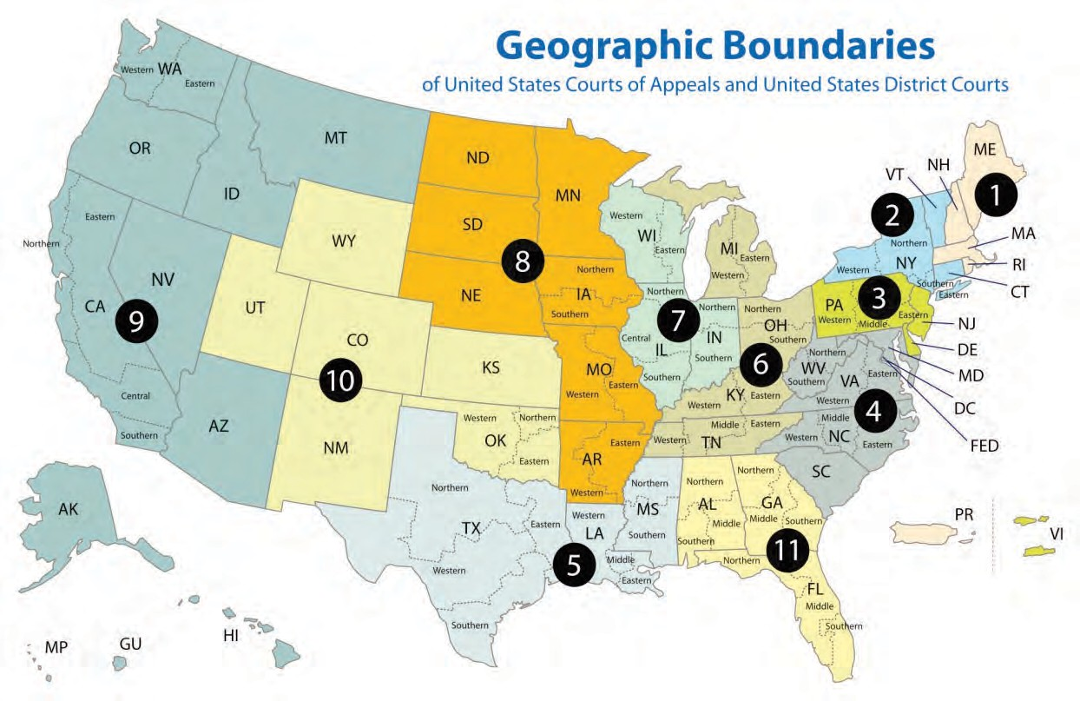
United States Courts of Appeals

- EOIR* compiles and files the Certified Administrative Record

- OIL maintains one paper copy in ARU

- Electronic copy on Share Point

Electronic copy of record

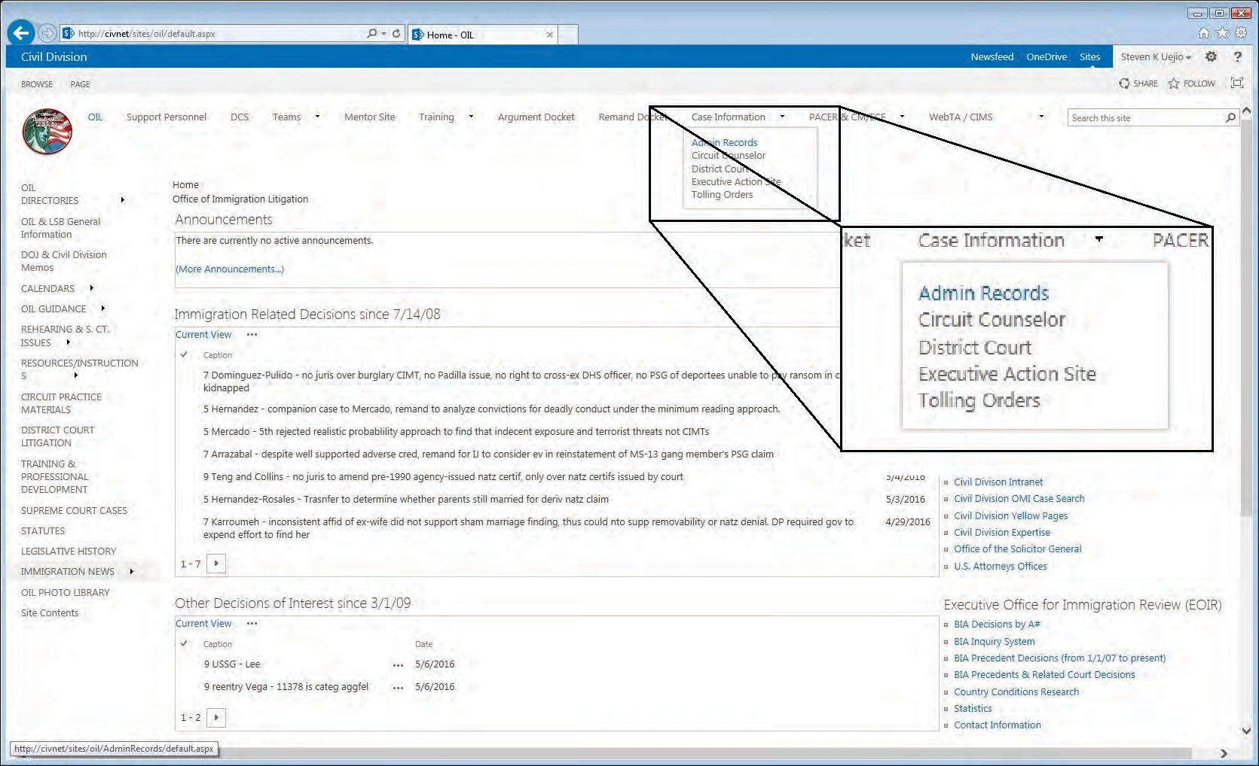7

Electronic copy of record

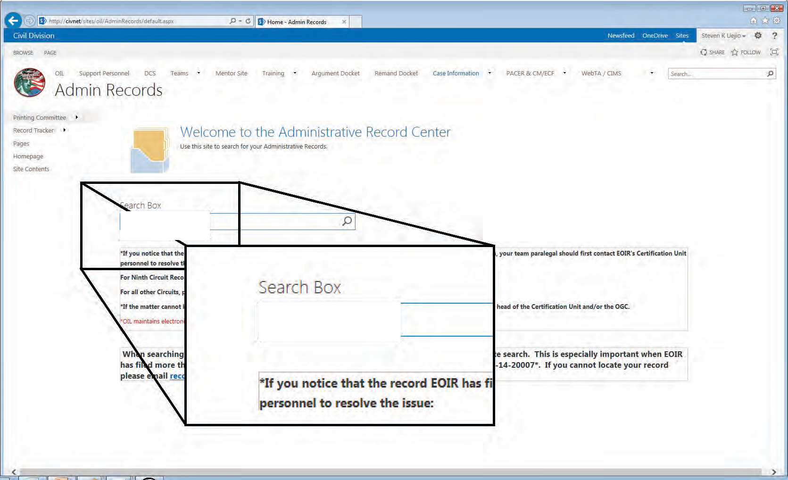(b) (6)

(b) (6)

8

Electronic copy of record

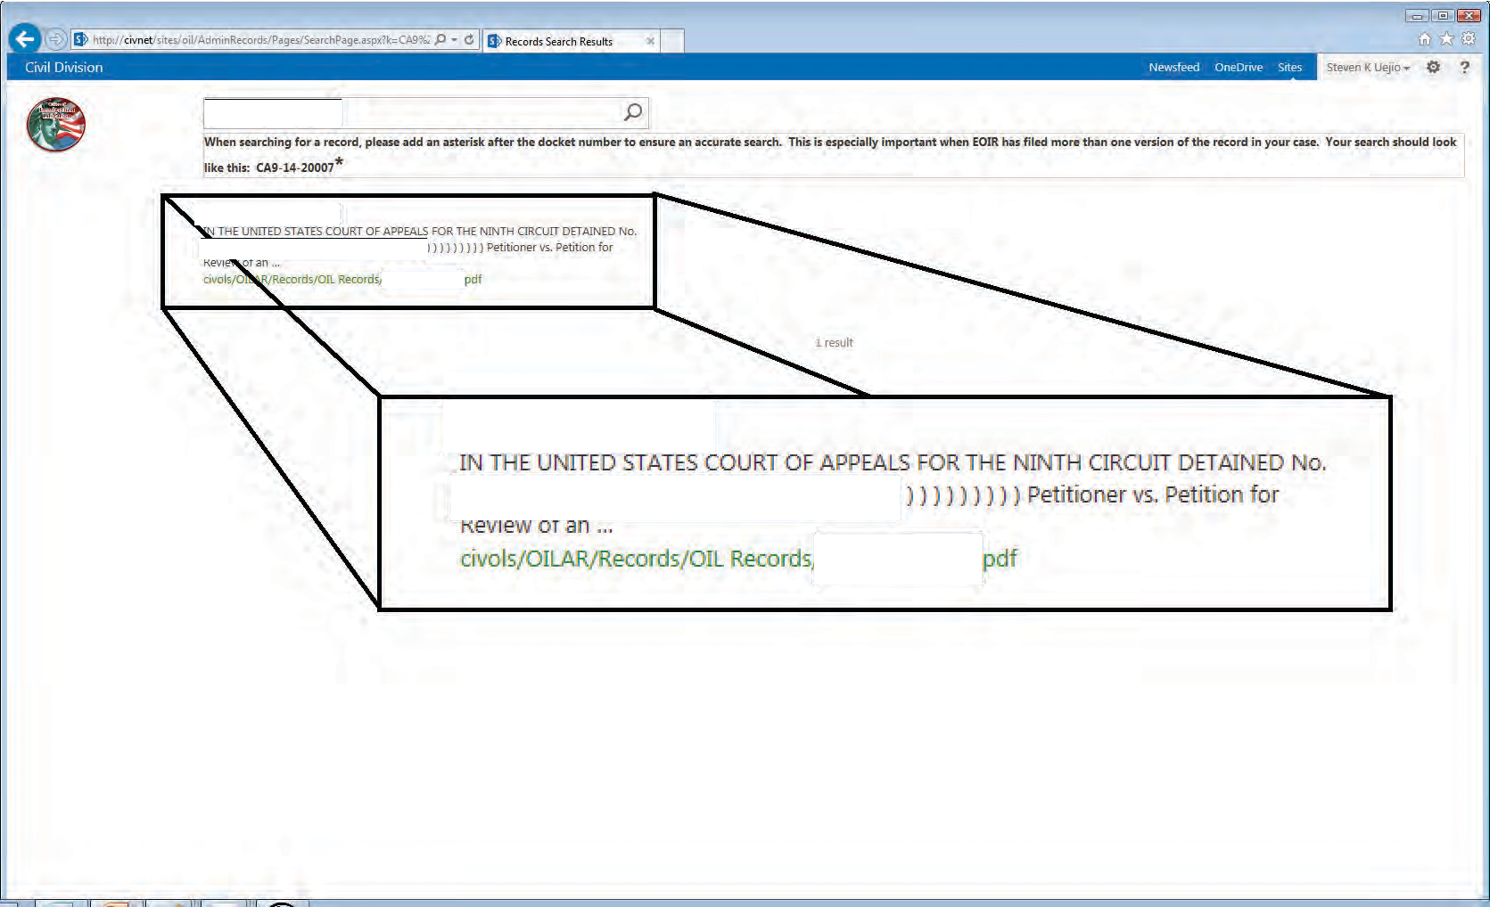(b) (6)

(b) (6)
(b) (6)
(b) (6)

(b) (6)

(b) (6)
(b) (6)

9

- Use this as a general guide

- Start with the oldest documents at the back of your record and work your way to the newest documents at the front

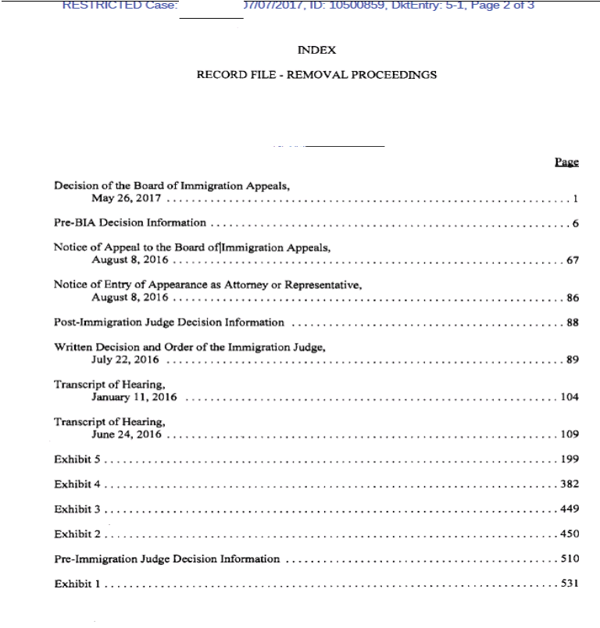
(b) (6)
(b) (6)

Reviewing the Record:
Notice to Appear (NTA)

- Look to the NTA for:
- Date, place, and manner of entry
- Charge of removability
- Date and manner of service
- Date proceedings were initiated in immigration court

Reviewing the Record: NTA

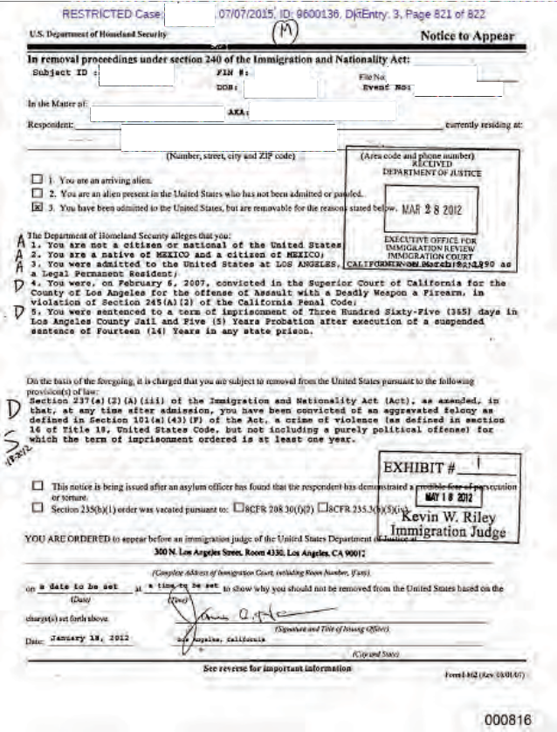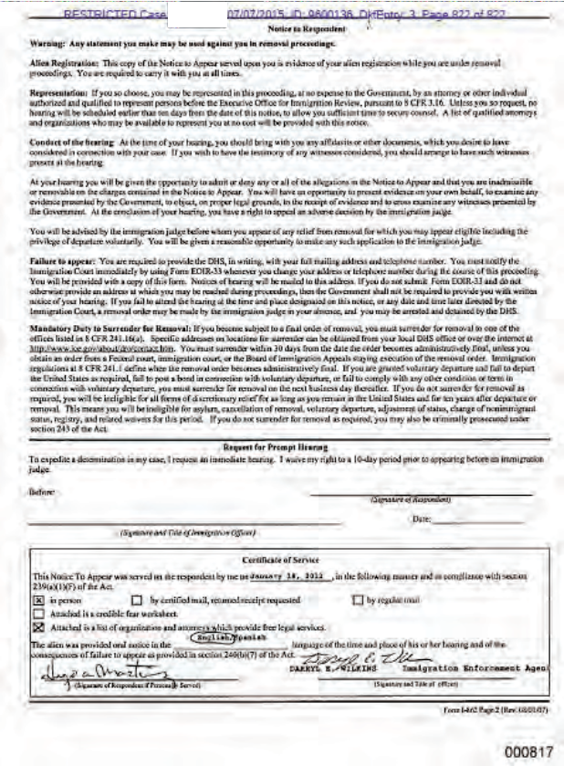
(b) (6)
(b) (6)
(b) (6)
(b) (6)
(b) (6)
(b) (6)
(b) (6)
(b) (6)
(b) (6)
(b) (6)

13

- The petitioner may file a motion to change venue

(b) (5)

- Form I-589: Application for asylum and withholding of removal

- Form EOIR 42A: Application for cancellation of removal

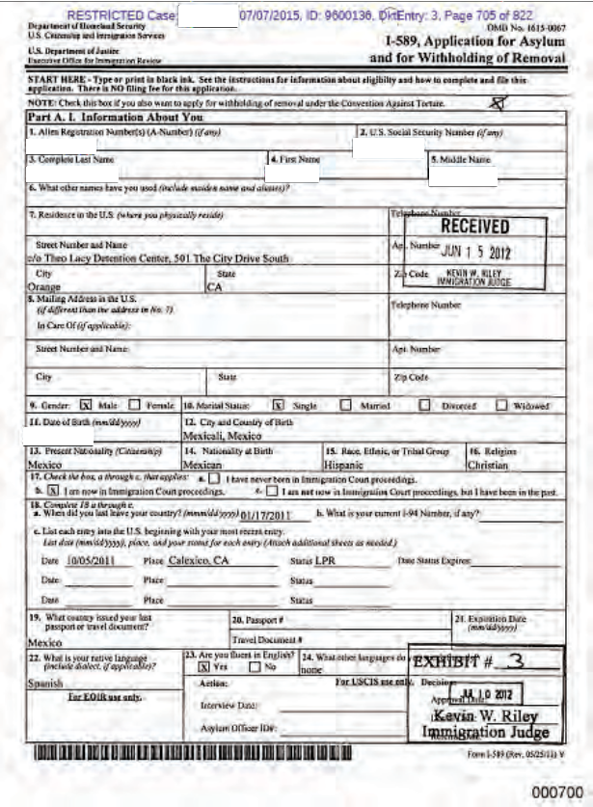
(b) (6)
(b) (6)
(b) (6)
(b) (6)
(b) (6)
(b) (6)
(b) (6)

- Petitioner’s Affidavit
- Witness Statements
- State Department Country Condition Reports
- Medical Documents
- Criminal Court Records

(b) (6)

(b) (6)

(b) (6)
(b) (5)

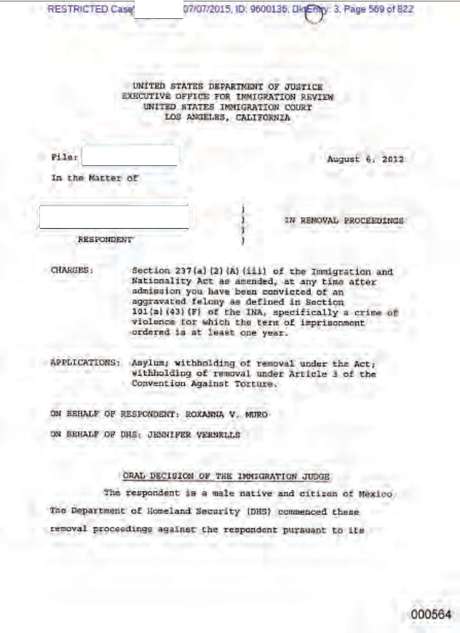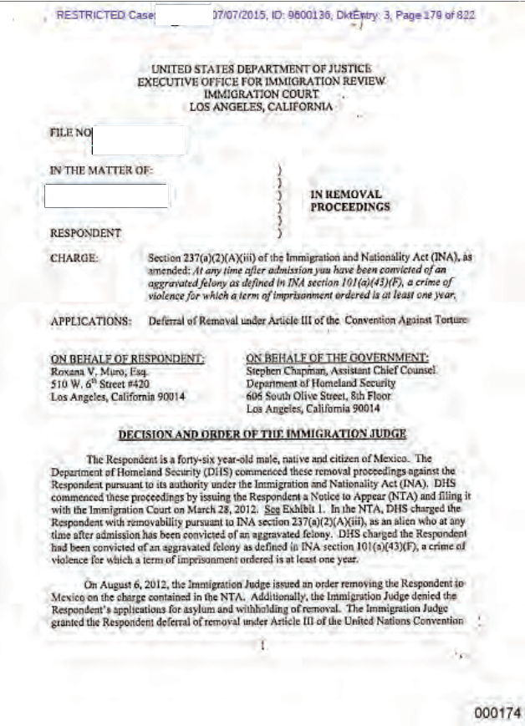
(b) (6)

(b) (6)

(b) (6)
(b) (6)

(b) (6)

(b) (6)

19

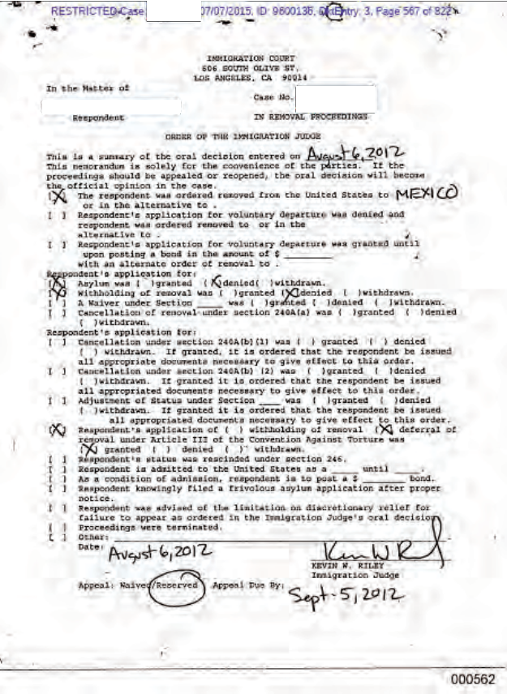
(b) (6)
(b) (6)
(b) (6)

Notice of Appeal
(b) (6)

(b) (6) (b) (6)
(b) (5), (b) (6)
  - Form EOIR-26

  - Three-page document

  - Completed by the petitioner’s counsel or the petitioner if pro se

Petitioner’s Brief to the Board

(b) (5)
(b) (5)
(b) (5)

Board Decision
(b) (6)

(b) (6)
(b) (6) (b) (6)
(b) (5), (b) (6)
  - This will likely be the first document in your record

Motions to Reopen

- If the petitioner is seeking review of a motion to reopen, look for:
(b) (5)

