In person, if possible, and recorded.

EOIR’s
Requirements for the IJ Hearing
IJ reviews the AO’s entire record including:

🞄 Form I-863, Notice of Referral
🞄 AO’s notes,
🞄 A summary of the material facts, and
🞄 Any other supporting materials. (DHS ROP).

Parties may offer written or oral statements.
Immigration Court Practice Manual, Ch 7.4(e)(iv).

The IJ has the discretion to decide:

EOIR’s
Requirements for the IJ Hearing
🞄 Whether the alien may be represented at the hearing,

and

🞄 Whether additional evidence may be introduced.

Immigration Court Practice Manual, Ch. 7.4(e)(iv)(C) &
(E).

If the IJ disagrees with the AO and finds a reasonable fear:

🞄 Withholding-only proceedings

The IJ’s Decision
If the IJ concurs with the AO and finds no reasonable fear:

🞄 The case is returned to DHS.
🞄 There is no appeal to the Board.
🞄 PFR must be filed within 30 days.

Venue
It depends on what the case involved.
Reinstatement only
Where DHS entered the reinstatement or 1228(b) order

Reasonable fear as well

Where the IJ completed the reasonable-fear or withholding-only proceedings

Bibiano v. Lynch, 834 F.3d 966, 973 (9th Cir. 2016).

🞄 A pending reasonable fear or withholding-only proceeding means the underlying removal order is not final for judicial review purposes.

Finality for Review
🞄 Ortiz-Alfaro v. Holder, 694 F.3d 955 (9th Cir.
2012).
(b) (5)

Briefing Issues

PFR Filing Deadline
30 days from the IJ’s concurrence with the AO’s negative reasonable-fear finding . (Petitioner can challenge both reasonable fear and reinstatement.)

Appealing to the Board does not toll the 30-day deadline.
See Umude-Louis v. Holder, 368 F. App’x 544, 547 (5th Cir.
Mar. 4, 2010);

However, the 9th Circuit sees things differently.

“The constellation of statutes, regulations, instructions contained on various forms, and responses from the BIA [regarding appeals] create a landscape that is confusing at best.”

Martinez v.
Sessions
Petitioners are “susceptible to being caught in a trap for the unwary.”
Martinez v. Sessions, 873 F.3d 655, 659-60 (9th Cir. 2017);
Ayala v. Sessions, 855 F.3d 1012 (9th Cir. 2017).

Therefore . . .

In the 9th Circuit, when a petitioner:

Martinez v.
Sessions cont’d
🞄 Appeals a negative reasonable fear decision to the Board within 30 days of the IJ decision,

and

🞄 Files a PFR within 30 days of the Board decision,

The Board decision is the final order of removal and the PFR is timely.

OIL’s position –

Standard of Review (for the concurrence)
(b) (5)

Standard of Review cont’d
Other courts have simply avoided the question by applying the more rigorous substantial evidence test first.

See, e.g., Telles v. Lynch, 639 F. App’x 658, 662 (1st Cir. Mar. 9, 2016); Lucas v. U.S. Att’y Gen., 652 F. App’x 854,
859 n.5 (11th Cir. June 16, 2016).

(b) (5)

(b) (5)

Insufficient
Analysis by the IJ
“If the administrative action is to be tested by the basis upon which it purports to rest, that basis must be set forth with such clarity as to be understandable.”

SEC v. Chenery Corp., 332 U.S. 194, 196 (1947).

Insufficient Analysis cont’d
(b) (5)

Motions to Reopen/ Reconsider
🞄 General view – IJs cannot reopen or reconsider negative reasonable fear decisions.
🞄The RF regulations do not specifically prohibit reopening or reconsideration.
🞄“An Immigration Judge may . . . reopen or reconsider any case in which he or she has made a decision, unless jurisdiction is vested with the Board of Immigration Appeals.”

🞄 8 C.F.R. § 1003.23(b)(1).

Reopen/ Reconsider cont’d
(b) (5)

The 9th Circuit View:
(b) (5)
See Ayala v. Sessions, 855 F.3d 1012, 1017 (9th Cir. 2017) (IJ ruled on the merits of a combined motion to reopen/reconsider); Bartolome v. Sessions, 904 F.3d 803 (9th Cir. 2018) (immigration judge’s “failure to recognize that he had at least sua sponte jurisdiction to reopen proceedings was an abuse of discretion”).

Right to Counsel
🞄 Right is listed on the NOI FARO itself
🞄 At initial contact with DHS
🞄 CTA9: must show prejudice if the right to counsel is violated during initial contact with DHS officers, as long as the alien has the opportunity to consult with an attorney before the order is executed
🞄 At IJ review hearing
🞄 Notice of hearing says that if you want an attorney, s/he should appear at your hearing.
🞄 CTA9: statutory right to counsel exists under plan language of FARO statute. Prejudice presumed. Zuniga v. Barr, -- F.3d --,2019 WL 3917527 (Aug. 20, 2019).
🞄 CTA3: sidestepped the question where the alien’s attorney simply failed to show up. Bonilla v. Sessions, 891 F.3d 87 (3d Cir. 2018).

More Potential Reasonable Fear Issues
🞄Procedural challenges

🞄Scope of review before IJ

🞄Ability to present testimony and documents

🞄Work with your paralegal in charge of DHS records to obtain a DHS record in any case with a DHS removal order

Record Issues

🞄Some offices won’t certify the record – work with your reviewer if that happens to you

QUIZ TIME!

These cases are very different from OIL’s normal PFRs.

Don’t Forget

The good news: There are resources! You usually don’t need to reinvent the wheel here.

- Sample briefs
- Sample motions
- Points of contact
And always free to reach out!

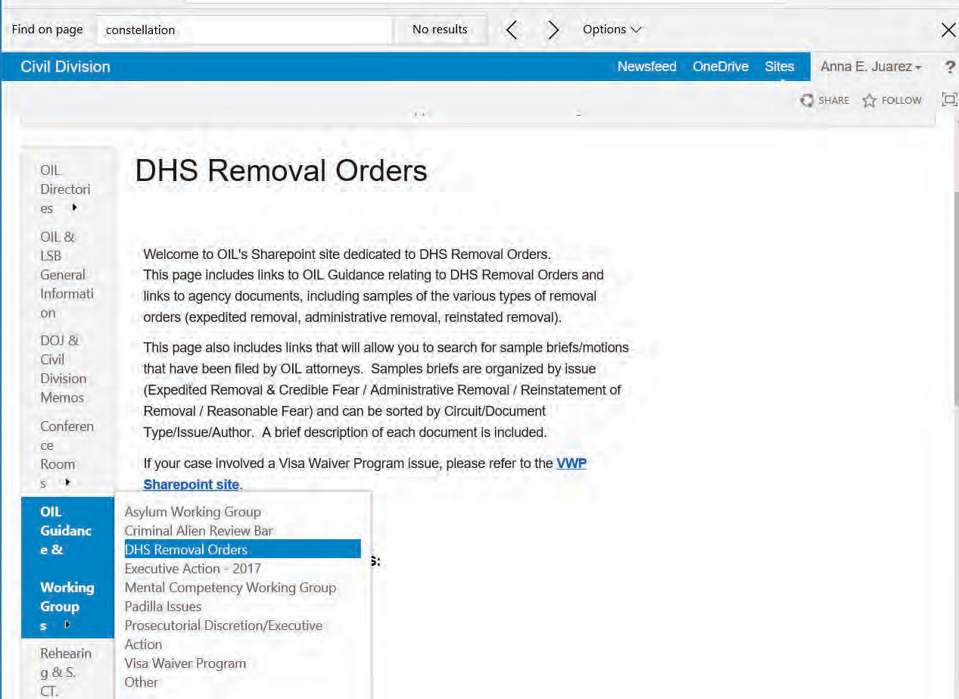

(b) (6)

Anna Juarez Allison Frayer

Contact Information

Exhaustion Chart-OIL Appellate

(b) (5)

Attorney work product Last updated 9.19.2019

Government Role
Element in Persecution
Virginia L. Gordon, Trial Attorney
(b) (6)

Objectives
- Understand why government role is an element of persecution claims
- Be able to effectively defend decisions finding the applicant did not establish the government role element

Topics
- Brief History of Government Role in Persecution
- Establishing Government Role

Brief History of
Government Role in
Persecution

Brief History of
Government Role Element

UNHCR
- BIA

Courts of Appeals

Challenges What challenges might exist in
evaluating the government
role element?

Key Reminder

Government role = “inherent” in persecution definition

Evaluating the Government Role
Element

Government Role Element
- Unable or Unwilling to control persecutor

- BOP: Applicant

- NB: “condone” / “completely helpless”

You Be the Judge
- Read the fact scenario provided in your materials
- Is the government of Trelovia unable or unwilling to control the DX-7 gang?

Briefing Tips

(b) (5)

Wrap Up

Questions?
- Reminders

Next Steps

Government Role Element in Persecution
Background

“Inherent” → need for international protection of a refugee only arises when national or state protection is unavailable to an individual.

UNHCR Handbook, paragraph 65: “[p]ersecution is normally related to action by the authorities of a country” but also may be committed by non-government segments of the population of a country if their conduct is “knowingly tolerated by the authorities, or if the authorities refuse, or prove unable, to offer effective protection.”

BIA: incorporated unwilling or unable to control element in 1960s, before enactment of Refugee Act of 1980; ruled that it still applied after enactment

Courts of Appeals: the inability to control private actors is a distinct issue from the unwillingness to control the actors → analyze them separately

Examining the Evidence

Condoned/Complete Helplessness
(b) (5)
(b) (5)

Government Role Element of Persecution

Hypothetical Scenario

Charlotte is a native and citizen of Trelovia. On several occasions, members of the DX-7 gang, a notorious gang in Trelovia, sexually assaulted her because she is a lesbian woman and they think they can “convert” her. Charlotte reported the first sexual assault to the police in her community. The police took a report, but said the officer did not think that the gang members could or would be captured because Charlotte could not identify the specific individuals, who had worn ski masks during the assault. Charlotte and the police were certain the perpetrators were DX-7 members, however, because of their highly recognizable gang tattoos and because the men acknowledged being DX-7 members and warned Charlotte not to report them or she would suffer greater consequences “next time.” The threat materialized when DX-7 members assaulted Charlotte on a second occasion and said they had a friend in the police department who saw her report and let them know about it. Fearing even greater retribution, Charlotte did not report the second incident, or a third that followed shortly afterward. But, her brother, who lived in a different community in Trelovia, reported the assaults to the national rape hotline that had been recently implemented in the country through a partnership between the government and several NGOs. After that report, Charlotte received free assistance from a new government social service agency that helps sexual assault victims handle the effects of trauma. In the meantime, Charlotte was assaulted on two other occasions, but she continued to refuse to speak to police. Her social worker urged her to report the assaults, but Charlotte was afraid that doing so would result in her death. Ultimately, Charlotte’s brother assisted Charlotte in obtaining a visitor visa to the United States. Shortly after arriving in Boston, MA, she applied for asylum protection.

In addition to her personal story, Charlotte presented country conditions evidence showing that the DX-7 gang is feared throughout Trelovia by citizens and local police alike. The gang influenced and infiltrated police departments and other government agencies by covertly joining ranks, bribing officers and officials, and disappearing family members of police who investigated or threatened gang members. They were rarely prosecuted for crimes because they always covered their faces and had matching tattoos on their left arms so they would be difficult to identify by victims. Often, police were too frightened to investigate reports of crimes by DX-7 gang members, rendering the gang essentially immune to local prosecution. Nevertheless, the national government initiated efforts to combat the gang through military crackdowns against gang activity. In addition, the national government collaborated with several NGOs to establish nationwide protections and services for victims of sexual assault and domestic violence, such as the social services that Charlotte received. Still, prosecutions of perpetrators remained low given the challenges facing local law enforcement.

Given the facts as provided above, does it appear that the government of Trelovia is unable or unwilling to control the DX-7 gang and protect Charlotte?

Checklist for generally evaluating whether the state action requirement is fulfilled
(b) (5)

For Use in OIL Fall Training 2019 (Convention Against Torture) Elizabeth Fitzgerald-Sambou (Sept. 3, 2019)

Circuit-specific checklist for determining whether an applicant demonstrated acquiescence of a public official
(b) (5)

For Use in OIL Fall Training 2019 (Convention Against Torture) Elizabeth Fitzgerald-Sambou (Sept. 3, 2019)

Judicial Review of Removal Orders
Deputy Director Ernie Molina Trial Attorney Ilana Snyder October 9, 2019

Judicial Review Topics
Overview

- History
- Threshold Jurisdictional Issues
- Review Bars and Exceptions
- DHS Removal Orders
- Miscellaneous Review Bars

History

History
(b) (6)

  - Before 1952
  - Interplay with the APA
  - The Immigration Act of 1961
  - AEDPA and IIRIRA
  - REAL ID Act of 2005

Former INA § 106, 8 U.S.C. § 1105a
  - (a): Invokes the Hobbs Act, 28 U.S.C. 2341.
  - (a)(1): File within 90 days, but 30 days in the case of an alien convicted of an aggravated felony.
  - (a)(10): Habeas corpus for an alien in detention, with no time limit.
  - (b): Habeas corpus for exclusion proceedings.
  - (c): Exhaustion of remedies.

Threshold Issues

Threshold Issues
Overview

- Finality
- Exhaustion
- Venue

Finality
PFR “must be filed not later than 30 days after the date of the final order of removal.”

Typically, a removal order is “final” when
  - A Board decision ends all administrative proceedings; or
  - Where no appeal is filed with the Board,
    - When the alien waives review of the immigration judge’s decision, or
    - When 30 days have passed from the IJ’s decision 8 U.S.C. § 1101(a)(47)(B);
8 C.F.R. § 1003.39

Finality
What to look out for:

(b) (5)

30-Day Filing Deadline

PFR “must be filed not later than 30 days after the date of the final order of removal.”

- Alien Must Establish Jurisdiction
- Deadline Is Mandatory & Jurisdictional
- Computation Considerations:
  - PFR deemed “filed” when clerk receives it.

  - Board decision issuance considerations

Exhaustion

Overview

The Court only reviews the final order “if the alien has exhausted all remedies available to the alien as of right.” 8 U.S.C. § 1252(d)(1).

Exhaustion

Purposes

- Give the agency the opportunity to resolve a controversy or correct its errors before judicial intervention

- Allow the Board to compile a record which is adequate for judicial review.

Exhaustion

Is Issue Exhaustion Jurisdictional?

1. Most Circuits say yes!
(b) (5)

Exhaustion

At what level of specificity must the alien have raised the
issue for it to be considered exhausted?
Things to Look Out For
(b) (5)

Exhaustion

Waiver of the Exhaustion Requirement

1. Most Circuits agree that the agency waives exhaustion when:
(b) (5)

Exhaustion

When is petitioner NOT required to exhaust?

- When the claims (s)he is asserting are not within the BIA’s jurisdiction to consider;
- Claims, the remedy for which the agency is not capable of granting “as of right;” or
- Claims that (s)he is not an “alien”

The Venue Requirement

- 8 U.S.C. § 1252(b)(2) (PFR “shall be filed with the court of appeals for the judicial circuit in which the IJ completed the proceedings”)
- Venue is not jurisdictional. It can therefore be waived.
- What about when the alien and the IJ are in different locations?
  - Generally, venue is determined by the location of the IJ.
  - But, the 10th Circuit!

Stays of
Removal

Stays of Removal

Standards

(b) (5)

Stays of Removal

(b) (5)

(b) (5)

Stays of Removal

Ex Parte Communications and NOIRs.

(b) (5)

Bars to The Courts’ Review

1252(a)(2) Review Bars

- : Some discretionary decisions
- : Some orders against criminal aliens

Savings Clause:
- : Jurisdiction preserved to review “constitutional claims or questions of law”

Discretionary Bars

Statutes
- INA § 242(a)(2)(B)(i): No review of “any judgment regarding the granting of relief under section 212(h), 212(i), 240A, 240B, or 245.”

- INA § 242(a)(2)(B)(ii): No review of “any other decision or action of the Attorney General the authority for which is specified under this title to be in the discretion of the Attorney General, other than the granting of relief under section 208(a).”

Discretionary Bars

Applying the Bars: Section 242(a)(2)(B)(i)

Suspension of Deportation (§ 244)
- Non-Discretionary Aspects Are Reviewable
  - Physical Presence
  - Good Moral Character (statutory grounds)
  - Constitutional Challenges
- Discretionary Challenges Are Not Reviewable
  - Good Moral Character (non-statutory grounds)
  - Extreme Hardship
  - Ultimate Grant

Discretionary Bars

Applying the Bars: Section 242(a)(2)(B)(ii)

- Kucana v. Holder, 558 U.S. 233 (2010):
  - Review barred only when a statute, not a regulation, make decision discretionary.
  - Once change of import: Particularly serious crimes are reviewable

Discretionary Bars

Applying the Bars: Section 242(a)(2)(B)(i)

Complications
  - Motions to reopen
  - What is discretionary
  - Disguised challenges

Discretionary Bars

Applying the Bars: Section 242(a)(2)(B)(i)

Motions to Reopen/Reconsider:
- Rodriguez v. INS, 253 F.3d 797 (5th Cir. 2001)
  - Alien filed motion to reopen an application for suspension of deportation, Board found inadequate hardship.
  - “It is axiomatic that if we are divested of jurisdiction to review an original determination. . . we must also be divested of jurisdiction to review . .
. a motion to reopen on the ground that the alien has still failed to establish such hardship.”

Discretionary Bars

Applying the Bars: Section 242(a)(2)(B)(i)

Motions to Reopen/Reconsider:
- Fernandez v. Gonzales, 439 F.3d 592 (9th Cir. 2006)
  - No jurisdiction over hardship finding in denying a motion to reopen where the alien presents substantially the same hardship
  - Suggests that a “new” hardship would be subject to judicial review

Discretionary Bars

Applying the Bars: Section 242(a)(2)(B)(i)

What is a discretionary decision?
  - Romero-Torres v. Ashcroft, 327 F.3d 887 (9th Cir. 2003)
    - “exceptional and extremely unusual hardship”
    - “good moral character” is “almost necessarily subjective” (citing Kalaw)
    - “in the opinion of” is unnecessary
    - “value judgments”

Discretionary Bars

Applying the Bars: Section 242(a)(2)(B)(i)

Disguised challenges
  - Delores Jean v. Gonzales, 435 F.3d 475 (4th Cir. 2006)
    - IJ denied 212(h) relief
    - BIA affirmed and adopted and later denied a motion to reconsider cancellation and reopen for 212(h)
    - Alien alleged the IJ’s decision contained misstatement of fact
    - “To the extent that a petition asks us to review a discretionary or factual determination, however, we still lack jurisdiction.” (Citing Vasile v. Gonzales, 417 F.3d 766 (7th Cir. 2005)).

Discretionary Bars

Applying the Bars: Section 242(a)(2)(B)(i)

Disguised challenges
- Meraz-Reyes v. Gonzales, 436 F.3d 842 (8th Cir. 2006): “[T]he petitioner attacks the BIA determination that the evidence failed to show an ‘extraordinary and extremely unusual hardship.’ This finding, however, is precisely the discretionary determination that Congress shielded from our review.”
- See also Ebrahim v. Gonzales, 471 F.3d 880 (8th Cir. 2006) (no review of “discretionary” facts relating to marriage waiver) (citing Suvarov v. Gonzales, 441 F.3d 618 (8th Cir. 2006))

The Criminal Alien Bar

8 U.S.C. § 1252(a)(2)(C)
- “Final order of removal” against alien who is
- “Removable by reason of having committed” a criminal offense
- Covered in:
  - 1182(a)(2) → criminal inadmissibility grounds
  - 1227(a)(2)(A)(iii) → aggravated felony
  - 1227(a)(2)(B) → conviction relating to a controlled substance

The Criminal Alien Bar

8 U.S.C. § 1252(a)(2)(C)

3. Covered in (cont.):
  - 1227(a)(2)(C) → certain firearms offenses
  - 1227(a)(2)(D) →conviction for enumerated provisions (relating to espionage, sabotage, treason and sedition etc.)
  - 1227(a)(2)(A)(ii) → conviction of two CIMTs not arising out of a single scheme of misconduct for which a sentence of one year or longer may be imposed on both predicate offenses

The Criminal Alien Bar

“Removable by reason of having committed”

Most circuits want to see symmetry between the covered offense (1252(a)(2)(C)) and the charge of removability that was sustained by the agency (NTA charge).

    - 5th and 11th Circuits
    - 6th and 8th Circuits

he Criminal Alien Bar
T

1252(a)(2)(C)’s Limited Applicability In the 9th Circuit

- The Ninth Circuit has held that the CAB does not apply where the agency denies relief on the merits of AS/WH/CAT claim or MTR (as opposed to relying on the alien’s conviction as the basis for its order) as opposed to the criminal conviction
- No other circuit has joined the 9th

The Criminal Alien Bar

1252(a (2)(C)’s Limitation In The 7th Circuit

- The Seventh Circuit has held that the CAB does not apply to bar its review of factual claims in PFRs arising from denial of D- CAT
- Not the same reasoning as the Ninth Circuit

Miscellaneous Review Bars

All subject to 1252(a)(2)(D)
- Untimely filed asylum app 1158(a)(3)
- Voluntary departure 1229c(f)
- Certain waivers:
  - Unlawful presence waiver 1182(a)(9)(B)(v)
  - The 212(h) & 212(i) waivers
  - Waiver of the filing of the joint petition to lift conditional resident status 1186a(c)(4)
  - Document fraud waivers 1182(d)(12)

Questions?

(b) (6)

U.S. Department of Justice
Civil Division, Office of Immigration Litigation – Appellate

National Security and Human Rights Removal Grounds and Bars to
Relief and Protection

OIL Immigration Law Seminar October 2019
Paul F. Stone Deputy Chief
National Security Unit OIL - Appellate

National Security Unit | Office of Immigration Litigation - Appellate 1

OR
When criminal prosecution
doesn’t or won’t or can’t work
(or even when it does), what are the next steps?

National Security Unit | Office of Immigration Litigation - Appellate 2

Limitations on Prosecution of NS & HRV Crimes

Criminal prosecution may require disclosing national security information or law enforcement sensitive information
- Disclosure could compromise ongoing investigations of greater importance
- Disclosure could reveal sources and methods of intelligence gathering
Criminal prosecution requires the highest standard of proof in the law – beyond a reasonable doubt
- There may be insufficient disclosable evidence to meet the burden
- Evidence or witnesses are abroad and unavailable
- Statutes of limitations

National Security Unit | Office of Immigration Litigation - Appellate 3

“Exclusion” Proceedings

Visa Denial and Revocation

Offshore aliens

- Consular officers have the authority to deny, and the Secretary of State may revoke visas “at any time” under INAg221(g) & (i)

INAg235(b) Expedited Removal
–8 U.S.C.g1182(g) & (i)
Uninspected aliens

- Admission decision is by an immigration officer, but if an alien passes credible fear interview then asylum-only hearing is before an immigration judge
- Alien has burden to prove admissibility
- The IJ may consider classified information from the Department of State in

evaluating asylum and protection applications
INAg235(c) Security Summary Removal
–8 U.S.C.g1225(b)
Arriving aliens

- Low burden: Immigration officer or immigration judge “suspects . . . may”
- Desktop adjudication – no adversarial hearing

- Confidential information may be used without limitation
–8 U.S.C.g1225(c)

National Security Unit | Office of Immigration Litigation - Appellate 4

Deportation Proceedings - ATRC

Alien Terrorist Removal Court “ATRC” Admitted aliens

  - Takes place before an Article III Judge so DOJ represents the Government

  - Government has lower burden of proof for removal of “more likely than not”

  - Classified evidence can be used with only a summary supplied to the alien

  - Never been used

– INAgg501-507, 8 U.S.C. gg1531-1537

National Security Unit | Office of Immigration Litigation - Appellate 5

Removal Proceedings – Conventional

INAg240 Removal Proceedings Admitted aliens+
  - Only “clear and convincing” evidence to prove removability
  - National security or human rights violator removal ground unnecessary
  - National security information used to establish deportability must be disclosed, but discovery is limited
  - National security information can be used, without disclosure, to address applications for admission and discretionary relief
  - The Federal Rules of Evidence are inapplicable

National Security Unit | Office of Immigration Litigation - Appellate 6

National Security Grounds of Removal

National Security Unit | Office of Immigration Litigation - Appellate 7

Terrorist Organizations in the INA – (1)

National Security Unit | Office of Immigration Litigation - Appellate 8

Terrorist Organizations in the INA – (2)

Terrorist Organizations & Groups, as defined in the INA
  - TEL/ITO – a group designated by the Secretary of State onto the “terrorist exclusion list” also referred to as “immigration terrorist organizations”, or more commonly as Tier II.
The only requirement is that the organization engages in terrorist activity

  - Undesignated Terrorist Organizations – a group of two or more individuals (or a subgroup) engaged in terrorist activity, also referred to as Tier III.

May also include foreign sovereigns – A.A.
May require authorization – Uddin

– INAg212(a)(3)(B)(vi)(II) & (III),
8 U.S.C. g1182(a)(3)(B)(vi)(II) & (III)

National Security Unit | Office of Immigration Litigation - Appellate 9

Terrorism Inadmissibility Charges – Individual Conduct

Any alien who –
    - has engaged in a terrorist activity;
    - a consular officer, the Attorney General, or the Secretary, DHS, knows or has reasonable ground to believe is engaged in or is likely to engage after entry in any terrorist activity;
    - has incited terrorist activity;
    - endorses or espouses terrorist activity or persuades others to do so or to support a terrorist group;
is inadmissible.
– INAg 212(a)(3)(B)(i)(I) – (III) & (IV),
8 U.S.C. g1182(a)(3)(B)(i)(I) – (III) & (IV)

National Security Unit | Office of Immigration Litigation - Appellate 10

Terrorism Inadmissibility Charges – Individual w/ a Group

Any alien who –
    - is a representative or member of a designated terrorist organization;
    - is a member of an undesignated terrorist organization unless the alien can demonstrate the alien “did not know and should not reasonably have known” the organization was a terrorist one;
    - has received military training from any terrorist organization;
    - Any alien who has associated with a terrorist organization and intends to engage in activities in the U.S. that could endanger U.S. welfare, safety, or security;
is inadmissible.
– INAg 212(a)(3)(B)(i)(IV) – (VI), (VIII) & (a)(3)(F)
8 U.S.C. g1182(a)(3)(B)(i)(IV) – (VI), (VIII) & (a)(3)(F)

National Security Unit | Office of Immigration Litigation - Appellate 11

Terrorism Inadmissibility Charges – Material Support

Engage in terrorist activity includes, among many other things, committing an act the alien knows or reasonably should know provides material support –
- to a Tier I or Tier II organization, or
- to a Tier III organization, unless the alien can demonstrate by clear and convincing evidence that the alien “did not know, and should not reasonably have known, that the organization was a terrorist one.
– INAg212(a)(3)(B) & (F), 8 U.S.C.g1182(a)(3)(B) & (F)

National Security Unit | Office of Immigration Litigation - Appellate 12

Breadth of the Material Support Provision

There is no exception for material support given under duress.
- Matter of M-H-Z-, 26 I. & N. Dec. 757 (BIA 2016)

Material support does not include a quantitative component.
- Matter of A-C-M-, 27 I. & N. Dec. 303 (BIA 2018)

National Security Unit | Office of Immigration Litigation - Appellate 13

Terrorism Inadmissibility Charges – Exemptions

The Secretary of State or Secretary of Homeland Security may determine in his or her unreviewable discretion:
- that the terrorism grounds of inadmissibility shall not apply to a particular alien, or
- that the terrorism grounds of inadmissibility shall not apply to a Tier III group.
No exemption may be granted for:
- aliens found to be engaging in or likely to engage in terrorist activity after admission,
- aliens who are members or representatives of, or who have advocated on behalf of, or received military training from a Tier I or Tier II org, or
- for an org that targeted the U.S., other democratic countries, or civilians.
– INAg212(d)(3)(B), 8 U.S.C.g1182(d)(3)(B)

National Security Unit | Office of Immigration Litigation - Appellate 14

Terrorism Removal Charges - Deportability

Any alien who is described in INAg212(a)(3)(B) or (F) is deportable.

– INAg237(a)(4)(B), 8 U.S.C.g1227(a)(4)(B)

National Security Unit | Office of Immigration Litigation - Appellate 15

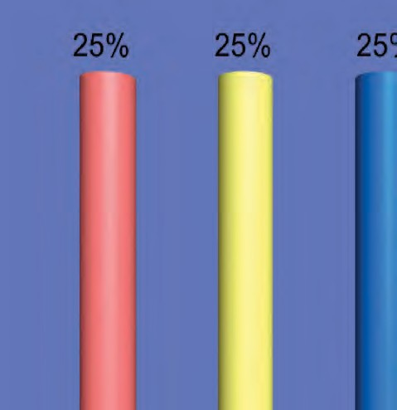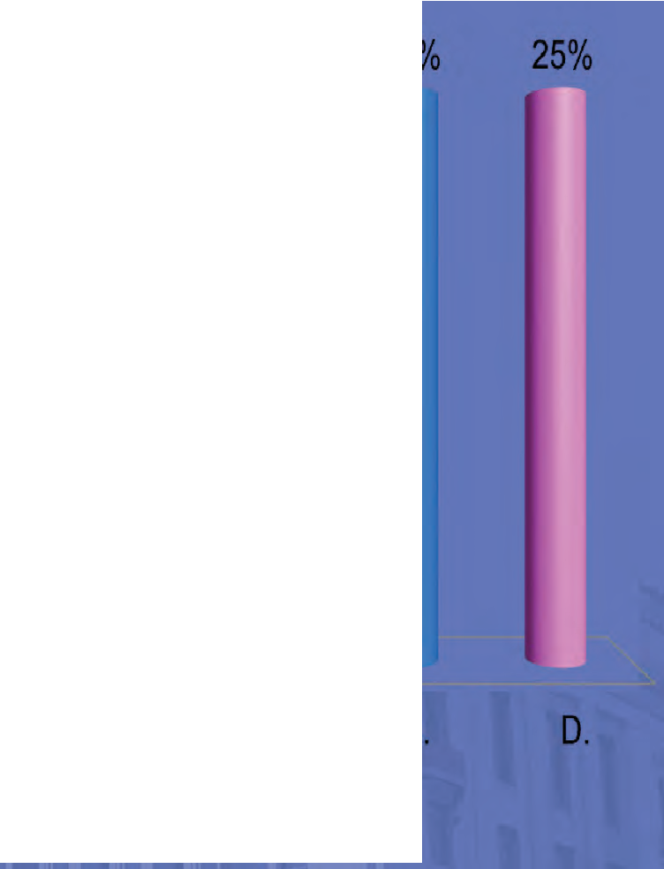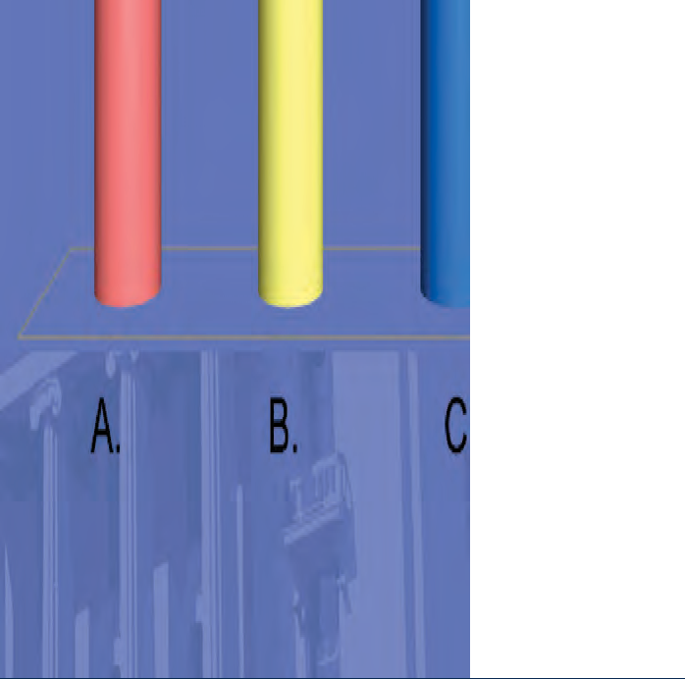Quiz # 1 – Terrorism Bars

An alien was kidnapped and forced under threat of death to cook and clean for members of the FARC, a terrorist organization in Colombia. What terrorism bar, if any, is the alien subject to?

- As an alien who has associated with a T org and intends, when in the U.S., to engage in T activities
- Providing material support for terrorism
- Representative or member of a T org
- On these facts the alien is not subject to a T bar

16

Security and Related Grounds – Inadmissibility

Any alien who a consular officer or the Attorney General (or DHS Secretary) knows, or has reasonable ground to believe seeks to enter the United States to engage solely, principally, or incidentally in —
  - any activity to violate any law of the United States relating to espionage or sabotage,
  - any other unlawful activity,
  - any activity to violate or evade any law prohibiting the export from the United States of goods, technology, or sensitive information,
  - any activity a purpose of which is the opposition to, or the control or overthrow of, the U.S. Government by force, violence, or other unlawful means,
is inadmissible.

– INAg212(a)(3)(A), 8 U.S.C.g1182(a)(3)(A)

National Security Unit | Office of Immigration Litigation - Appellate 17

Security and Related Grounds – Deportability

Any alien who has engaged, is engaged, or at any time after admission
engages in –
  - any activity to violate any law of the United States relating to espionage or sabotage,
  - any activity to violate or evade any law prohibiting the export from the United States of goods, technology, or sensitive information,
  - any other criminal activity which endangers public safety or national security,
  - any activity a purpose of which is the opposition to or the control or overthrow of U.S. Government by force, violence, or other unlawful means
is deportable.

– INAg237(a)(4)(A)(1); 8 U.S.C.g1227(a)(4)(A)(1)

National Security Unit | Office of Immigration Litigation - Appellate 18

Bonus Security Ground of Deportation

Any alien who at any time has been convicted of any violation of, or an attempt, or a conspiracy to violate, any provision of the Foreign Agents Registration Act of 1938 (22 U.S.C.g611, et seq.)
is deportable.

– INAg237(a)(3)(B)(ii), 8 U.S.C.g1227(a)(3)(B)(ii)

National Security Unit | Office of Immigration Litigation - Appellate 19

Illustration of the Benefits of Removal Proceedings

L-Rod the Cuban Spy
Luis Rodriguez had spy tradecraft material in his possession – but he was never charged criminally.
INS charged him under INAg237(a)(4)(A)(i) – any activity to violate any law relating to espionage
50 U.S.C.g851: Every person who “has knowledge of, or has received instruction or assignment in, the espionage, counter-espionage, or sabotage service or tactics of a foreign country or of a foreign political party, shall register with the Attorney General.”
Low threshold of proof required:
    - Section 851 requires only “knowledge of” tactics, not actual espionage
    - no criminal conviction required underg851 to establish deportability
– Matter of Luis, 22 I. & N. Dec. 747 (BIA 1999)

National Security Unit | Office of Immigration Litigation - Appellate 20

Applicants Have the Burden to Show Bars do not Apply

    - Aliens applying for relief, protection, or other immigration benefits have the burden to prove eligibility, which includes showing that mandatory bars do not apply. INAg240(c)(4)(A), 8 U.S.C. g1229a(c)(4)(A) (removal proceedings).

    - Aliens are held to their burden “[i]f the evidence indicates that one or more of the grounds for mandatory denial of the application for relief may apply . . . .” 8 C.F.R.g1240.8(d).

    - For withholding of removal – “[i]f the evidence indicates the applicability of one or more of the grounds for denial of withholding enumerated in the Act . . . .” 8 C.F.R.g1208.16(d)(2)

National Security Unit | Office of Immigration Litigation - Appellate 22

“Evidence Indicates” Standard for NS and HRV

Record “contains some evidence from which a reasonable factfinder could conclude that one or more grounds for mandatory denial of the application may apply.”
- Matter of M-B-C-, 27 I. & N. Dec. 31 (BIA 2017)

The record must contain evidence that raises “the inference that each element of the bar applies.”
- Budiono v. Lynch, 837 F.3d 1042 (9th Cir. 2016)

National Security Unit | Office of Immigration Litigation - Appellate 23

Relief and Protection Barred on Nat Sec Grounds

      - National security removal grounds act as bars to almost all forms of relief, protection, and immigration benefits.
      - The exemption authority of the Secretaries of HS and State can be applied to some of the terrorism bars, but the exemption’s scope is limited for aliens involved in Tier I and II organizations.

USCIS Guidance on TRIG Exemptions – https://www.uscis.gov/legal-resources/terrorism-related- inadmissability-grounds/terrorism-related-inadmissibility- grounds-trig
      - Barred aliens remain eligible for deferral of removal under the Convention Against Torture (“CAT”).

National Security Unit | Office of Immigration Litigation - Appellate 24

Human Rights Violator Grounds for Removal and Bars to Relief and Protection

National Security Unit | Office of Immigration Litigation - Appellate 25

Torture and Extrajudicial Killing Grounds for Removal

Any alien who, outside the United States, has committed, ordered, incited, assisted, or otherwise participated in the commission of —
- any act of torture, as defined in section 2340 of Title 18; or
- under color of law of any foreign nation, any extrajudicial killing, as defined in section 3(a) of the Torture Victim Protection Act of 1991
is inadmissible.
– INAg212(a)(3)(E)(iii), 8 U.S.C.g1182(a)(3)(E)(iii),
identical deportation provision, INAg237(a)(4)(D), 8 U.S.C.g1227(a)(4)(D)

National Security Unit | Office of Immigration Litigation - Appellate 26

Genocide Ground for Removal

Any alien who ordered, incited, assisted, or otherwise participated in genocide of a national, ethnic, racial, or religious group (18 U.S.C. g1091(a)) is inadmissible.

– INAg212(a)(3)(E)(ii), 8 U.S.C.g1182(a)(3)(E)(ii),
identical deportation provision, INAg237(a)(4)(D), 8 U.S.C.g1227(a)(4)(D)

National Security Unit | Office of Immigration Litigation - Appellate 27

Recruitment or use of Child Soldiers Ground of Removal

Any alien who has engaged in the recruitment or use of child soldiers in violation of section 2442 of Title 18, is inadmissible
– INAg212(a)(3)(G), 8 U.S.C.g1182(a)(3)(G),
identical deportation provision, INAg237(a)(4)(F), 8 U.S.C.g1227(a)(4)(F)

National Security Unit | Office of Immigration Litigation - Appellate 28

Severe Violations of Religious Freedom Ground for Removal

Any alien who, while serving as a foreign government official, was responsible for or directly carried out, at any time, particularly severe violations of religious freedom, as defined in section 6402 of Title 22, is inadmissible.
Includes, but not limited to, torture, prolonged detention without charges, disappearances, and other flagrant denials of the right to life, liberty, or the security of persons.

– INAg212(a)(2)(G), 8 U.S.C.g1182(a)(2)(G),
identical deportation provision, INAg237(a)(4)(E), 8 U.S.C.g1227(a)(4)(E)

National Security Unit | Office of Immigration Litigation - Appellate 29

Human Rights Violator Bars to Relief and Protection

Aliens removable for taking part in genocide, torture or extrajudicial killings, recruitment or use of child soldiers, or severe violations of religious freedom are barred from almost all forms of relief or protection,
Except: Human rights violator grounds of removal do not bar asylum, withholding of removal, and CAT withholding*
But: The persecutor bar does.

* The Child Soldiers Accountability Act of 2008 directed DOJ and DHS to issue regulations making C.S. users and recruiters subject to the serious non-political crime bar, which bars asylum. Those regulations are now in process.

National Security Unit | Office of Immigration Litigation - Appellate 30

Persecutor Bar to Asylum, Withholding, and Benefits

The definition of “refugee” excludes those who “ordered, incited, assisted, or otherwise participated in the persecution of any person on account of race, religion, nationality, membership in a particular social group, or political opinion.”
– INAg101(a)(42), 8 U.S.C.g1101(a)(42)
The persecutor bar to asylum uses nearly identical language, INAg208(b)(2)(A), 8 U.S.C.g1158(b)(2)(A), as does the
withholding statute, INAg241(b)(3)(B)(i), and the CAT
withholding implementation regulations, 8 C.F.R.g1208.16(d)(2).
There is no ground of deportability or inadmissibility for aliens who persecuted others, so the persecutor bar does not apply to some forms of relief such as adjustment of status.

National Security Unit | Office of Immigration Litigation - Appellate 31

Quiz # 2 – HRV Bars to Adjustment, Asylum & W/H

The alien in his asylum interview admitted that he was a soldier in the S2 military intelligence unit in Guatemala. While in S2, he would arrest suspected guerillas who his superiors would torture for information.

In immigration court he is seeking adjustment of status or in the alternative, asylum, withholding, and CAT protection.
Which bars must be raised to preclude non-CAT relief?

32

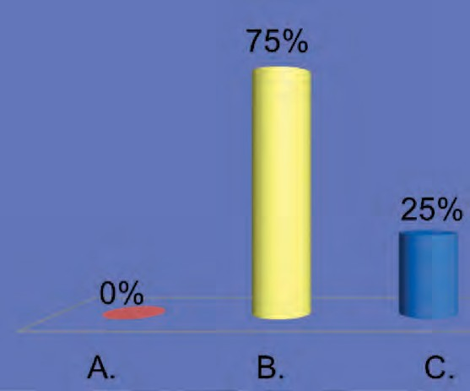Quiz # 2 – HRV Bars to Adjustment, Asylum & W/H

Which bars must be raised to preclude adjustment, asylum, and withholding?

- Torture bar
- Persecutor bar
- Torture & Persecutor bar
- Just trying to stay awake

33

Srebrenica Genocide – Path of Fleeing Bosnian Men & Boys

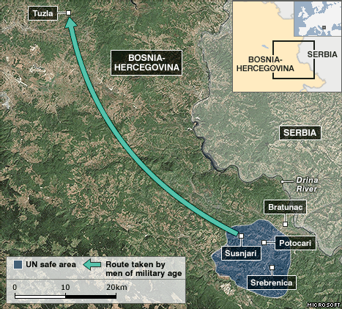
National Security Unit | Office of Immigration Litigation - Appellate
Around the night of July 11th and 12th of 1995, between 10,000 and 15,000 Bosnian Muslim men and boys gathered in the area of Jaglići and Šušnjari and formed a column 12 to 15 kilometers long, which included about 1,000 armed soldiers. The column attempted to flee to Tuzla.

34

Srebrenica Genocide – Execution Sites

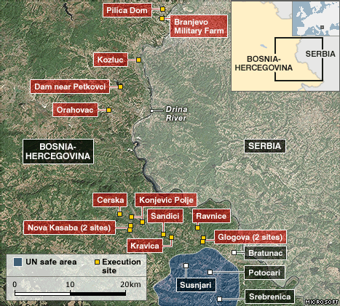
National Security Unit | Office of Immigration Litigation - Appellate
From July 13th to July 17th the VRS killed between 7,000 and 8,000 Bosnian Muslim men and boys who were attempting to flee to Tuzla. Most were killed at execution sites along the Drina river valley and some were killed in ambushes as they fled. Most victims were unarmed civilians.

35

Interaction of HRV Grounds of Removability and Bars

The Case of Zeljko Bošković
- A federal district court convicted Bošković of fraud or misuse of a visa because he failed to disclose his service with the Zvornik Brigade Military Police, Army of the Republika Srpska (VRS).
- Bošković was a lawful permanent resident so ICE charged him with removability for fraud or misuse of a visa.
- As relief and protection from removal, Bošković sought adjustment of status, asylum, withholding, CAT protection.
- Because the record evidence indicated HRV bars may apply to Bošković, he had the burden to prove they did not, which he failed to do so credibly.
- The genocide and extrajudicial killing bars precluded Bošković from adjustment of status, and any necessary waivers, but they did not bar asylum.
- The acts constituting genocide and extrajudicial killing also constituted persecution of others so the persecutor bar precluded his applications for asylum, withholding, and CAT withholding.

National Security Unit | Office of Immigration Litigation - Appellate 36

National Security Unit (NSU)

Chief: Ethan B. Kanter –(b) (6)
Deputy Chief: Paul F. Stone –
(b) (6)

Senior Counsel for National Security: Daniel I. Smulow –
(b) (6)
(b) (6)
(b) (6)
(b) (6)
(b) (6)
Alison M. Igoe – Lindsay M. Murphy – Andrew Brinkman – Jesse Busen –
Counsel for National Security:
Stefanie N. Hennes –
(b) (6)
Historian:
Dr. Harold Cubert –
(b) (6)
NSU Secure Suite STE:
(b) (6)
Classified email addresses available on request

National Security Unit | Office of Immigration Litigation - Appellate 37

Packet A

Packet B

Packet C

Packet D

Particular Social Group Claims: Litig ating in a
Post-A-B- and Post-L-E-A- II World
CHRISTINA P. GREER AND SARAH K. PERGOLIZZI

Overview

▶ PSG requirements (3 + 2 = 5)
▶ Matter of A-R-C-G- and Matter of A-B-
▶ Gender PSGs post-A-B-
▶ Matter of L-E-A- I and Matter of L-E-A- II
▶ Family PSGs post-L-E-A- II

Particular Social Group
Requirements

3 + 2 = 5

3+2 = 5

▶ 3 M-E-V-G- Requirements
▶ Immutability
▶ Particularity
▶ Social distinction
▶ 2 More Important Requirements
▶ Delineation – Matter of W-Y-C-
▶ Independent Existenc e (anti-circularity) – Matter of M-E-V-G- &
Matter of A-B-

  - Immutability

▶ Group members share a characteristic that is innate/unchange able or fundamental to their identity
▶ (i.e. they should not be required to change it).
▶ Shared past experience may be immutable.
▶ See :
▶ Matter of Acosta , 19 I. & N. Dec. 211 (BIA 1985)

  - Particularity

▶ Line-drawing – Pertains to the boundaries of a group.
▶ Terms must provide a “clear benchmark.”
▶ Terms must be recognizable in the society in question.
▶ Common language denying on particularity: group is “too diffuse, amorphous, or diverse.”
▶ But diversity of group members cannot be the sine qua non.
▶ Size alone does not doom a group definition as question is whether the bound aries are clear.
▶ Must analyze group as a whole, not terms individually.

  - Social Distinction

▶ Society perceives/recognizes the group as a group.
▶ Members of the group also tend to understand their own affiliation with the grouping.
▶ Persecutor’s perception may be relevant, but is not dispositive.
▶ Does evidence show that group members are set apart from society?

  - Deline ation

▶ Matter of W-Y-C- & H-O-B- , 27 I. & N. Dec. 189 (BIA 2018)
▶ Applicant must clearly delineate her PSG(s)
▶ Board will not address new PSGs on appeal
▶ Board relied on adversarial nature of removal proceedings –
(b) (5)

(b) (5)

▶ Burden is on applicant to delineate, but if the exact delineation of the group is uncle ar, “the Immigration Judge should seek clarification.”
▶ W-Y-C- affirmed in Cantarero-Lagos v. Barr , 924 F.3d 145 (5th Cir. 2019)

  - Independent Existence (Anti-Circularity)

▶ The group “must exist independently” of the persecution.
▶ In other words, the persecution cannot be in the group definition.
▶ Question of law
(b) (5)

5. Independent Existence ( cont’d)

(b) (5)

Matter of A-R-C-G-
and Matter of A-B-

OR HOW TO DEAL WITH “UNABLE TO LEAVE”

Matter of A-R-C-G-

▶ DHS conceded “married women in Guatemala who are unable to leave their
relationship” was cognizable
(b) (5)

▶ Immutability – Marriage can be “ where unable to leave relationship” and range of factors should be considered (only evid ence in ARC G was threats by husband)
▶ Particularity – Terms “married,” “ women,” and “unable to leave the relationship” have commonly accepted definitions within Guatemalan society based on facts in this case
▶ Social Distinction – Cited a culture of “machismo and family violence” and that sexual offenses such as spousal rape remain a problem
▶ Circularity – Citing W-G-R-, “[n]otably, the group is not defined by the fact that the applicant is subject to domestic violence”

Matter of A-B-

▶ Overruled Matter of A-R-C-G-
▶ Criticized A-R-C-G- for:
▶ Relying on DHS’s concession that the PSG was cogniza ble and for doing minimal analysis otherwise
▶ Failing to properly follow the M-E-V-G- framework
▶ Leading to decisions that also failed to adequately analyze the PSG requirements and instead just compared the claim to that in A-R-C-G-
▶ Reiterated that the M-E-V-G- framework must be followed for all PSGs
▶ Reiterated from W-Y-C- that the applicant has the burden to delineate the group

Matter of A-B-

Circularity
▶ By accepting concessions, “[t]he Board [] avoided considering whether A-R- C-G- could establish the existence of a cognizable [PSG] without defining the group by the fact of persecution.”
▶ A PSG “ must ‘exist independently’ of the harm asserted”
▶ “ A-R-C-G- never considered that ‘married women in Guatemala who are unable to leave their relationship’ was effectively defined to consist of
women in Guatemala who are victims of domestic abuse because the inability ‘to leave’ was created by harm or threatened harm.”

Matter of A-B-

Particularity
▶ A-R-C-G- considered the terms “married,” “ women,” and “unable to leave the relationship” as each being particular
▶ Must determine whether the terms “identif[y] a particular social group as such . . . or that people who meet all of those criteria constitute a discrete social group.”
▶ Consider the terms together, not separately

Matter of A-B-

Social Distinction
▶ A group defined to avoid particularity issues will often lack social distinction and will instead be “a description of individuals sharing certain traits or experiences”
▶ “ A particular social group must avoid, consistent with the evidence, being too broad to have definable boundaries and too narrow to have larger significance in society.”
▶ Board in A-R-C-G- provided no explanation how “ evidence established that Guatemalan society perceives, considers, or recognizes ‘married women in Guatemala who are una ble to leave their relationship’ to be a distinct social group.”
▶ “[T]he key thread running through the particular social group framework is that social groups must be classes recognizable by society at large.”

Matter of A-B-

▶ What Matter of A-B- Held:
▶ Overruled Matter of A-R-C-G- - “concessions should not set precedential rules”
▶ PSGs must be defined “independently of the alleged harm”
▶ “unable to leave” cannot be used in a group definition
(b) (5)

Board Decisions after A-B-

DEFENSIBLE OR NOT?

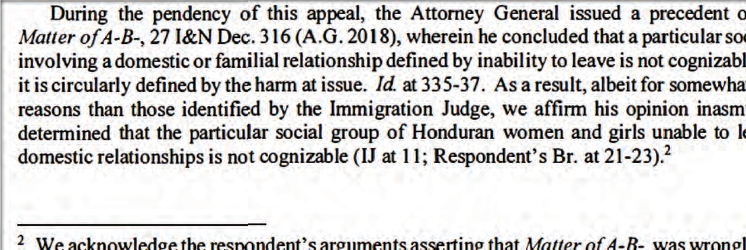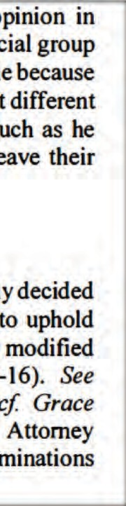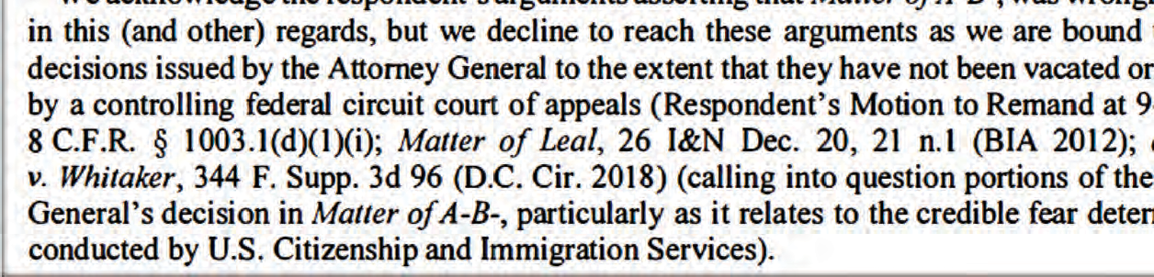Fifth Circuit Case

Defensible ?

- Yes
- No
- Maybe ?

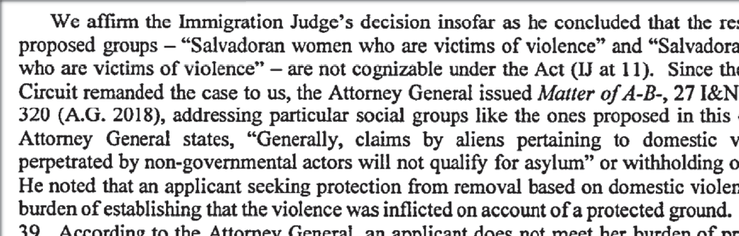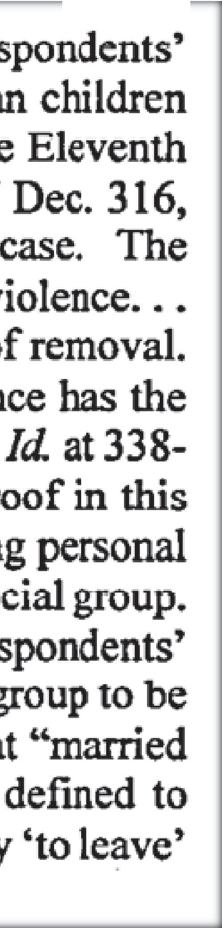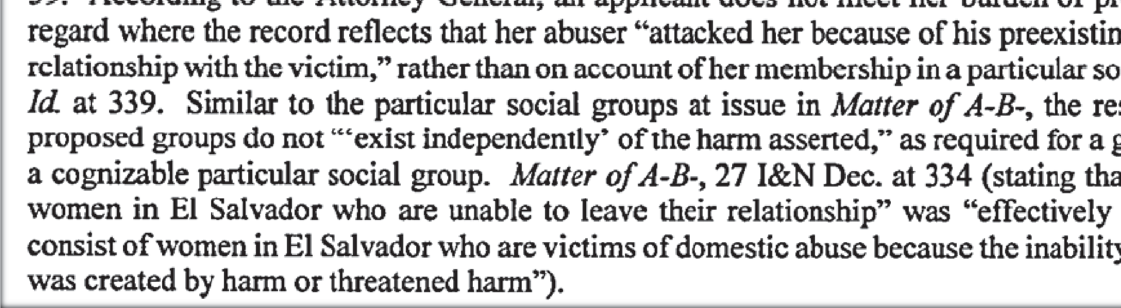Eleventh Circuit Case

Defensible ?

- Yes
- No
- Maybe ?

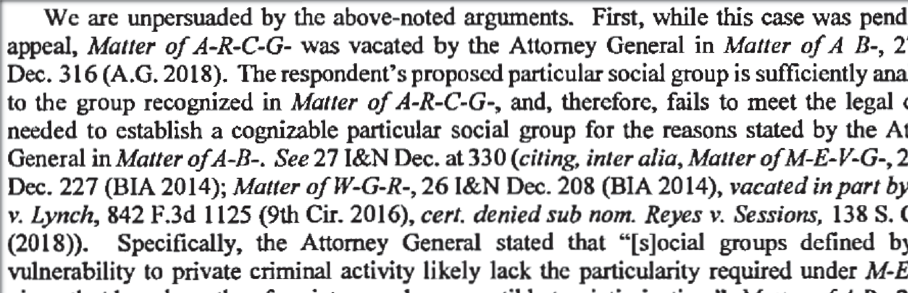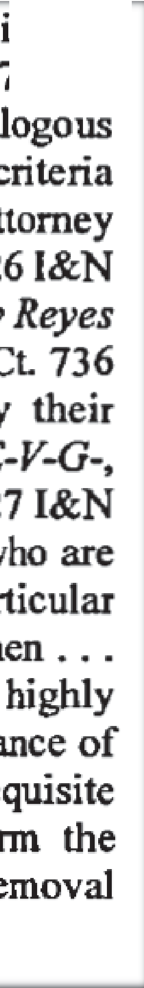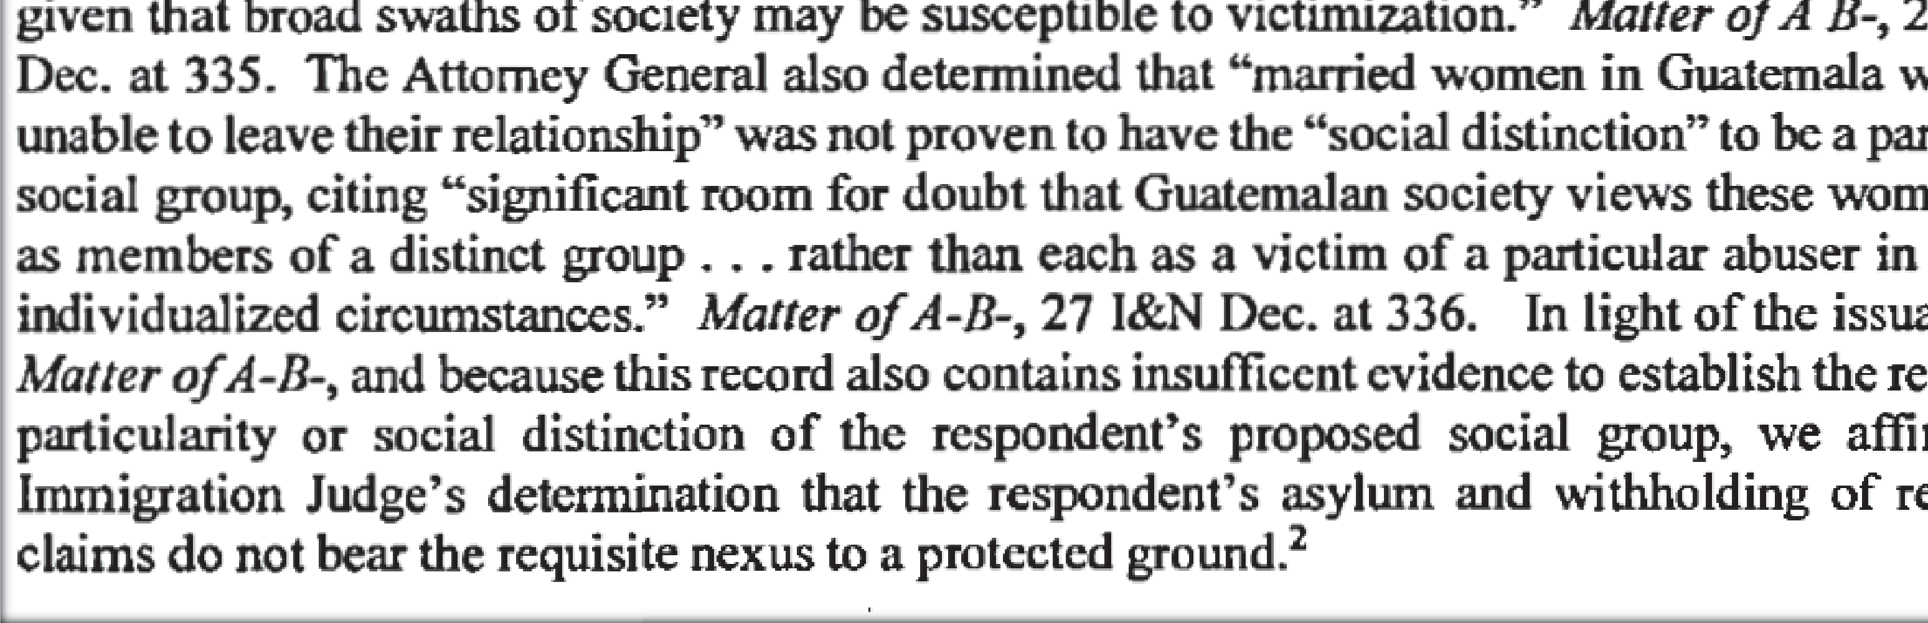

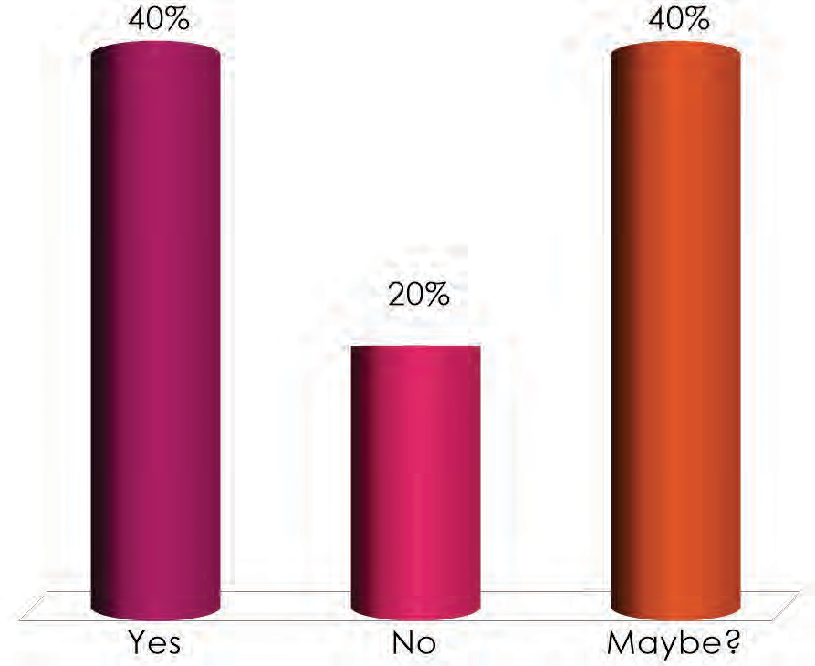

Defensible ?

- Yes
- No
- Maybe ?

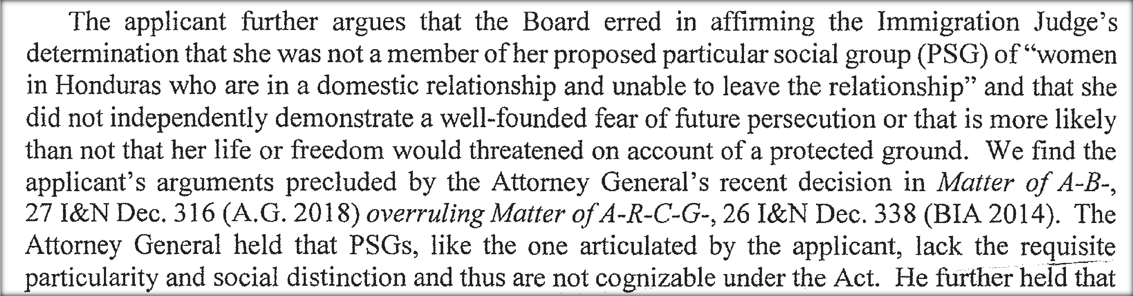Fifth Circuit – No PFR

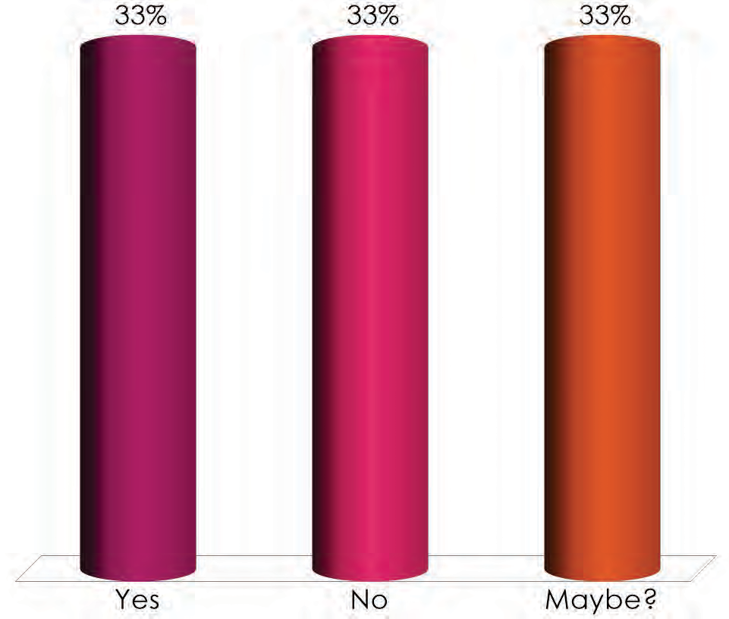

Defensible ?

- Yes
- No
- Maybe ?

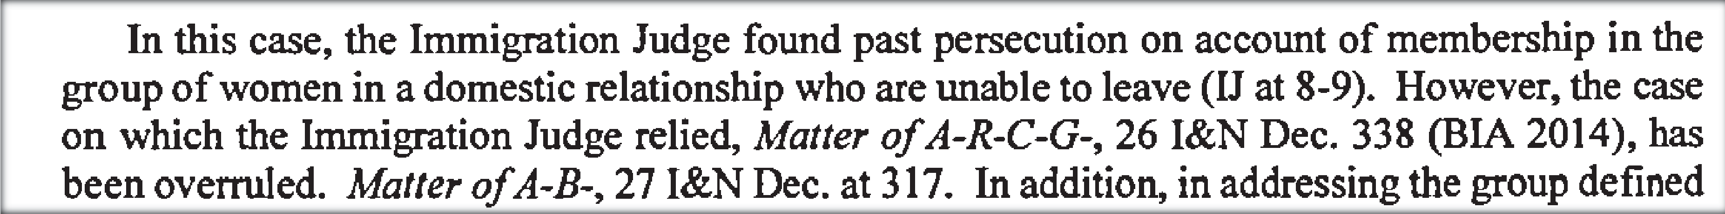

Ninth Circuit Case

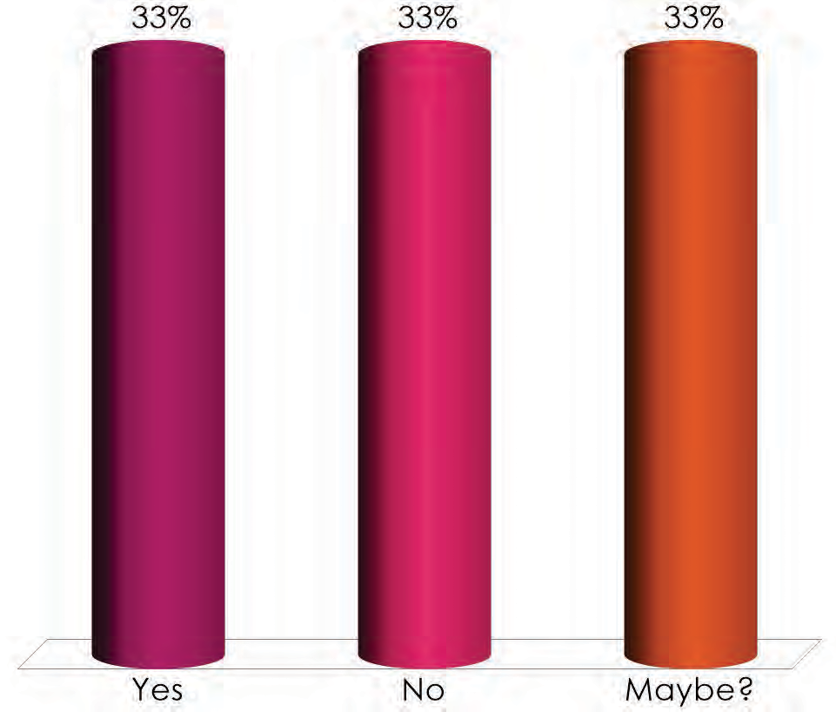

Defensible ?

- Yes
- No
- Maybe ?

Conclusion GENDER PSGS AFTER A-B-

Takeaways

(b) (5)

Family PSGs
WHERE WE’VE BEEN AND WHERE WE’RE HEADED

Categories of Family PSGs

▶ Families or family units, generally (“families,” “ Jose’s family,” “ brothers”)
▶ Immediate family groups (i.e., “immediate family of Jose Hernandez”)
▶ Family-plus groups (i.e., “families of young men recruited by gangs”)
▶ Clans (“the Marehan sub clan of Somalia ”)

Pre-L-E-A- II: Board and Circuit Precedent

▶ Immediate family groups: can be PSGs; “the immediate family of [app’s] father” was
(b) (5)
a PSG.
L-E-A- I
(b) (5)

*L-E-A-’s claim denied on nexus.*
(b) (5)
▶ Family-plus groups: in the context of a family-of-gang-recruits case, the Board held that the term “family” was indeterminate. S-E-G-.
▶ Clans: can be PSGs,
b) (5)
(b) (5)
(

▶
(b) (5)

L-E-A- II, 27 I. & N. Dec. 581 (A.G. 2019)

▶ VACATED the cogniza bility portion of L-E-A- I.
▶ The Board relied improperly on party concessions, and did not conduct the case-spe cific, fact-b ased inquiry required by the M-E-V-G-/W-G-R- framework.
(b) (5)
▶ Immediate family units still can be PSGs
(b) (5)

(b) (5)

▶ LEFT UNDISTURBED/REINSTATED the nexus portion of L-E-A- I.
(b) (5)

Family PSG Hypos

DEFENDING FAMILY PSG DENIALS POST-L-E-A- II

Wrapping Up TAKEAWAYS

Takeaways

(b) (5)

Please don’t hesitate to call or
email us if you have any questions.

(b) (6)

Thank you!

Plain Meaning of “Persecution” from the Board to the Bench

Margaret Perry
Senior Litigation Counsel, OIL margaret.perry@usdoj.gov

What We’ll Be Covering
- Chevron Overview: Purpose and Analysis for Determining Meaning of Statutory Terms

- Term “Persecution” in our Laws Before Refugee Act of 1980

- Plain Meaning of “Persecution” Before and After the Refugee Act

- What are Common Concepts in Plain Meaning of “Persecution”

- Comparing Plain Meaning of “Persecution” and its Concepts with Certain Judicial Views

- Comparing U.S. Plain Meaning and Concepts with International Approaches

- Briefing Plain Meaning

- Appendix: Circuits Applying Acosta Plain Meaning of “Persecution”

Chevron Overview: Purpose and Analysis

E.g., INS v. Cardoza-Fonseca, 480 U.S. 421, 432
(1987); INS v. Aguirre-Aguirre, 526 U.S. 415 (1999); Pereira v. Session, _ U.S. _, 138 S.Ct 2015 (2018)

Purpose of Chevron

Ascertain Congress’ Intent About Meaning of Statutes and Terms

Chevron Analysis
Examine:

- Congressional Definition or Plain Meaning
- Statute’s Structure / Context
- Canons of Statutory Construction
- Legislative History
- Purpose / Policy

After Full Analysis, If Term is Still Ambiguous, or Statute Still Silent with Respect to the Issue . . .

Defer to Authoritative Agency Interpretation, if Permissible or Reasonable

Chevron, U.S.A. Inc. v. Natural Resources Defense Council, Inc. 467 U.S. 837 (1984)

The Term “Persecution”
in our Relief / Protection Laws Before the Refugee Act

Before 1980
1950: Discretionary Withholding of Deportation: clear probability of “physical persecution”

1965: Amended Definition of Discretionary Withholding: clear probability of “persecution on account of race, religion, or political opinion”

Pre-1980: Conditional entry for people fleeing certain Communist countries because of “persecution” or “fear of persecution on account of race, religion, or political opinion”)

1968: U.S. acceded to U.N. Refugee Protocol

1980: U.S. enacted Refugee Act with “refugee” definition, asylum, mandatory withholding

Plain Meaning of “Persecution” Before the Refugee Act

Plain Meaning Before 1980 - Board
Matter of Diaz 10 I & N Dec. 199 (BIA 1963) “Persecution” in context of withholding means:
(1a) “infliction of sufferings, harm or death on those who differ (as in origin, religion or social outlook) in a way regarded as offensive or meriting extirpation;

(1b) a campaign having . . . its object the subjugation or extirpation of the adherents of a religion or way of life (pogroms in Russia).”

(Quoting Webster’s Third New Int’l Dictionary (1961)).

Plain Meaning Before 1980 – 9th Circuit

Kovac v. INS, 407 F.2d 102, 107 (9th Cir. 1969)
(holding amended INA requires “persecution” not “physical persecution” for withholding)
- “persecution” means “the infliction of suffering or harm upon those who differ (in race, religion, or political opinion) in a way regarded as offensive”

(Quoting Webster’s Third New International Dictionary 1685 (1965))

Plain Meaning Before 1980 – Dictionary

“Persecution” is “a program or campaign to exterminate, drive away, or subjugate a people because of their religious, ethical, or moral beliefs or practices: the persecutions of Christians by the Romans.”

The Random House Dictionary of the English Language 1074 (1966)

Plain Meaning Before 1980 – Congress re Deportation / Exclusion
- In 1978 Congress considered adding definition of “persecution” to INA for deportation/exclusion for participating in Nazi “persecution”

- Congress decided this was unnecessary, because ordinary meaning of “persecution” was established by administrative and court decisions

Plain Meaning Before 1980 – Congress and Deportability cont’d
Congress considered “persecution” means:

“[T]the infliction of suffering or harm, under government sanction, upon persons who differ in a way regarded as offensive (e.g., race, religion, political opinion, etc.) in a manner condemned by civilized governments.”

Matter of Laipeneiks, 18 I & N Dec. 433, 455-57 (BIA 1983) (quoting H.R. Rep. No. 95-1452 at 5 95th Cong., 2d Sess 3 (1978 U.S.C.C.A.N. 4700)

Plain Meaning of “Persecution” After the Refugee Act

Board Interprets Plain Meaning as Carried Over by the Refugee Act

Matter of Acosta (1985) referring to pre-1980 plain-meaning of “persecution” in interpreting the Refugee Act:
- “Persecution” means “either a threat to life or freedom of, or the infliction of suffering or harm upon those who differ in a way regarded as offensive” (Citing Kovac; Diaz). See also Laipenieks)

Plain Meaning Interpreted as Carried Over
“Persecution” in Refugee Act means “a threat to life or freedom or the infliction of suffering or harm, upon those who differ in a way regarded as offensive” or “to punish [them]. . for possessing a belief or characteristic a persecutor seeks to overcome.”
Acosta 19 I & N Dec. at 222-23.

Board Plain-Meaning Interpretation After the Refugee Act
“Persecution” is “the infliction of suffering or harm on those who differ (in race, religion, or political opinion) in a way regarded as offensive”) Matter of S-A-, 22 I & N Dec. 1328, 1336 (BIA 2000)

Persecution” is “the infliction of suffering or harm by a government, or persons a government is unwilling or unable to control, to overcome a characteristic of the victim.” Matter of Kasinga, 22 I & N Dec. 357, 365 (BIA 1996)

Judicial Use of Acosta Plain Meaning After Refugee Act
Ninth Circuit:
“[T]he Board is bound by our earlier decisions, which define ‘persecution’ generally as “the infliction of suffering or harm upon those who differ (in race, religion or political opinion) in a way regarded as offensive” and is “extreme conduct.”

Fisher v. I.N.S., 79 F.3d 955, 961 (9th Cir. 1996) (en
banc) (at least 17 Ninth Circuit cases spanning 40 years use this definition”) (See OIL Asylum Monograph at 59)

Judicial Use of Acosta Plain Meaning After Refugee Act

  - Eight Circuits (1st, 2d, 3d, 5th, 6th, 7th, 9th, 10th) have applied the Acosta plain meaning of “persecution” as a “threat to life or freedom” or “infliction of suffering or harm on those who differ in a way regarded as offensive” or variants

*See Appendix at end of Slides

Third Circuit Plain Meaning After Refugee Act
Fatin v INS, 12 F.3d 1233, 1240 n. 10 (3d Cir.
1993) (Alito, J.) “In ordinary usage, the term ‘persecution’ denotes extreme conduct,” and there is nothing indicating Congress intended otherwise.

“For example [persecution means] a program or campaign to exterminate, drive away, or subjugate a people because of their religion, race, or beliefs.” (Quoting The Random House Dictionary of the English Language, 1444 (2d ed. 1987).

List common concepts in the plain meaning of “persecution” (referring slides above)

List:

Comparing Plain Meaning of “Persecution” and its Common Concepts with Certain Judicial Views

Ninth Circuit
Persecution is “an extreme concept, marked by the infliction of suffering or harm . . . in a way regarded as offensive.” Li v. Ashcroft, 356 F.3d 1153, 1158 (9th Cir. 2004) (en banc)

In other words “persecution” is “objective”: “it turns not on the subjective intent of the persecutor, but rather on what a reasonble person would deem ‘offensive.’” Pitcherskaia v. INS 118 F.3d 641, 647 (9th Cir. 1997)

Seventh Circuit
The distinction between “harassment” and “persecution” is the difference “between the nasty and the barbaric” or

“between wishing you were living in another country and being so desperate that you flee without any assurance of being given refuge in any other country.” Stanojkova v. Holder, 645 F.3d 943 (7th Cir. 2011)

First Circuit
“Persecution” requires harms or conduct that are “systematic” rather than “sporadic.” Pakasi v. Holder, 577 F.3d 44, 47-48 (1st Cir. 2009)

Third Circuit
“[P]ersecution denotes ‘severe conduct’” and “does not encompass all treatment our society regards as unfair, unjust, or even unlawful or unconstitutional.”

Li v. Att’y Gen., 400 F.3d 157, 166-67
(3d Cir. 2005)

Comparing Plain Meaning of “Persecution” and its Common Concepts with International Approaches

E.U. “Human Rights” Approach (Not Plain Meaning)
European Union: (1) “Acts of Persecution” must be :
- “Sufficiently serious by nature or repetition as to [be] a severe violation of basic human rights” or

- “[A]ccumulation of . . . measures, including violations of human rights which is sufficiently severe . . to affect an individual in similar manner as mentioned in (a).

E.U. Approach cont’d.
“[T]here must be a connection between the [Convention] reasons [i.e., race, religion, nationality, etc] and the acts of persecution [listed] in paragraph (1) or the absence of protection against such acts.”

Directive 2011/95/EU of the European Parliament and of the Council (13 Dec 2011)

UNHCR Human Rights Approach (Not Plain Meaning)
  - “[P]ersecution” is “a threat to life or physical freedom on account of [a protected ground] and “[o]ther serious violations of human rights for the same reasons.”
  - “Serious discriminatory or other offensive acts committed by [a] local populace, . . . can be . . persecution if they are knowingly tolerated by the authorities, or if the he authorities refuse, or prove unable, to offer effective protection.
UNHCR Handbook paras. 52, 54.

What to Consider if Briefing a Plain-Meaning Argument

    - Is there a Plain Meaning or a Common Law Meaning?

    - Need for Full Chevron Analysis, Canons of Construction?

    - Effect of Stare Decisis/ Brand X?

    - Chenery (Defending Agency Decision)?

    - Cf. Kisor v. Wilkie, 139 S. Ct. 2400, 204 L. Ed. 2d 841 (2019)

Appendix: Circuits Endorsing Acosta Plain Meaning of “Persecution”
  - Second Circuit: Mei Fun Wong v. Holder, 633 F.3d 64, 72 (2d Cir. 2011); Bab v. Holder, 569 F.3d 79, 85 (2d Cir. 2009)

  - Third Circuit: Fatin v. INS, 12 F.3d 1233, 1240 (3d Cir. 1993)

  - Fifth Circuit: Eduard v. Ashcroft, 379 F.3d 182, 187 (5th Cir. 2004) Abdel-Masieh v. INS, 73 F.3d 579, 583-84 (5th Cir. 1996)

Sixth Circuit: Mikhailevitch v. INS, 146 F.3d 384, 389-90 (6th Cir. 1988) (quoting Surita v.
INS, 95 F.3d 814, 819 (9th Cir. 1996)

Seventh Circuit: Zalega v INS, 916 F.2d 1257, 1260 (7th Cir. 1990) ; Schellong v. INS, 805 F.2d 655 (7th Cir. 1986)

Ninth Circuit: Mansour v. Ashcroft, 390 F.3d 667, 672 (9th Cir. 2004); Fisher, 79 F.3d at 961 (en banc)

    - Tenth Circuit: E.g., Karki v. Holder, 715 F.3d 782, 801 (10th Cir. 2013); Ritonga v. Holder, 633 F.3d 971, 975 (10th Cir. 2011); Neuyen v. INS, 991 F.2d 621, 625 (10th Cir. 1993)

